https://www.bbc.co.uk/bitesize/topics/z8yv4wx/articles/zs3b2nb
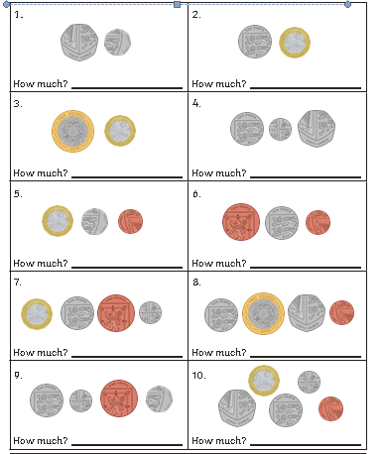
LI: I can count mixed coins in pounds and pence. Entry

