Maple and Beech Restorative Curriculum for Term 3 2021
Dinosaurs
Once again, we find ourselves in lockdown. Some of us ventured through the first lockdown together last spring and those of you who joined us at Fitzwaryn in September 2020 will be new to this with us.

Each week there will be a document uploaded to the school website containing activities for you to complete with your child, which link to the activities we are completing in school with the children who are attending. Everyone’s situations are different so please only attempt what you feel you are able to and that which interests your child. All activities included in these letters are suggestions so please don’t feel you have to complete all or any of them.

In addition, not all will be appropriate for your child as we cannot include completely tailored activities in this format. We also appreciate that many children keep home and school separate and so are reluctant to complete ‘work’ at home. This is also ok! Again, these activities are here for you to dip in and out of if it works for you, your child and your family.

We also refer you to the school website and the Homework guide which has a wealth of resources, suggestions and links to some really wonderful websites and free resources for you to access. We will be sending out details for two online libraries which we have access to as a school in the coming weeks.

We are also preparing home learning resource packs for children for English and Maths activities. These will be linked to your child’s IEPs where possible. We will endeavour to update these resources as regularly as is necessary by sending out new resources via the post.

The main focus is to have fun together. Try each day to complete something which gets your body moving, something which gets your brain working, something which helps you to feel calm and something which gets the whole family working together. Repetition is key with children this age so if you enjoy something keep repeating it!

Below is a suggested timetable to help you provide some structure for the children at home. It can be adapted to fit your family circumstances, it is not set in stone.
8-9am  Get up, dressed and ready for learning including a healthy breakfast. | 9-9.30am  Active Movement:  Cosmic Yoga, take a walk or bike ride, complete a PE challenge. | 9.30-10.15am  Focused activity 1: Story Time – Writing/reading, fine motor skills and mark making or activities from you English packs.
10.15-11am  Break and free time including a healthy snack. Try to get a bit of fresh air! | 11-11.45am  Focused activity 2: Maths Activity packs, jigsaw puzzles, gams such as snakes and ladders or some ‘shopping’ role play – allowing your children to explore any coins you might have. | 11.45-13.00  Lunch time  Help to prepare, share and tidy up lunch. Enjoy some time relaxing and chatting!
13-13.30pm  Relaxation:  Either engage with a relaxation video, Reading, mindful colouring, TACPAC (see school website for details of how to access this at home). | 13.30-14.30pm  Focused activity 3: Wider curriculum activities (Art, Music, Science, Horticulture, Cookery) share a story linked to our class topic. | 14.30- 15.10pm  Free-time, Relaxation/ Meditation before the end of the day tidy up.  Good choices could be jigsaws, colouring, word searches and listening to music.

At the end of every day take a few moments to reflect on the great work you have completed. Remember to take pictures of your children completing activities or their work, this is important evidence of their learning and progress but can also be used to create a journal to look back on. If you want to email pictures to school, we will be happy to print them for you and send them back home.
Good luck with your home learning! We will be in touch this week to make check-in phone calls. Keep reading below for this week’s suggested wider curriculum activities.

Best Wishes,

Becky Allen and Jess Cox

Maple and Beech Class Teachers

Topic History:
Our Topic This term is Dinosaurs so fish out any toys dinosaurs you might have or dinosaur costumes and books to support your child to participate in our weekly suggested activities.
This week we encourage you to create a dinosaur of your very own! Using paint, collage, drawing or colouring you can create your very own dinosaur collage however you would like. In school we used sponges, paint and paper plates to make our own dinosaurs, but you can get as creative as you would like and make as many big or small dinosaurs as you want to! Don’t forget to take a picture!
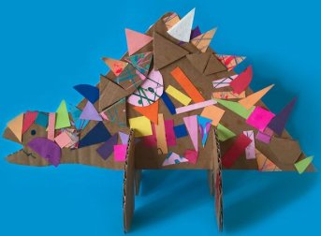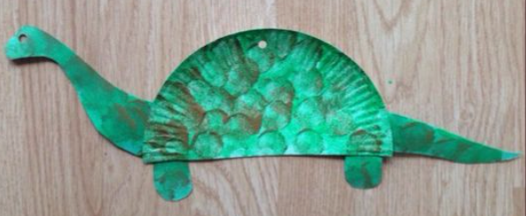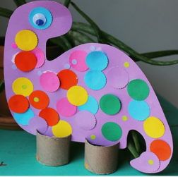

Science Activity:
In Science this term we will be learning about the human body. This week we will focus on exploring and labelling the parts of our faces. Begin with a quick round of heads, shoulders, knees and toes to cue your child into thinking about their body.
Resources:
Mirror
Card or paper,
Pens, pencil crayons,
Any collage items such as wool or string,
coloured pieces of paper
Scissors
Glue
Activity: A collage of your face!
Using a mirror, encourage your child to look at their face in the mirror, can they point to the different parts of their face? If not label them as you point to them on your child. If your child can tell you what colour their eyes or hair are, then encourage them to choose the matching colour craft item, pen or pencil crayon and support them to draw their own face and colour it in or create a collage. If your child cannot tell you what colour their features are, again just label them for them and show them the matching-coloured craft item.
We would love to see what you manage to create as a collage of your child’s face so take a picture at the end!

Music:
In Music this term we are going to be exploring body percussion. We will be discovering what sounds we can make using just our bodies. In class this week we will be looking at some pictures and describing what we might hear. For example, we might look at a picture of a woodland and you might hear the wind. We could create this sound by rubbing our hands together. Or you might hear someone’s footsteps crunching leaves, you could make this sound by rubbing your hands on your clothes on your tummy or your legs.
Explore a few different pictures like this with your child and see what different sounds you can create just using your body.
Across the term we are also going to look at rhythm and keeping a beat to a steady rhythm. We will be doing this through one of our favourite songs to listen to at the end of the day. This video has some body percussion actions/symbols which your child can try to copy and play along in time with the beat: Try Everything by Shakira (body percussion): https://www.youtube.com/watch?v=64M44FYz5d4
Support your child to clap and stomp in time to the music!

PE Activities:
In School this term our PE focus is ball skills and coordination. This week we will be focusing on slow and steady movements with a ball. You can use any size ball to attempt this challenge. Your challenge is to roll a ball up and down your legs using two hands whilst sitting on the floor with your legs out straight. Once it reaches your tummy can you roll it up and down your body or all the way around your tummy to your back and then back again? If you can manage this without dropping it try doing this whilst standing up, maybe even standing on one leg?

Art:
We are going to explore art through the theme of ‘Dinosaurs’ this term. For art this week, we are going to use charcoal to create rubbings. All you need to do is hold a piece of paper up against something with a texture or pattern, such as a leaf, then use the side of the charcoal to rub on the paper. You can create some really fabulous patterns! These might be found in your garden, in your home or even on a walk – it is up to you! Please don’t worry if you don’t have charcoal at home, chalk and crayon will do the job too! To help inspire you, here is a video on cave markings we are going to watch in class Cave Art 101 | National Geographic
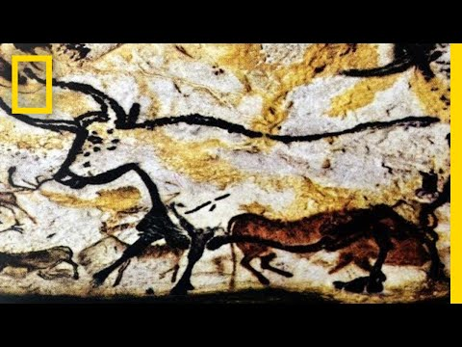
We would love to see what you have created so please email into school some examples of your work!
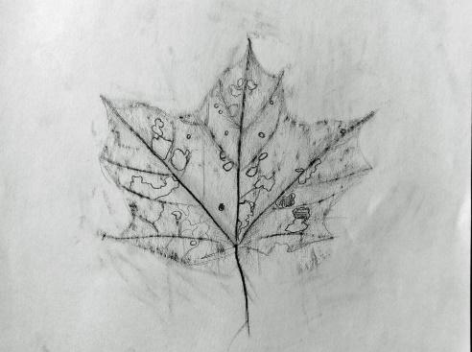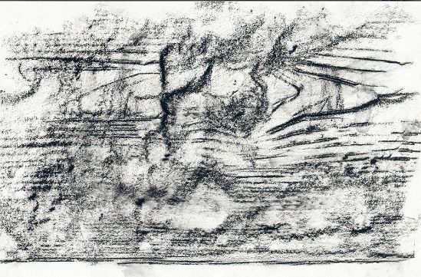

PSHCE
Throughout this term, we will be looking at what the body needs to be healthy. Including healthy eating, exercise and wellbeing. This week in PSHCE, we are going to be exploring and trying some fruit and vegetables and explaining whether we like them or not. Some children will only sniff and touch the fruit and vegetables and that’s okay! You may want to include this activity in any natural opportunities for eating. For a further challenge, see if you child can name any of the food they are eating!

RE
This term we will be linking with PSHCE to focus on our wellbeing and relaxation. It is more important than ever to look after our body, both physically and mentally, so with that in mind, this week we are going to participate in some mindfulness water colouring. Calming music with dimmed lighting would be a great backdrop for this peaceful lesson. Your child can create anything they would like using the watercolours and take part for as long as they want. Once the activity has finished, it’s great to reflect on the work they did and how it made them feel, any answer they give is okay!

Horticulture
We are going to be planting some beans this term in horticulture! In your next home learning pack a bean will be sent home for you to plant. So, your first lesson will be planting your bean! Encourage and support your child to do as much as they can without your help, including using the tools and watering their plant – they all love horticulture at school so I’m sure they will be enthusiastic to take part!

Computing
For computing this term, we are linking our lessons to horticulture. The children are going to use a device that can take pictures, such as iPads, to capture their plant growing. So, each time you tend to your plant, get your child to take a photo. Hopefully the plant will grow and over time they will notice the changes in the plant; these will be documented through the photographs. This activity supports their computing skills as well as helping them understand the concept of time. We would love to see your plants growing so please email in the photographs for us to see!

