The Good Samaritan
Can you cut out each scene and stick them in the correct order? Check you have the story set out properly before you stick it down!
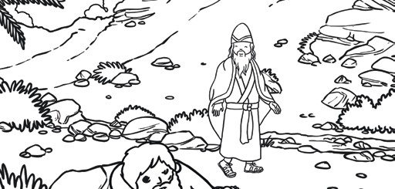 | 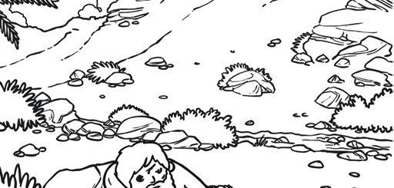 | 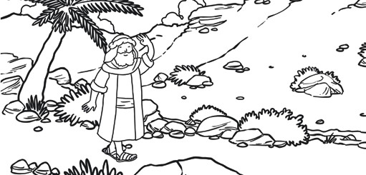 | 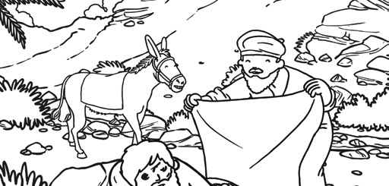
The next traveller to walk by was a Levite. The Levite’s job was to help at the temple in Jerusalem. But he did not stop to help the man. He kept walking by. | The bandits stole his clothes, beat him up and left him for dead at the side of the road. | One day, a Jewish man went out for a stroll along the road between Jerusalem and Jericho. | But the Samaritan stopped to help the Jewish man. He covered him with his cloak and took the man to a nearby inn.
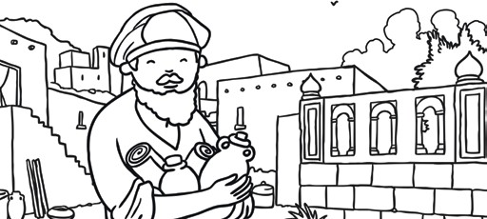 | 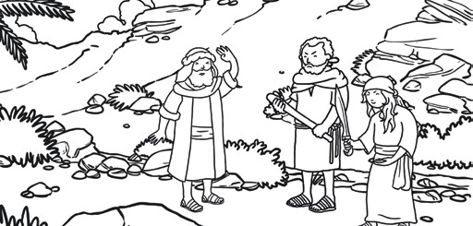 | 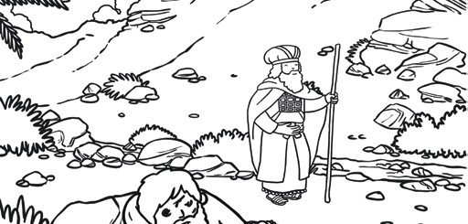 | 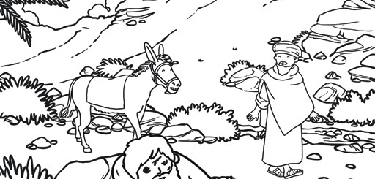
He paid for medicine and bandages to help the injured man. Even though Samaritans and Jews did not always get along, he showed him kindness and was a true neighbour. | Along the way, two bandits jumped out onto the road and stole all the man’s belongings. | After a short while, a priest walked by and saw the man lying on the ground. But he did not stop to help him. He kept walking by. | Soon, along came a Samaritan who saw the Jew lying on the ground. Samaritans and Jews didn’t usually get along at all. They had different beliefs which made them treat each other badly.

The Good Samaritan
Can you cut out each scene and stick them in the correct order? Check you have the story set out properly before you stick it down!

1 2 3 4

5 6 7 8

The Good Samaritan
Can you match the text to the pictures and stick them in the correct order? Check you have the story set out properly before you stick it down!
Soon, along came a Samaritan who saw the Jew lying on the ground. Samaritans and Jews didn’t usually get along at all. They had different beliefs which made them treat each other badly. | After a short while, a priest walked by and saw the man lying on the ground. But he did not stop to help him. He kept walking by. | Along the way, two bandits jumped out onto the road and stole all the man’s belongings. | He paid for medicine and bandages to help the injured man. Even though Samaritans and Jews did not always get along, he showed him kindness and was a true neighbour.
But the Samaritan stopped to help the Jewish man. He covered him with his cloak and took the man to a nearby inn. | One day, a Jewish man went out for a stroll along the road between Jerusalem and Jericho. | The bandits stole his clothes, beat him up and left him for dead at the side of the road. | The next traveller to walk by was a Levite. The Levite’s job was to help at the temple in Jerusalem. But he did not stop to help the man. He kept walking by.

The Good Samaritan
Can you match the text to the pictures and stick them in the correct order? Check you have the story set out properly before you stick it down!

1 2 3 4

5 6 7 8

