Indian Foods
India is known as the ‘land of spices’ This is because they are the largest producers of spices in the world!
What do Indians eat?
Indians have been eating the same foods for thousands of years. This includes lentils, whole-wheat flour and rice. An Indian cuisine includes lots of different herbs and spices that all mix well together.
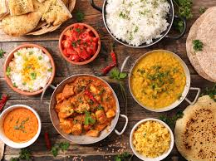
Where do they buy their foods from?
Indians love the traditional recipes that were created thousands of years ago. They buy most of their food of street sellers.
What do they eat for a snack?
For snack they eat various foods:
Samosas- Filled with potatoes, herbs, spices, peas, onions, meat and sometimes cheese.
Dahi kebab- onions, green chilies, ginger, raisins, nuts and corn flour.
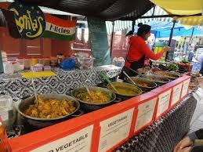
Banana chips- dried out bananas and spices.

What do they drink?
In India, the most popular drink is masala chai tea, it is Made with milk, sugar and spices.
Did you know…….?
In India they encourage you to eat with your hands!!!
Imagine not using knifes and forks!!

