Design a Planet
You have discovered a brand new planet! Complete an astronaut report to send to Mission Control about what

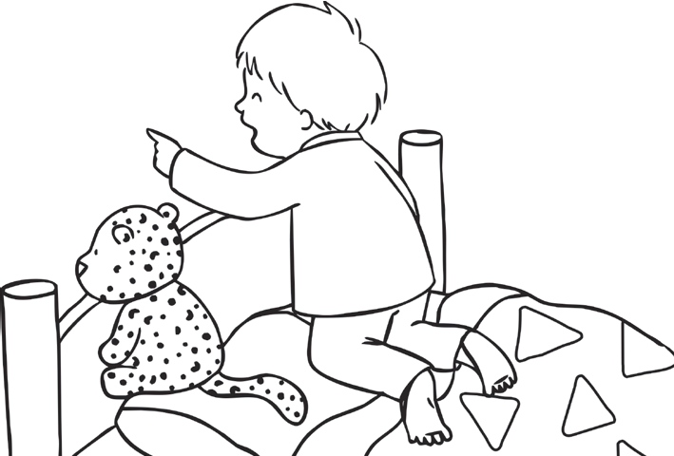
you have found.
Surface
Materials:

Signs of life (water, oxygen):
Key Facts
Colour: Size: Number of moons:
Name of Planet:

Other information:
Inhabitants
(People Who Live There)

