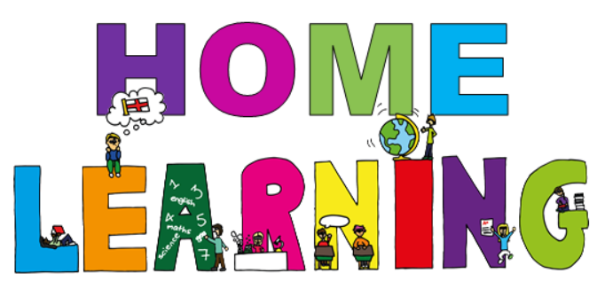

Week beginning 1st February 2021

Dear Willow & Ash parent(s)/carers,

Below are activities which can be completed at home. We have suggested subjects to be completed on certain days, which correspond with what we are completing at school. This said, if you would like to change the order of the lessons then you are welcome to do so. If you have any trouble accessing resources or if you have any questions, please do not hesitate to get in contact with us at school. Some of the activities will require access to a computer. If your child is unable to access a computer, please let us know and we can discuss how we can help.

Face to face Zoom sessions –
We would like to invite you to join us for 3 zoom sessions each week – details will be sent via email before each session, including login details and passwords.
Session 1 – Monday morning at 10:00 – 10:20 –Social session; pupils will have an opportunity to see their friends and share their weekend news.
Session 2 – Monday afternoon 1:30 – 2:00 - Explanation session for parents and pupils; to give you an opportunity to ask any questions or discuss home learning packs.
Session 3 – Thursday or Friday (times to be confirmed during our weekly phone calls or via email prior to the sessions) – Sharing session one to one face to face zoom session with the class teacher; pupils will have an opportunity to speak with their class teacher and show off their work.

Timetable -
Here is a copy of our timetable at school, which has been slightly adapted to suit home learning:
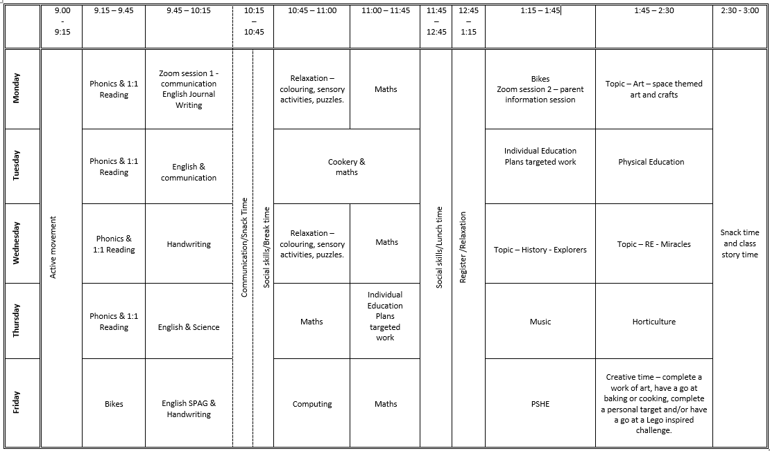

Monday home learning activities -
Subject | Activities that can be completed at home.
Active movement | Just Dance 2018 • Waka Waka (Football Version) - YouTube  Banana Banana Meatball - Blazer Fresh | GoNoodle - YouTube
Phonics | (If you need support with the pronunciation of the sounds you can listen to them on the following link Phonics Phase 3 Sounds for Pronunciation - YouTube)  Login to phonicsplay.co.uk - PhonicsPlay Username: jan21 Password: home  Play flashcards: speed trial. Practise the sounds of the letters in phase 3 that your child finds tricky.  Introduce: Play grab a giggling grapheme phase 3 on phonicsplay.co.uk  Revisit: Sing alphabet song - Phonics Song 2 (new version) - YouTube and ask the child to write the alphabet on their whiteboard or order the letters using magnetic letters.  Teach: Intro the new sounds – ‘oi’ – show the chn the sound. Show the children the grapheme ‘oi’, follow the ‘oi’ shape with your finger; children to copy drawing an ‘oi’ letters in the air. Practise writing the sound on their W/B.  Practise: Practise writing words with the ‘oi’ sound e.g. coin, boil, soil, coil, foil, using whiteboard and pens.  Apply: Watch - Geraldine the Giraffe learns /oi/ - YouTube
Reading | Oxford Owl ebook Library – see separate leaflet for details –  https://www.oxfordowl.co.uk/login?active-tab=students  Ash & Willow –  Username: fitzwarynashwillow  Password: ashwillow  - Read a level appropriate book with your child.  - Share your favourite picture/chapter novel with them.
English | Weekend News Journal Writing.  You are welcome to join us on zoom at 10am for our weekly news social session. Details will be emailed prior to the session. Encourage your child to share their weekend news with the other pupils then ask your child to draw a picture of what they did at the weekend.  Extension: Ask your child to write a simple sentence or a few key words to accompany their picture. This can be done by copying a sentence you have written for them after they have told you what to write or overwriting a sentence that has been written for them in a felt tip pen.
Maths | Learning intention:  - I can solve subtraction problems by counting back from a given number.  Success criteria:  - pupils will count reliably to 10.  - pupils will recognise mathematical symbols.  -pupils will count back from a given number using resources.  Starter: Play subtraction song on youtube - Subtraction Song for kids | Subtraction Facts | Subtraction Action | Jack Hartmann – YouTube  Main: Children are presented with a series of subtraction questions in the conventional format which include plus signs. Two boxes feature the corresponding number of animals which need to be subtracted - Subtraction To 10 (topmarks.co.uk)  Activity: Complete Maths worksheet 1 – counting back using a number line (objects may be used for support)
Bikes/Physical movement | Go outside –  Ride a bike or walk around your local nature reserve or country park or play a game in your garden e.g., bat and ball, football, catch.
Topic - Art | Crayon Resist Space Art  You will need: wax crayons, white card, paintbrush, watered down/water colour paint, paper towel.  Step 1: start by colouring a space scene on the card. Stars, planets, shooting stars, rockets, and aliens. Ensure they have been coloured in completely with the crayons.  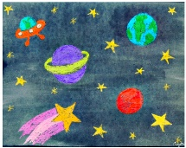  Step 2: brush over the whole paper with the black water colour. The waxy crayons won’t absorb the paint and it beads up a little.  Step 3: pat with a paper towel to clean off paint that beads up on the crayon.  Step 4: let dry and display your beautiful space picture.

Tuesday home learning activities -
Subject | Activities that can be completed at home.
Active movement | Just Dance 2015 - Happy Pharrell Williams Gameplay - 5 Stars Rating [ HD ] - YouTubeou t  You tube – Joe Wickes PE session
Phonics | If you need support with the pronunciation of the sounds you can listen to them on the following link Phonics Phase 3 Sounds for Pronunciation - YouTube)  Login to phonicsplay.co.uk - PhonicsPlay Username: jan21 Password: home  Play flashcards: speed trial. Practise the sounds of the letters in phase 3 that your child finds tricky.  Introduce: Play grab a giggling grapheme phase 3 on phonicsplay.co.uk  Revisit: Sing alphabet song - Phonics Song 2 (new version) - YouTube and ask the child to write the alphabet on their whiteboard or order the letters using magnetic letters.  Revisit: the new sounds – ‘oi’ – show your child the sound. Show the children the grapheme ‘oi’, follow the ‘oi’ shape with your finger; children to copy drawing an ‘oi’ letters in the air. Practise writing the sound on their paper.  Practise: Practise writing words with the ‘oi’ sound e.g. coin, boil, soil, coil, foil, using whiteboard and pens/paper and pen.  Apply: Watch - Geraldine the Giraffe learns /oi/ - YouTube  Can they spot Words with “oi” in when they are reading a book?
Reading | Oxford Owl ebook Library – see separate leaflet for details –  https://www.oxfordowl.co.uk/login?active-tab=students  Ash & Willow –  Username: fitzwarynashwillow  Password: ashwillow  - Read a level appropriate book with your child.  - Share your favourite picture/chapter novel with them.
English - communication | Introduction: Talk about your child’s pet/favourite animal – what do they like about them?  Main activity: Make up a story one or two sentences at a time, taking it in turns with your child. Can they add anything to it? It can be as weird as they like. A possible starter is: “I was walking down the road when I heard a strange noise. I turned around and I saw…..” Then see what your child says. This can be supported by a range of pictures, as necessary. Keep recapping the story and encourage them to add to it.
Cooking/Maths  Learning intention:  To measure out ingredients correctly  Success criteria:  - I can use scales independently  I can use the correct mathematical terms when measuring ingredients | Encourage your child to help you prepare a meal this week. If possible, concentrate on your child helping to measure out the quantities. It’s good to model the mathematical vocabulary when measuring, for example grammes, litres, tablespoon etc.  At school we are making ratatouille this week. The recipe will be available on the website if you would like to do it as well.
Individual Education Plan targeted work | Choose an activity to complete from your child’s individual education plan.
PE | Outside: go for a walk, run, bike ride, scooter ride.  Inside: there are online activities such as just dance or Joe Wickes PE sessions on youtube.  We finish off PE with a yoga session. We are using the one below this week but there are a wide range of choices under cosmic yoga on youtube.  Mike The Cosmic Space Monkey | A Cosmic Kids Yoga Adventure! - YouTube

Wednesday home learning activities -
Subject | Activities that can be completed at home.
Active movement | Just Dance 2015 - Happy Pharrell Williams Gameplay - 5 Stars Rating [ HD ] - YouTube  Just Dance Kids 2014 A Pirate You Shall Be - YouTube
Phonics | Introduce: New tricky word: ‘you’ and how to read and write it.  Revisit: Practise reading phase 3 tricky words. Play tricky word trucks phase 3 on phonicsplay.co.uk.  Teach: How to read the tricky word: ‘you’. Play train your brain phase 3 on phonicsplay.co.uk.  Practise: Watch and sing Phase 3 Tricky Words Song Say Hello To - YouTube  Apply: Play pick a picture on phonicsplay.co.uk
Reading | Oxford Owl ebook Library – see separate leaflet for details –  https://www.oxfordowl.co.uk/login?active-tab=students  Ash & Willow –  Username: fitzwarynashwillow  Password: ashwillow  - Read a level appropriate book with your child.  - Share your favourite picture/chapter novel with them.
English & handwriting | (support/information for parents Nelson guide for parents | Oxford Owl)  Starter: Let's Go To The New Dough Disco - Bing video – warm up ready for handwriting (you will need a blob of playdough)  Main: Watch Handwriting for kids: Learn to Write Letters h, b, r, n, m p with the Handwriting Heroes Bouncers! - Bing video – use the video to practise writing the letters – bouncer letters. Stop after each letter to practise witing it in their exercise books or on whiteboards.
Maths | Starter: Play subtraction song on youtube - Subtraction Song for kids | Subtraction Facts | Subtraction Action | Jack Hartmann - YouTube  Main: Play Helicopter Rescue - Mental Maths for 4 to 8 Year Olds (topmarks.co.uk) – Recap knowledge of numbers up to 20 – find the number given on the number line.  Use PowerPoint (saved on Fitzwaryn website home learning maths) alien themed subtraction up to 20. Practise solving the problems using cubes. Count out the given number of cubes into a pot or on the table. Then ask the child to take away the given number of cubes and place them in a separate pot/area of the table. Finally, ask them to count how many cubes are left in the pot/on the table in front of them. Write it as a calculation using mathematical symbols. Repeat for all the problems in the PowerPoint.  Example of how pots and objects can be used to help support Maths:  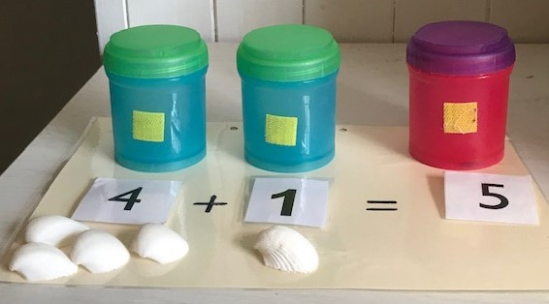
Topic - History | This week’s we are learning all about the explorer Amelia Earhart.  Watch - History KS2 | Explorers: Amelia Earhart | BBC Teach - YouTube  Discuss: what happened in the video clip. Can you recall any facts about Amelia Earhart?  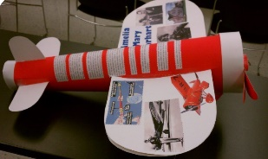  Activity: Draw a picture/poster/art project all about Amelia Earhart. You could make a plane out of junk modelling. Colour/cover with coloured paper and stick-on facts about her using the word mat for support.
Topic - RE | Watch the video of Jesus calming the storm https://www.youtube.com/watch?v=uYLHqdSO9OY or read through the story PowerPoint (saved as RE PowerPoint week 4)  Discuss; have you ever had a problem you could not fix? What did you do? Like the disciples, we are all afraid sometimes. In this story the disciples learnt to trust in God to help them even when it seemed impossible.  Activity: Either design and make a sailboat using junk modelling or lego or sequence the story using story sequencing cards.  Cut up the sequencing cards (saved as RE worksheet week 4) and mix them up. Pupils can then put them back in the right order. As an extension, pupils can write a sentence or two for each card.

Thursday home learning activities -
Subject | Activities that can be completed at home.
Active movement | Just Dance 2018 • Waka Waka (Football Version) - YouTube  Banana Banana Meatball - Blazer Fresh | GoNoodle - YouTube
Phonics | Revisit: New tricky word: ‘you’ and how to read and write it.  Revisit: Practise reading phase 3 tricky words. Play tricky word trucks phase 3 on phonicsplay.co.uk.  Teach: How to read the tricky word: ‘you’. Play train your brain phase 3 on phonicsplay.co.uk.  Practise: Watch and sing Phase 3 Tricky Words Song Say Hello To - YouTube  Apply: Play pick a picture on phonicsplay.co.uk
Reading | Oxford Owl ebook Library – see separate leaflet for details –  https://www.oxfordowl.co.uk/login?active-tab=students  Ash & Willow –  Username: fitzwarynashwillow  Password: ashwillow  - Read a level appropriate book with your child.  - Share your favourite picture/chapter novel with them.
English & Science Learning Intention:  To recall facts about rockets  Success Criteria:  - I can remember a new fact about rockets.  - I can write a sentence incorporating that fact. | The Solar System Song - YouTube  This week we’re learning about rockets.  [HD] IMAX // Shuttle launch (Hubble 2010 - STS 125) - Excellent Quality - YouTube  The space shuttle was the world’s first reusable spacecraft. It takes off like a rocket but lands back on earth like a glider. It is used for launching satellites and building space stations.  Fun fact: rockets fly at 17,000 mph to orbit the earth.  Having Fun in Space! - YouTube Discuss why we think astronauts float in space. Would they like to go to space in a rocket? Can they say why/why not?  Children use picture of rocket to write about. Discuss with adult what they want to write. If needed, adult to write sentence for them to copy. Remember capital letters and full stops. Use symwriter sentences (pre-cut) for children to create their own sentence for those that need it. The writing sheet is available on the website.  If your child is interested in space, then there are many more clips on youtube about rockets and space.
Maths Learning intention:  To understand 1 more/1 less  Success criteria  - I can say 1 more/less than a given number to 5 or 10  - I can count out 1 more/less using objects | Numbers Song | Math Song | The One More Number Game | Jack Hartmann - YouTube  1 more and 1 less than a given number.  Pupils to be given several beads (you could also use lego/duplo bricks) – up to 5 or 10, depending on your child. Can they state what is 1 more or 1 less than that number? Extend to 2 more if they are confident with 1. Support as necessary and use a number line where needed.
Music | The Planets - VII. Neptune, the Mystic - Gustav Holst - YouTube  Gustav Holst wrote a series of music about the planets. Neptune is the god of the sea and this music is about mystery.  Play the recording and talk about how it makes you feel.  Listen to the rhythm, choose an instrument to play and encourage pupils to follow the beat as they play along to the orchestra. Your child could clap or bang on the table as a drum or use glasses as chime bars.
Horticulture  Learning Intention:  To conduct an experiment to discover what conditions seeds will grow in  Success Criteria  - I can state what seeds need to grow  - I can conduct an experiment  - I can make a prediction | Explain we’re going to conduct an experiment to find out what seeds need to grow. Can they state what conditions seeds need.? We’re using cress at school because it usually grows within a week. A yogurt pot with some compost at the bottom is fine, but you can also use kitchen roll or cotton wool instead of soil.  Talk through different conditions – water, soil, sun – and what would happen if seeds didn’t have one of those conditions. Would they still grow?  Plant seeds in 4 pots: 1. In soil in dark  2. In soil, in light  3. In soil, with water, in dark  4. In soil, with water, in light.  Label each pot so it is easy to compare how well the seeds have grown afterwards.  Complete prediction sheet. Can pupils correctly predict which will grow the best? What do they think will happen to the others? Cress grows really quickly so they will be able to check daily and see differences between the pots.  The prediction sheet is available on the website. We will be looking at the cress next week, so any feedback from you/photos would be great to see so we can share your findings with the group in school.

Friday home learning activities -
Subject | Activities that can be completed at home.
Active movement | Just Dance 2018 • Waka Waka (Football Version) - YouTube  Banana Banana Meatball - Blazer Fresh | GoNoodle - YouTube
Bikes | Go outside –  - Ride a bike.  - Have a walk around your local nature reserve or country park.  - Play a game in your garden e.g., bat and ball, football, catch.
English spelling, punctuation and grammar & handwriting  Learning Intention:  -to use capital letters at the start of a sentence  Success Criteria:  -pupils will use the correct letter formation/size.  -pupils will include finger spaces, capital letters and full stops. | Starter: Watch and follow along to dough disco finger warm up - to warm up your child’s hands ready for writing.  Main: Parent/carer to write a sentence with a simple mistake i.e. without a capital letter at the start or full stop at the end. Can your child spot the mistake? You could ask them- does my sentence start with a capital letter? Does it end with a full stop? Have I spelt words used phonics to help me spell words? Have I put finger spaces between words?  Share English worksheet Friday’s semantics sheet with image of a spaceman. Ask your child to explain/discuss who, what doing, where? e.g. The alien is flying in space. Encourage your child to cut out the chosen word and stick it on the corresponding box, e.g. cut out alien and stick it on the ‘who?’ box.  Extension: When they have finished with the activity above ask your child to copy the sentence underneath, remembering to include the little words and a capital letter at the start of the sentence- The astronaut is standing on a rocket in space.
Computing | You will need: to download Kids Drawing, Doodle Painting app free from the app store.  Starter: Introduce the lesson using the technology song - Encourage your child to dance along.  Main: Use the internet to research the work of ‘Piet Mondrain’ and discuss what the child notice?  Demonstrate how to use the line and fill tools on a painting app to replicate his work.
Maths  Learning intention: I can count, read and write numbers to 5, 10 or 20. | Starter: Listen to Jack Hartman and then sing along.  Main: Show your child 5, 10 or 20 counters (or anything you can find at home). Model moving 1 counter at a time as you count the counters. Show numbers of counters, e.g. 5, 10, 15. Ask your child how many you are showing? Can they write the number on their whiteboards? How are they working it out?  Give your child counters. Can they use them to show you 5, 10, 15, 20, 6, 11, 12, 16 and 19?  Extension: Think about using groups of 5 to help.
PSHE | Creative Time- squishy soap  Ask your child to put the cornflour in the bowl and then add the wet ingredients. Mix until it forms a dough and then pour onto the table for your child to explore. It could be used for handwashing or bath time. You could place it in a lidded container between uses if you would like to keep it for longer.

Relaxation/mindfulness:
Guided Meditation for Children | Your Secret Treehouse | Relaxation for Kids - YouTube
Relax Music for Stress Relief, Study Music, Sleep Music, Meditation Music 💜 528Hz - YouTube
Guided Meditation for Kids | Spaceship to the Moon | Relaxation for Children - YouTube
Other helpful websites:
Home - GoNoodle
ictgames
PhonicsPlay
Welcome | Numeracy Warm Up
- username: fitzwaryn
- password: story
HelpKidzLearn
Writing warmups - dough disco for children - YouTube
Phonics song - Phonics Song 2 (new version) - YouTube
Jolly Phonics A-Z - YouTube
Counting song - Let's Get Fit | Count to 100 | Count to 100 Song | Counting to 100 | Jack Hartmann - YouTube
Space/planets song - The Solar System Song - YouTube

Stay safe and well!
All the best,

Ash and Willow Class teachers

