Home learning – Week 5
India
Focussed activities
Listed below are the focussed activities we will be doing each day in school. They have been adapted slightly so that they can be accessed from home. Please of course feel free to adapt any tasks or create your own!
In the task box you will see brief written instructions for a task and the name of the worksheet (highlighted in green) that can be downloaded. Worksheets and plans will be uploaded onto the website weekly.
IEP Target Work
Each morning in class, pupils will have 10 minutes focussed IEP work. You can choose with your child each day which target they would like to work on and keep a record of their progress using the progress sheet. Although we will be doing target work in the mornings, please feel free to choose when in the day you would like to do this.
Phonics
Each day in class we will be doing 10 – 15-minute phonics sessions. A great way for your child to access phonics at home is through using phonics play. Please see log in details below and I will let you know your individual child’s phonics level so you can access this online.
https://www.phonicsplay.co.uk/
username: jan21
password: home
There is also a great website to look at that can address any queries you may have around the phonics sounds. This website can be found via this link https://home.oxfordowl.co.uk/reading/learn-to-read-phonics/
Reading
Please try and read with you child as much as possible each week and keep a record using the reading diary document that is on the home learning page. There is always so much great reading achieved at home and we love hearing about this 😊.

Focussed activities – Week 5
Monday
Focussed activity | Task
IEP target work (10 minutes) | Choose a target to work on for about 10 minutes.
Focussed activity 1: English | Journal Writing  Have a discussion about the weekend. What did you do? Can you include a describing word to your sentence?  Pupils to write one or two sentences about their weekend and draw a picture to go with it.  (printable journal writing template on website)  Pupils could also use a computer if preferred and type a sentence about their weekend.
Focussed activity 2: Maths | LI – To complete subtraction sums  LI – To count back to complete subtraction sums  Monday worksheet 1  Monday worksheet 2  Please choose a worksheet that suits your child’s level to complete.
Phonics (10 minutes) | Please log onto Phonics Play and click on your child’s level for activities.  username: jan21  password: home
Focussed activity 3: Art | Go through the Rangoli PowerPoint  Choose a Rangoli pattern to colour in using paints.  Use a small paintbrush and a pallet of primary colours. Use your colour mixing sheets for reference. Encourage pupils to make secondary colours to make their Rangoli pattern nice and colourful.  Pupils to share their work at the end and each answer a simple question about their work and their work displayed.  

Tuesday
Focussed activity | Task
IEP target work (10 minutes) | Choose a target to work on for about 10 minutes.
Focussed activity 1: English | Indian culture – Holi Festival  LI – To recall a fact  Watch video clip explaining the story of the Holi festival https://www.bbc.co.uk/bitesize/topics/zh86n39/articles/z4qqy9q  Watch a second video clip  https://www.youtube.com/watch/wTfYhG2mOSA  Write a fact about the Holi festival. Tuesday English worksheet.  If you would like to, you can also choose a Holi colouring sheet to colour in.
Focussed activity 2: Maths | LI – To complete subtraction sums  LI – To count back to complete subtraction sums  Tuesday worksheet 1  Tuesday worksheet 2  Please choose a worksheet that suits your child’s level to complete.
Phonics (10 minutes) | Please log onto Phonics Play and click on your child’s level for activities.  username: jan21  password: home
Focussed activity 3: Science | LI – To make a food chain  Choose a game to play. Can you explore different food chains?  https://www.bbc.co.uk/bitesize/topics/zbnnb9q/articles/z93vdxs  http://interactivesites.weebly.com/food-chains.html  https://www.sciencekids.co.nz/gamesactivities/foodchains.html  Use the pictures provided on the Science worksheet and create a food chain mobile.  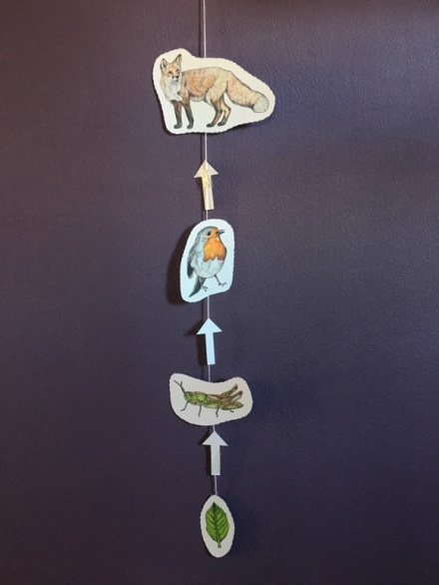

Wednesday
Focussed activity | Task
IEP target work (10 minutes) | Choose a target to work on for about 10 minutes.
Focussed activity 1: English  Research task | LI – To make a poster  Can you make a poster about India? Look back at all you have learned and choose what you would like to include on your poster.  Can it have a title and some pictures or drawings?
Focussed activity 2: Maths | LI – To complete subtraction sums  LI – To count back to complete subtraction sums  Wednesday worksheet 1  Wednesday worksheet 2  Please choose a worksheet that suits your child’s level to complete.
Phonics (10 minutes) | Please log onto Phonics Play and click on your child’s level for activities.  username: jan21  password: home
Focussed activity 3: RE | LI – To design and label a new religious building.  Look at pictures to support ideas on RE worksheet.  Draw a design for your place of worship; it can look how you want it to look. Think of places that are special to you maybe this can help with your design ideas.  What will be inside your place of worship? Look at the pictures to help and include some if you would like? What else would you include?  Have another look around a church using the link below.  Virtual visits | Explore Churches  Can you label the different parts of your place of worship?

Thursday
Focussed activity | Task
IEP target work (10 minutes) | Choose a target to work on for about 10 minutes.
Focussed activity 1: English | Indian culture - A day at school in Kerala  LI – To answer comprehension questions  Watch the video clip https://www.bbc.co.uk/programmes/p0113zg5  An insight into a typical day in the life of a school child in the Idukki region of Kerala, India.  Watch the video clip again and pause at certain parts and answer the questions on the worksheet.  Thursday English worksheet.
Focussed activity 2: Maths | LI – To complete subtraction sums  LI – To count back to complete subtraction sums  Thursday worksheet 1  Thursday worksheet 2  Please choose a worksheet that suits your child’s level to complete.
Phonics (10 minutes) | Please log onto Phonics Play and click on your child’s level for activities.  username: jan21  password: home
Focussed activity 3: PE | Get kids up and active.  Pupils could either do some cosmic yoga or a joe wicks home work out. Please see links below.  Yoga  https://www.youtube.com/results?search_query=cosmic+yoga  Joe Wicks  https://www.youtube.com/results?search_query=joe+wicks+pe+for+kids

Friday
Focussed activity | Task
IEP target work (10 minutes) | Choose a target to work on for about 10 minutes.
Focussed activity 1: English | LI – To prepare a question/work for Zoom  Starter  Talk about the zoom call this afternoon. Explain that it is a conversation and that they need to choose something they would like to tell them about their week. Can they include a question to ask the class?  Main activity  To prepare write what they would like to say or show.
Focussed activity 2: Maths | Play a maths subtraction game. Choose from one of the games below.  Subtraction To 10 (topmarks.co.uk)  Subtraction Games for Kids Online - SplashLearn  Subtraction Games Menu - Math Games (sheppardsoftware.com)
Phonics (10 minutes) | Please log onto Phonics Play and click on your child’s level for activities.  username: jan21  password: home
Whole class zooms | 1.45pm – 2.00pm  Whole class zoom to share work from the week.

