Pine and Rowan Home tasks for week 4

Below are the activities which can be completed at home. We have suggested subjects to do on certain days which correspond with what we will be doing at school. But if you want to do the activities in a different order that’s fine! We have sent home packs with phonics resources and your child’s logins for the online library and Gooseberry Planet as well as a book which can be used for activities that don’t require a worksheet or to stick in completed work. Some of the activities require access to a computer. If your child is unable to access a computer, please let me know and we can discuss how we can help.

If you have any trouble accessing the resources or if you have any questions, please feel free to contact me at school.

We are also having Zoom calls weekly. If your child wants to join in, they are as following:
Monday 10am- Social session
Tuesday 10am- Explanation session
Friday 10am- Sharing session.

If you are planning to join, please can you make sure you are ready for when it starts and if you are having any problems please let us know. You can access each of the three Zoom sessions via the following single link:
https://zoom.us/j/93878252793?pwd=UTRZczZJbEI1VWtyZFNJMXIHSU5Wdz09

Meeting ID: 938 7825 2793
Passcode: psKN9v

Monday
Subject | Activities that can be completed at home
Physical activity | Joe Wicks or Cosmic Yoga
Reading/ Phonics | Pupils can read a book at their level or complete phonics activities.  Review flashcards of sounds. Do they recognise all of the sounds? Can they think of any words that use the sounds?  Pupils can also do activities on Phonics Play.  https://www.phonicsplay.co.uk/  You may log in with the following details:  username: jan21  password: home
English | Journal Writing.  Pupils can write a sentence or more about what they have done either over the last weekend. This can be done either independently, copying a sentence or overwriting a sentence that has been written for them.
Maths | This week we will be focusing on Time.  A set of worksheets for your child will be on the website under Maths Week 4 (child’s initials)
PHSE | Introduce the concept of ‘prevention’. Use role play / example of moving a chair so someone does not trip over it. Explain that you have thought ahead and done something to help before an accident occurred.  Link this to health. Explain there are things we can do now to make sure we are healthy in the future.  Working through the power point (saved as PSHE PowerPoint week 4), ask pupils to identify:  - What is happening in the picture?  - Why are they doing it? / What are they preventing?
Art | Over the term in Art, we would like pupils to make a solar system. This can be done as a model or a picture and you or your child can choose how they would like to do it. Pupils can then build on their model/picture each week as they learn more about the different planets. Below are some examples you can use for inspiration but feel free to use your imagination!  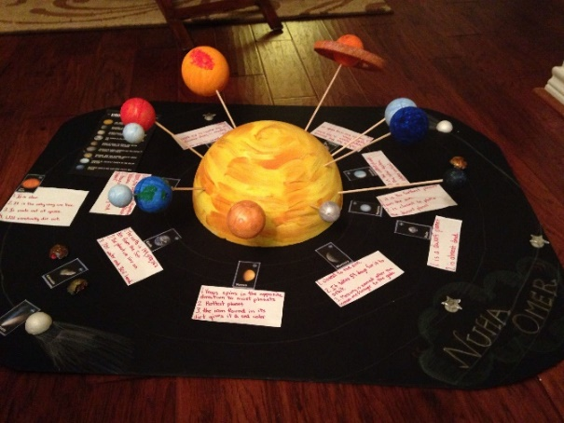  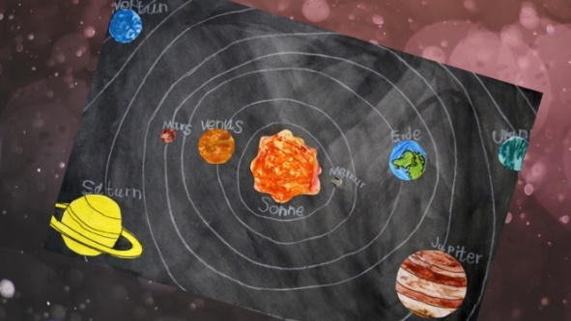  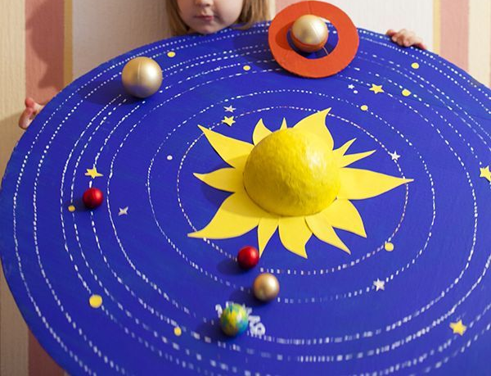

Tuesday
Subject | Activities that can be completed at home
Physical activity | Joe Wicks or Cosmic yoga
Reading/ Phonics | Pupils can read a book at their level or complete phonics activities from pack that has been sent home.  Pupils can also do activities on Phonics Play.  https://www.phonicsplay.co.uk/  You may log in with the following details:  username: jan21  password: home
Handwriting | Complete handwriting worksheets found on website.  Either continue Pencil control workbook or ‘k’ worksheets  Extension- Pupils can write a few sentences of their choosing, ensuring they are forming their letters correctly and keeping them on the line.
Maths | This week we will be focusing on Time.  A set of worksheets for your child will be on the website under Maths Week 4 (child’s initials)
RE | Watch the video of Jesus calming the storm or read through the story PowerPoint (saved as RE PowerPoint week 4)  https://www.youtube.com/watch?v=uYLHqdSO9OY  Cut up the sequencing cards (saved as RE worksheet week 4) and mix them up. Pupils can then put them back in the right order. As an extension, pupils can write a sentence or two for each card.
PE | Go for a walk/Bike ride/Run/complete a kid’s aerobic workout/just dance

Wednesday
Subject | Activities that can be completed at home
Physical activity | Joe Wicks or Cosmic Yoga
Reading/ Phonics | Pupils can read a book at their level or complete phonics activities from the pack that has been sent home.  Pupils can also do activities on Phonics Play.  https://www.phonicsplay.co.uk/  You may log in with the following details:  username: jan21  password: home
English | This term, pupils will be making a fact book about planets. Using the fact book template saved as English fact book extra sheets  Today, pupils can write a page and draw a picture about the planet Earth. It can range from a sentence to a paragraph with facts they have learnt about Earth  Please refer to last week’s science PowerPoint in you get stuck!
Maths | This week we will be focusing on Time.  A set of worksheets for your child will be on the website under Maths Week 4 (child’s initials)
Music | Watch the orchestra version video on the BBC website using the link below  http://www.bbc.co.uk/programmes/p02b14ld  Ask pupils to think back to the previous weeks and the chants and patterns they came up with. They can choose one of these chants and patterns or make up a new one. Pupils can combine the patterns and chants. Pupils can perform the pattern either by clapping, stomping, patting legs/table or using an instrument of available.
History | This week we will be learning about Amelia Earhart. First, read through the PowerPoint slides about Amelia Earhart. Then the pupils can make an aeroplane in the style of Amelia Earhart’s plane. We have given some instructions as a guide (saved at history task week 4) but if you don’t have the materials needed, they can make it out of anything they like e.g. Lego, paper etc.  Extension- answer the multiple choice questions saved as history extension week 4

Thursday
Subject | Activities that can be completed at home
Physical activity | Joe Wicks or Cosmic Yoga
Reading/ Phonics | Pupils can read a book at their level or complete phonics activities from the pack that has been sent home.  Pupils can also do activities on Phonics Play.  https://www.phonicsplay.co.uk/  You may log in with the following details:  username: jan21  password: home
English | This term, pupils will be making a fact book about planets. Using the fact book template saved as English fact book extra sheets  Today, pupils can write a page and draw a picture about the planet Mars. It can range from a sentence to a paragraph containing facts they have learnt about Mars.  Please refer to last week’s science PowerPoint in you get stuck!
Maths | This week we will be focusing on Time.  A set of worksheets for your child will be on the website under Maths Week 4 (child’s initials)
Computing | This term Pupils will learn about e-safety. We will be doing this through the Gooseberry Planet website. Each pupil has their own individual login which has been sent through the post. We will be working through the Gooseberry Playground section, completing one level each week.  Complete Level 4 this week. First, read through the supporting slides which are saved as Computing week 4. Students will then complete activities on the website as instructed throughout the slides.
Science | This week we will be learning about Jupiter and Saturn.  Read through the slides about Jupiter and Saturn (saved as science PowerPoint week 4). Pupils can then complete the worksheet (saved as science worksheet week 4). Pupils can either write the answers or stick in the correct answer from the symbols provided.

Friday
Subject | Activities that can be completed at home
Physical activity | Joe Wicks or Cosmic Yoga
Reading/ Phonics | Pupils can read a book at their level or complete phonics activities from the pack that has been sent home.
English | Journal Writing.  Pupils can write a sentence or more about what they have done either over the last week. This can be done either independently, copying a sentence or overwriting a sentence that has been written for them.
Cooking | Pupils can help prepare a meal at home. If possible, focus on asking your child to help measure out the ingredients.  At school we will be making bacon and broccoli cheesy pasta bake this week. The recipe is on the website if you would like to make it as well!
Geography | Amelia Earhart wanted to travel all the way around the world so this week we will be looking at the world as a whole with a focus on the continents and oceans. Read through the PowerPoint (saved as Geography PowerPoint week 4) about the continents and oceans. Pupils can then complete the worksheet (saved as geography worksheet week 4) where they have to cut and stick the continents in the correct place and then label them.
Free reading | Pupils can explore a book of their choice either independently or share a story together.

