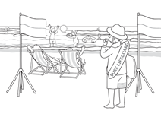
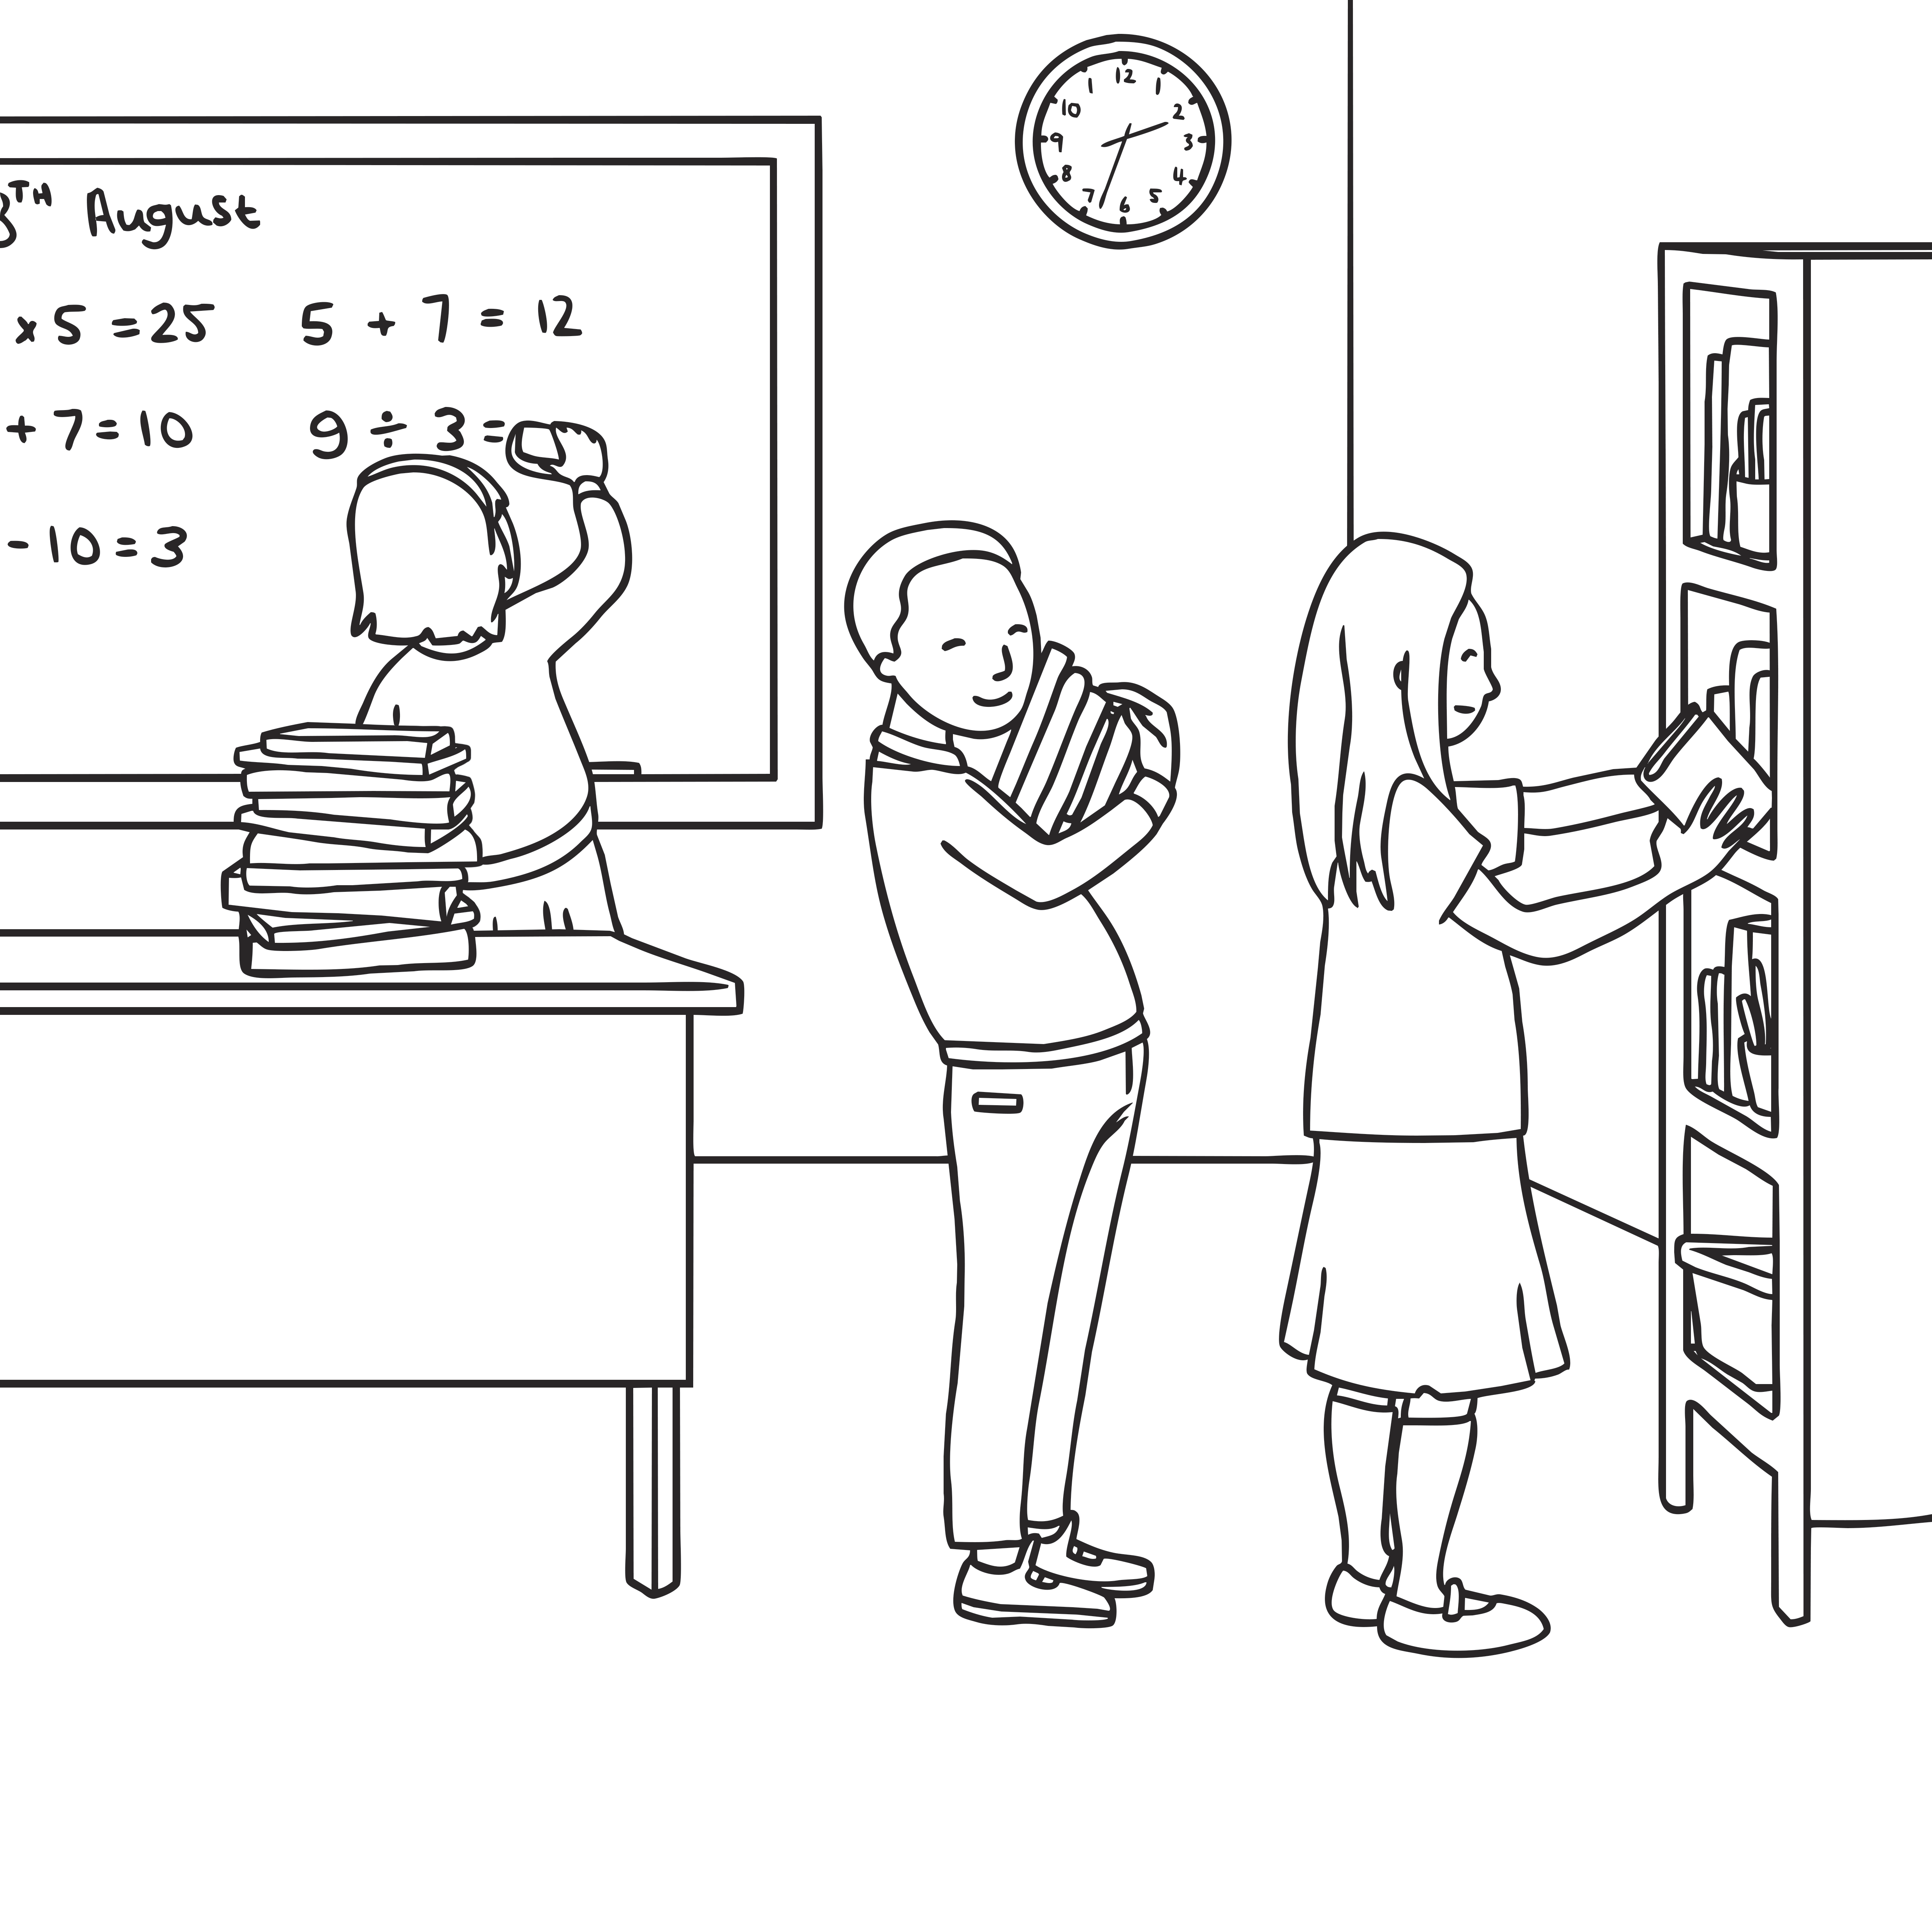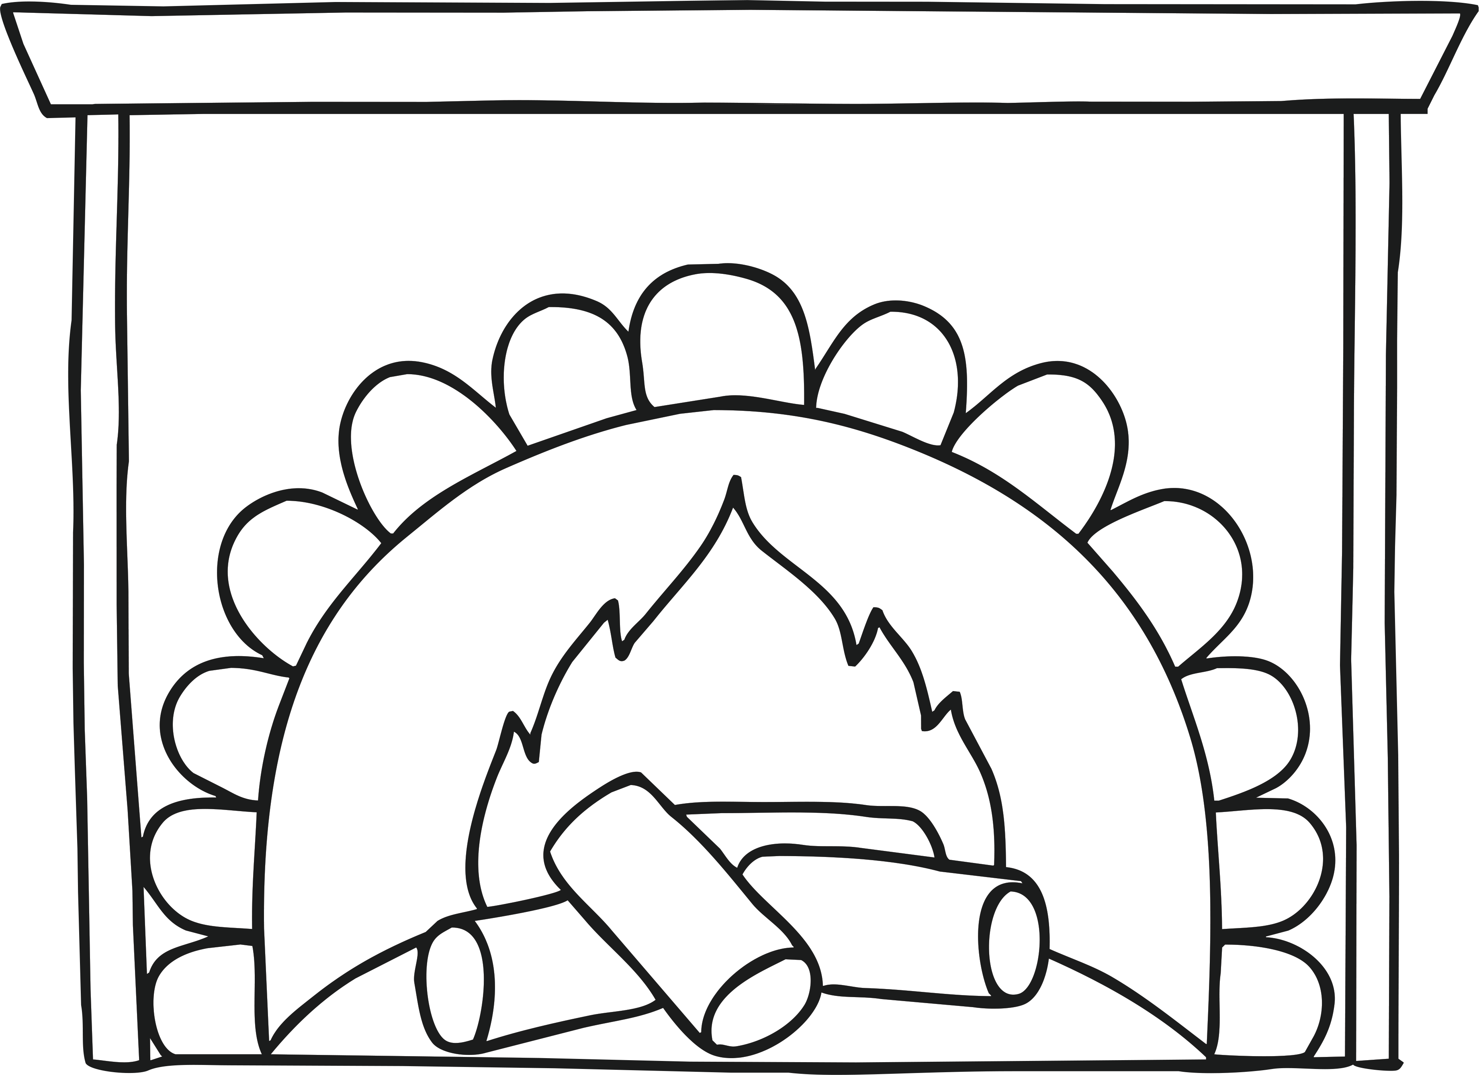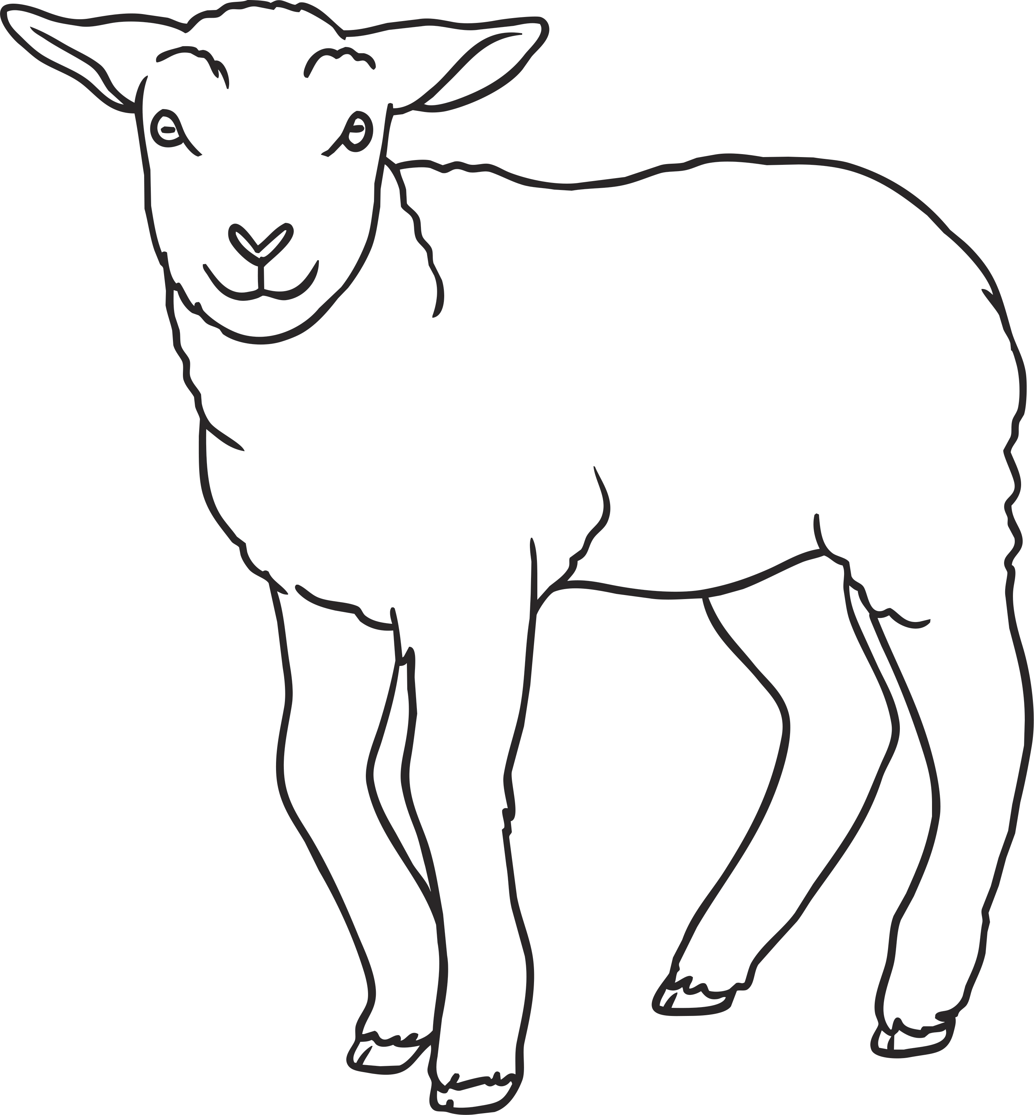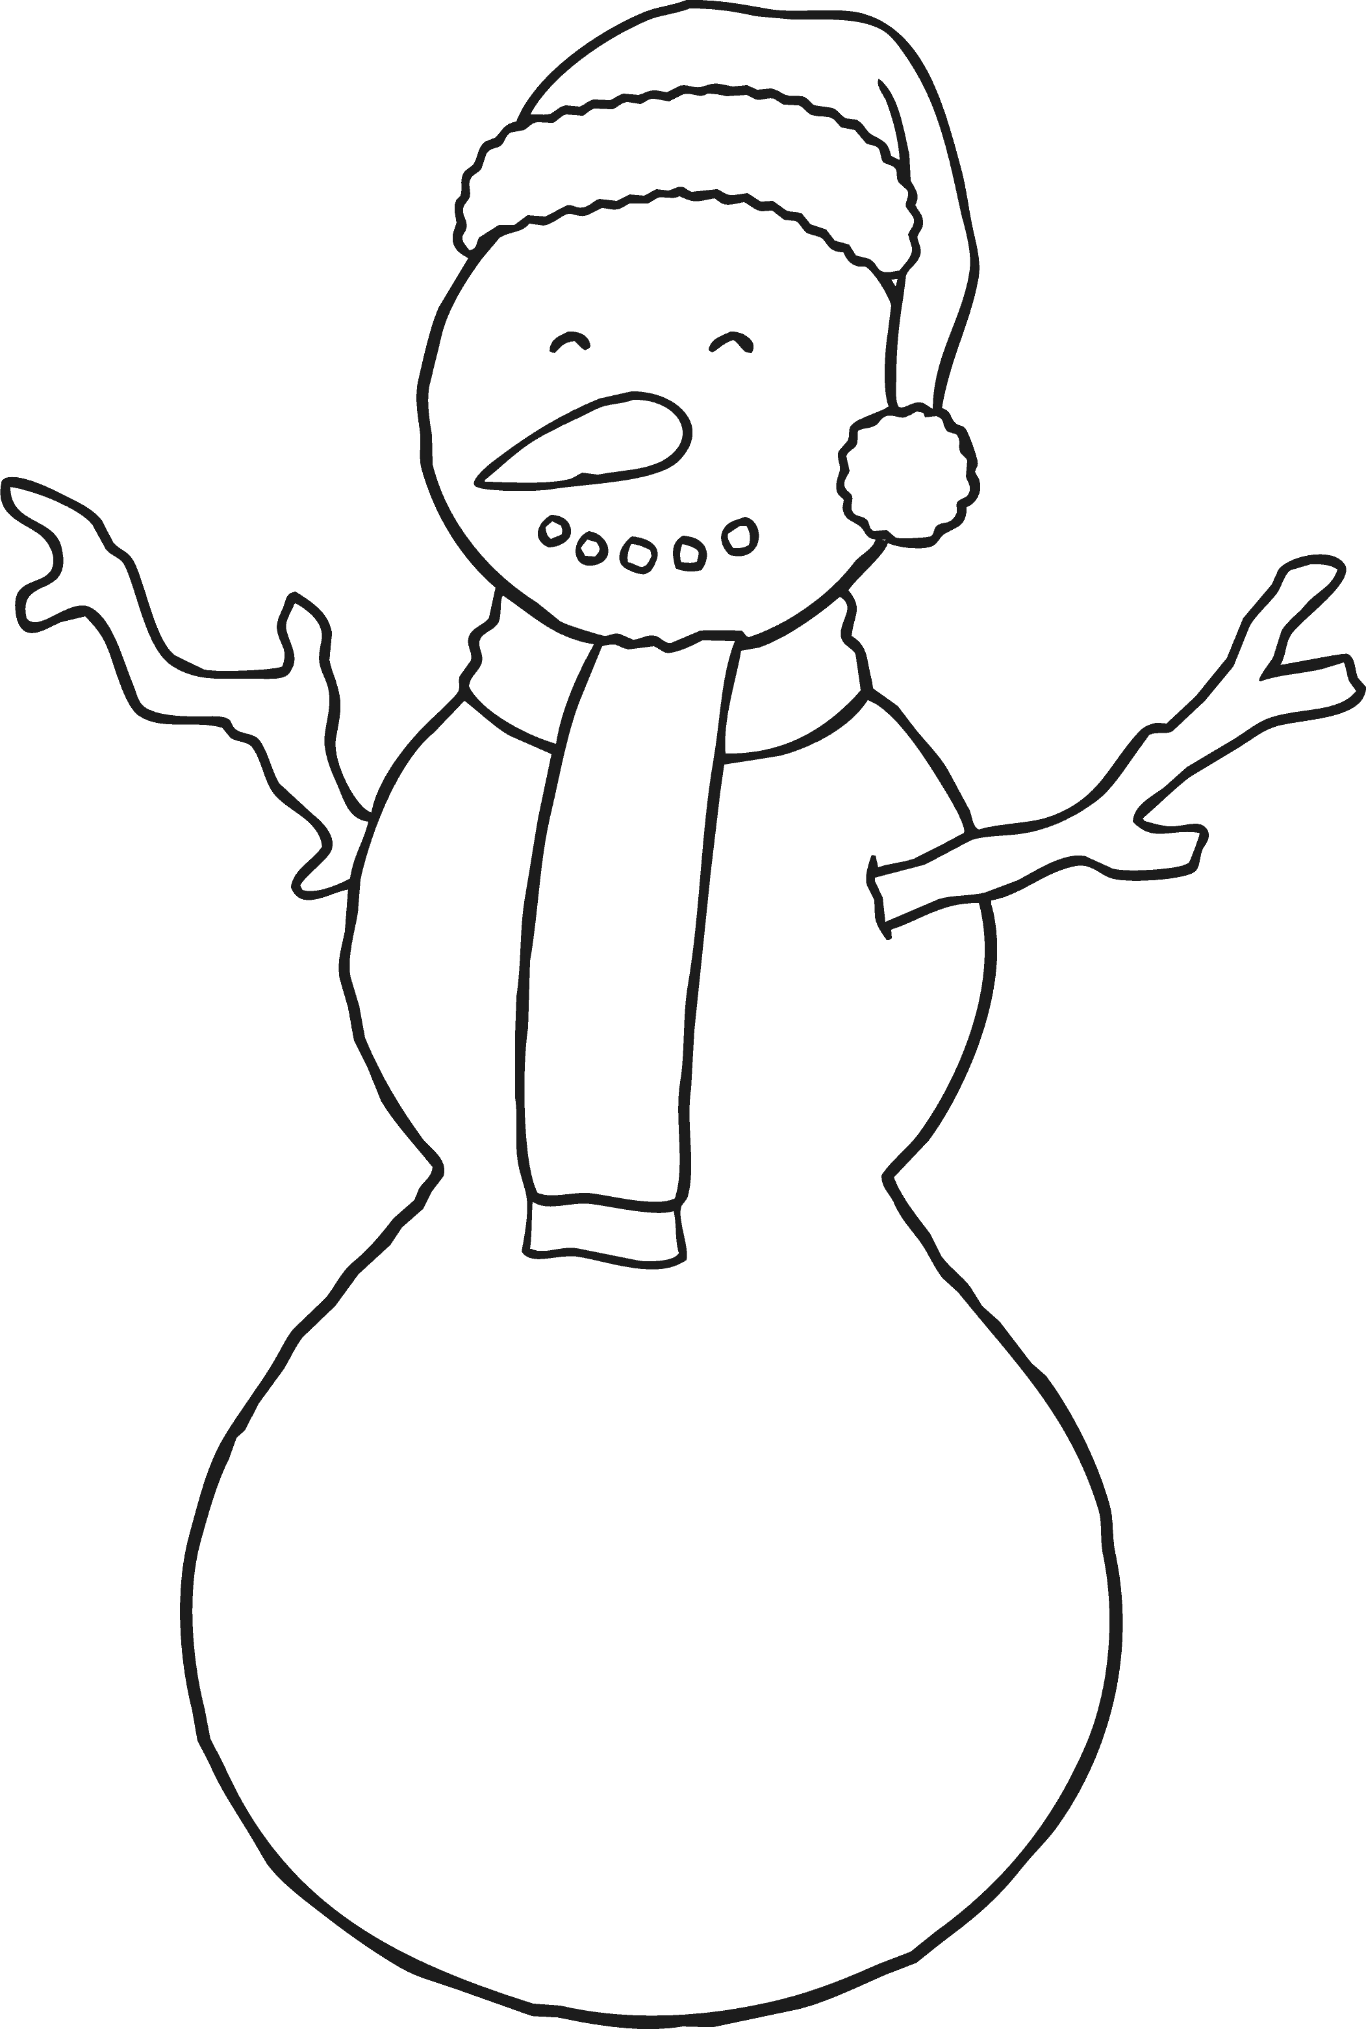
January
July
December
September
November
May
October
April
June
February
August
March
Order the Months Cut and Stick Activity Sheet
Cut out the months of the year and stick them in the right order.
Order the Months Cut and Stick Activity Sheet
Cut out the months of the year and stick them in the right order. Match the names at the bottom of the sheet to the correct month.
January
September
December
March
June
November
February
July
April
October
May
August
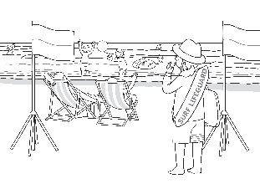
August
December
March
June
February
November
May
July
January
October
April
September
Order the Months Cut and Stick Activity Sheet
Cut out the months of the year and stick them in the right order. Match the names at the bottom of the sheet to the correct month.

