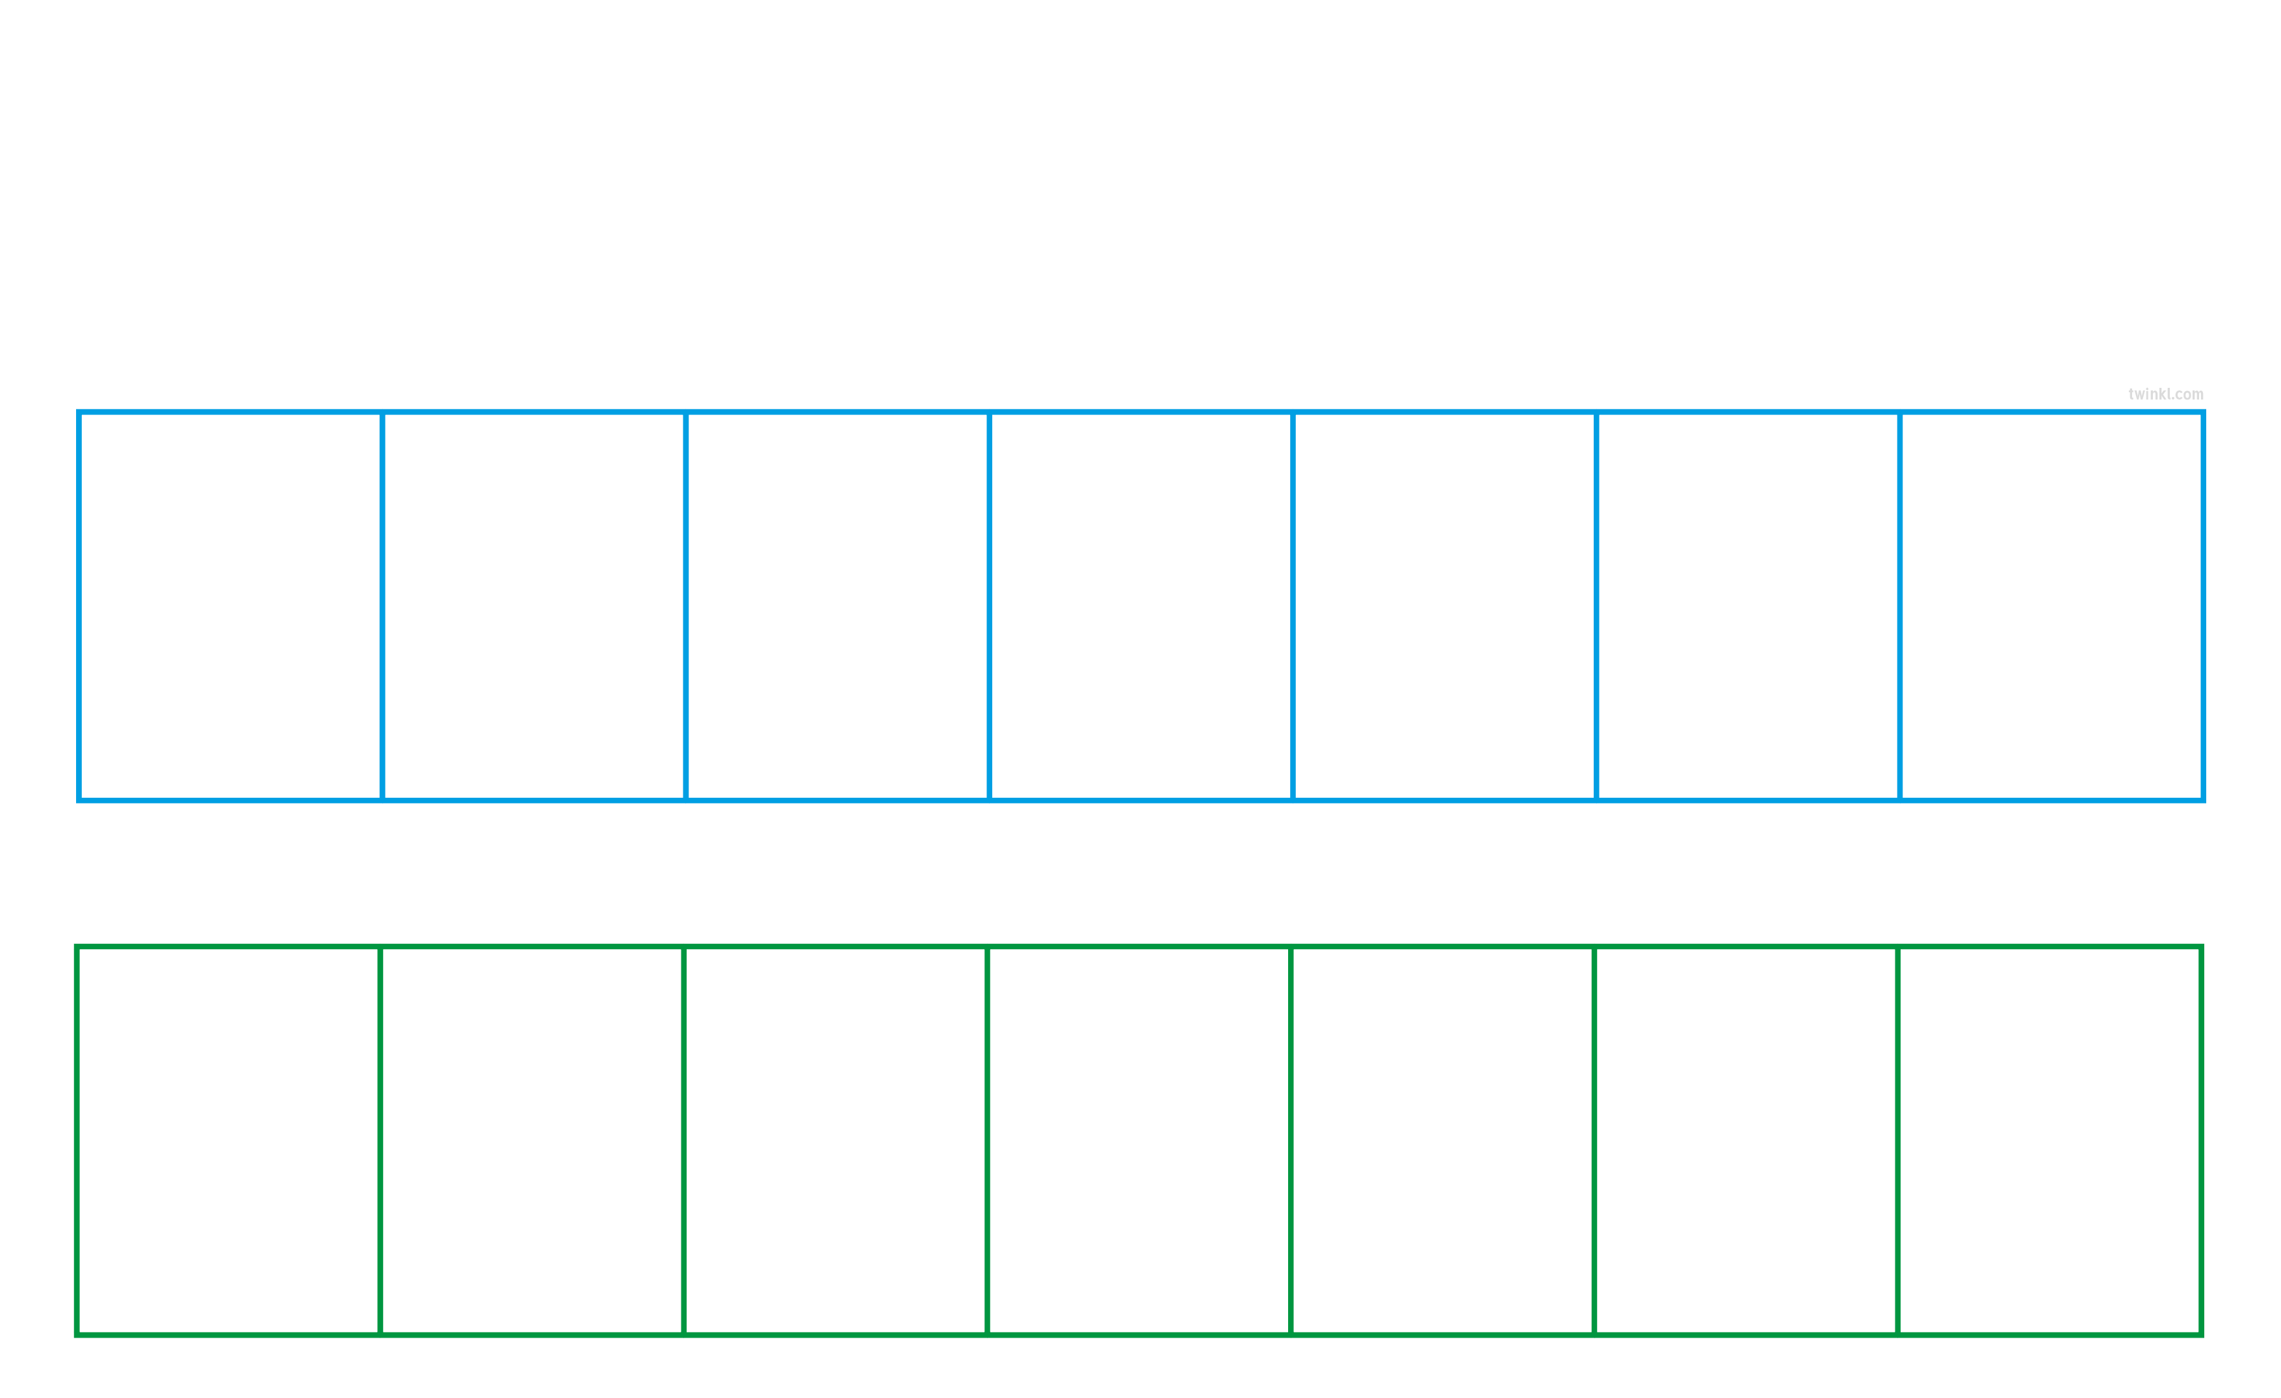
Days of the Week
Cut out the days of the week and stick them in the correct order.

Tuesday

Saturday

Thursday

Sunday

Monday

Friday

Wednesday

1

2

3

4

5

6

7

