Maple and Beech Home Learning Curriculum for Term 3 2021
Dinosaurs
Week Commencing 1st February
Here are your Wider Curriculum activities for Week five of this term. Your English and Maths packs should be coming home to you once again, some of the resources for the following activities are also included in your home learning packs.
We highly encourage you to take pictures of the work you are completing. You can email these to school, and we can print them and send them back for you to keep.

Where appropriate do continue to use the below timetable to help you provide some structure for the children at home. It can be adapted to fit your family circumstances, it is not set in stone.
8-9am  Get up, dressed and ready for learning including a healthy breakfast. | 9-9.30am  Active Movement:  Cosmic Yoga, take a walk or bike ride, complete a PE challenge. | 9.30-10.15am  Focused activity 1: Story Time – Writing/reading, fine motor skills and mark making or activities from you English packs.
10.15-11am  Break and free time including a healthy snack. Try to get a bit of fresh air! | 11-11.45am  Focused activity 2: Maths Activity packs, jigsaw puzzles, gams such as snakes and ladders or some ‘shopping’ role play – allowing your children to explore any coins you might have. | 11.45-13.00  Lunch time  Help to prepare, share and tidy up lunch. Enjoy some time relaxing and chatting!
13-13.30pm  Relaxation:  Either engage with a relaxation video, Reading, mindful colouring, TACPAC (see school website for details of how to access this at home). | 13.30-14.30pm  Focused activity 3: Wider curriculum activities (Art, Music, Science, Horticulture, Cookery) share a story linked to our class topic. | 14.30- 15.10pm  Free-time, Relaxation/ Meditation before the end of the day tidy up.  Good choices could be jigsaws, colouring, word searches and listening to music.

Good luck with your home learning! We will be in touch to make check-in phone calls. Keep reading below for this week’s suggested wider curriculum activities.
Best Wishes,
Becky Allen and Jess Cox

Maple and Beech Class Teachers

Topic/History:
This week we are going to explore where dinosaurs live and what it was like. The DKFind out website has some amazing visuals and information regarding all things dinosaurs please check it out here: https://www.dkfindout.com/uk/search/dinosaurs/
You could set up a sensory station for your children to explore using stones, mud or sand and water and any vegetation you might have in the garden such as leaves, twigs of leavy branches. If you have some toy dinosaurs, try burying them and encourage your child to use spoons or brushes to dig for the dinosaurs like an explorer!
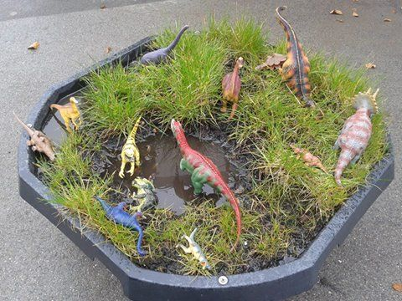
Support your child to find out which dinosaurs lived on land, which in the sea, and which could fly. As an extra activity, in school we will be making Pterodactyl sun catchers. The resources for this will be included in your pack, stick coloured tissue paper across the wings of your Pterodactyl and then hang him in a window or from the ceiling so you can watch him fly!

Science Activity:
For the last few weeks of term, we are going to start comparing our bodies to the bodies of animals. In your home learning packs this week should be some resources linked to body parts in animals. There will be a communication board which has symbols and words for different parts of an animal's body. Support your child to look at the different symbols and try to find some of these features on animals. You will also have a grid of animal pictures, point to the animals and describe the body parts as you look at the pictures, using your communication board to help you label. You can then continue to use your communication board to label the parts of animals you see in books or on the television when watching your favourite shows.

Music:
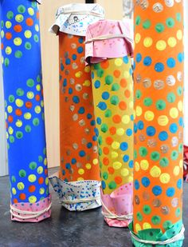
This week in school we are going to make our own percussion instruments. Start saving your different recycling boxes, tubes or tubs and make as many different percussion instruments as you can. You can paint or collage onto your containers to decorate them and make them look beautiful.
For a rain maker use rice, pasta or dried beans inside a toilet roll tube or wrapping paper tube if you have some. You can paint the outside of the tube or you can use a sheet of paper, colour it or draw a design on it then stick this to the outside of your tube using Sellotape.

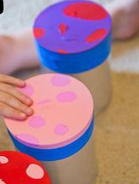
For a drum you can use tin cans or larger yoghurt pots or any empty tub and stretch a balloon over the top of it, securing it with very sticky tape. Again, decorate the outside using collage or paints.
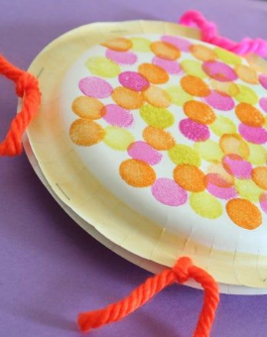
A Paper plate tambourine can be made by decorating the underneath of two paper plates however you would like – you can even try to make one look like a dinosaur’s face! Then begin to stick the two plates together using glue, string, staples or Sellotape. As you stick all the way round the edge you can also fill the space inside the plates with a small amount of rice to make it a shaker as well.

Once you have made all of your instruments you can use them to beat in time to the rhythm of any of your favourite songs!!
Continue to practice the body percussion actions to our Shakira song too: Try Everything by Shakira (body percussion): https://www.youtube.com/watch?v=64M44FYz5d4
Support your child to clap and stomp in time to the music!

PE Activities:
In School this term our PE focus is ball skills and coordination. Your PE challenge this week is to throw a ball to a partner and try to catch a ball thrown to you. Try practising this every day for 5-10 minutes. You can use really big balls, medium sized or small and if you don’t have a ball try using a balled-up pair of socks, a big cuddly teddy or a cushion. How many times can you throw or roll the ball back and forth before you drop it or it rolls in the wrong direction?
For some of you, you might just want to continue to focus on rolling a ball across the floor between you and a parent or sibling focussing on carefully rolling it to your partner and carefully catching it when they roll it back.

Art:
DINOSAURS: all you need to know | Educational Videos for Kids
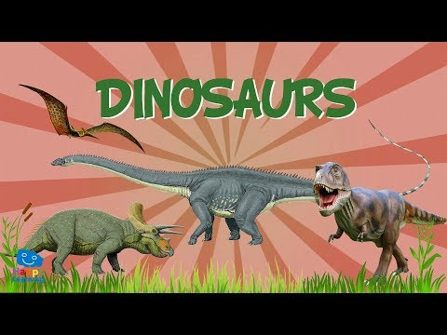
This week in art, we are going to create a very own dinosaurs! In class, we are going to use clay but please use playdough if you don’t have clay at home! Above is a video you can watch with your child. Help them to notice the different body parts of the dinosaur. Does the dinosaur have a long sausage neck? Does it have any spikes? You can use these ideas when making your own dinosaurs! You may also want to take inspiration from any toy dinosaurs you have at home! Encourage your child to make their dinosaur as independently as possible. Please send us some photos of the finished product – we would love to share them with the children and staff who are in school!

PSHCE
In PSHCE this week, we are again going to focus on exercise, and more specifically, exercise being a healthy choice. Last week, we asked you do take part in an activity with you child and encourage them to reflect on their breathing. Ask your child to think back to last week, what did you do? How did it make them feel? Explain that moving about, being active and exercising are healthy choices! Give some choices to your child of different activities you can do. Examples are going for a jog, yoga, playing a chase game, anything you think your child might like to do. The important thing is that they choose the activity and understand that they are making a healthy choice! Please send in any photos or put some photos on the Keeping Fitzwaryn Strong Facebook page for us to see any of the exercise you are doing!

RE
This week in RE, we will again be participating in mindfulness activities. This week, we are sending home some colouring pages linked to our topic. Encourage your child to find a quiet, peaceful place where they feel relaxed to take part in the activity. In class, we play relaxing music which can help the mind to focus. Allow your child to colour in the picture for as little or as long as they would like. Once the activity has finished, support your child in reflecting on how they feel. Do they feel energised or calm? Did they enjoy the activity? It’s okay if they say no!

Horticulture
I hope you enjoyed making your bird feeders last week - don’t worry if you haven’t made yours yet or finished it off – use your time for horticulture this week to complete bird feeders. When your bird feeders are full of seeds, lard and dried fruit, place them outside and spend time observing. Encourage your child to look out for different birds. What sounds can they hear? What do they notice about the birds? You may want to do some sketches together of the things you see in the garden.

Also, don’t forget about your beans! They need lots of watering, care and attention!
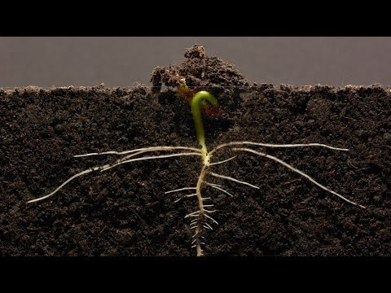

Computing
Again, in computing, we are asking you to take a photo of your plant! We are sending home some booklets where you can store your photos in to create a photo album! Please email in photos if you can’t print at home and we can return them to you printed in your home learning pack. Encourage your child to reflect on the changes between the photos and be proud of the work they have done!

