Home learning – Week 4
India
Focussed activities
Listed below are the focussed activities we will be doing each day in school. They have been adapted slightly so that they can be accessed from home. Please of course feel free to adapt any tasks or create your own!
In the task box you will see brief written instructions for a task and the name of the worksheet (highlighted in green) that can be downloaded. Worksheets and plans will be uploaded onto the website weekly.
IEP Target Work
Each morning in class, pupils will have 10 minutes focussed IEP work. You can choose with your child each day which target they would like to work on and keep a record of their progress using the progress sheet. Although we will be doing target work in the mornings, please feel free to choose when in the day you would like to do this.
Phonics
Each day in class we will be doing 10 – 15-minute phonics sessions. A great way for your child to access phonics at home is through using phonics play. Please see log in details below and I will let you know your individual child’s phonics level so you can access this online.
https://www.phonicsplay.co.uk/
username: jan21
password: home
There is also a great website to look at that can address any queries you may have around the phonics sounds. This website can be found via this link https://home.oxfordowl.co.uk/reading/learn-to-read-phonics/
Reading
Please try and read with you child as much as possible each week and keep a record using the reading diary document that is on the home learning page. There is always so much great reading achieved at home and we love hearing about this .

Focussed activities – Week 4
Monday
Focussed activity | Task
IEP target work (10 minutes) | Choose a target to work on for about 10 minutes.
Focussed activity 1: English | Journal Writing  Have a discussion about the weekend. What did you do? Can you include a describing word to your sentence?  Pupils to write one or two sentences about their weekend and draw a picture to go with it.  (printable journal writing template on website)  Pupils could also use a computer if preferred and type a sentence about their weekend.
Focussed activity 2: Maths | LI – To find half  Go through Monday maths PowerPoint  Complete Monday maths worksheet  Extension – Play a maths game. Can you find the other half?  Choose from different games below:  http://www.snappymaths.com/counting/fractions/interactive/halfornotimm/halfornotimm.htm
Phonics (10 minutes) | Please log onto Phonics Play and click on your child’s level for activities.  username: jan21  password: home
Focussed activity 3: Art | Show some pictures (on google image) of different of different henna designs. Explain that it is a tradition for Indian brides to have their hands decorated for their wedding. It is to express luck and happiness, and is often featured at ceremonial events like weddings and births.  Help pupils draw around their hands. Pupils can decorate their hands with their own henna designs.  Stick henna hands onto some bright coloured card of the pupil’s choice, can they name the colour of the piece of card they would like?  Pupils to share their work at the end and each answer a simple question about their work and their work displayed.  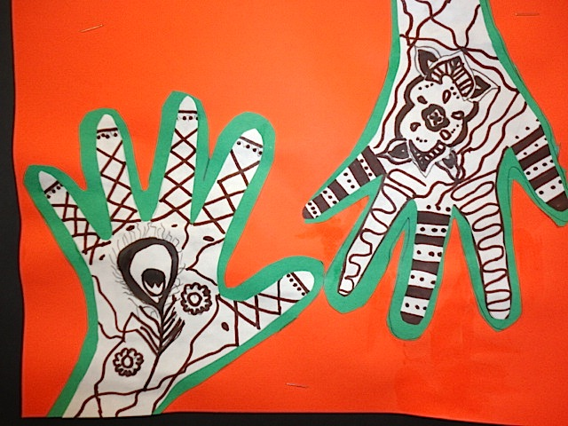

Tuesday
Focussed activity | Task
IEP target work (10 minutes) | Choose a target to work on for about 10 minutes.
Focussed activity 1: English | Indian Food  LI – To label a picture  Complete Tuesday English worksheet (on website). You can either cut out and stick the labels where you think they should go or copy them and write them in the boxes.
Focussed activity 2: Maths | LI – To share objects equally  Watch video clip https://www.bbc.co.uk/bitesize/clips/zqf34wx  Can you find objects around the house i.e. lego, books, toys and share them into two equal piles (split them in half).  Can you help make lunch and cut a sandwich in half or share crisps for example between two plates?  Take a photo to show your work.
Phonics (10 minutes) | Please log onto Phonics Play and click on your child’s level for activities.  username: jan21  password: home
Focussed activity 3: Science | LI – To make a food chain  Watch a video clip https://www.bbc.co.uk/bitesize/clips/z96r82p  Complete Science food chain worksheet (on website)

Wednesday
Focussed activity | Task
IEP target work (10 minutes) | Choose a target to work on for about 10 minutes.
Focussed activity 1: English  Research task | LI – To design a meal  Choose from the pictures on Wednesday English worksheet.  Stick the foods down which you would like to make a meal from or you can draw your own.  Write a sentence about your meal. Think about why you chose the foods you did.
Focussed activity 2: Maths | LI – To share objects equally  Play maths game below and help share objects equally.  https://pbskids.org/curiousgeorge/busyday/dogs/  Complete Wednesday maths worksheet (on website).
Phonics (10 minutes) | Please log onto Phonics Play and click on your child’s level for activities.  username: jan21  password: home
Focussed activity 3: RE | LI – To recall a fact about a Hindu Mandir  Go through RE Hindu-Mandir Powerpoint or watch the video clip https://www.youtube.com/watch?v=o-s0mN5P8jo .  Learn about Hindus place of worship.  Complete the RE worksheet. Can you write a fact about something you have learnt? Colour in the picture of ‘Brahman’ one of the Hindu Gods.

Thursday
Focussed activity | Task
IEP target work (10 minutes) | Choose a target to work on for about 10 minutes.
Focussed activity 1: English | LI – To write a description  Have a look in your cupboards for spices.  What do they look like? What colour is it? What does it smell like? Does the smell remind you of anything? Did you like it and why?  Write a sentence to describe a spice.
Focussed activity 2: Maths | LI – To share items between two  Complete Thursday maths worksheet.
Phonics (10 minutes) | Please log onto Phonics Play and click on your child’s level for activities.  username: jan21  password: home
Focussed activity 3: PE | Get kids up and active.  Pupils could either do some cosmic yoga or a joe wicks home work out. Please see links below.  Yoga  https://www.youtube.com/results?search_query=cosmic+yoga  Joe Wicks  https://www.youtube.com/results?search_query=joe+wicks+pe+for+kids

Friday
Focussed activity | Task
IEP target work (10 minutes) | Choose a target to work on for about 10 minutes.
Focussed activity 1: English | LI – To prepare a question/work for Zoom  Starter  Talk about the zoom call this afternoon. Explain that it is a conversation and that they need to choose something they would like to tell them about their week. Can they include a question to ask the class?  Main activity  To prepare write what they would like to say or show.
Focussed activity 2: Maths | LI – to share items between three  Choose between Friday maths worksheet 1 or 2 to complete.
Phonics (10 minutes) | Please log onto Phonics Play and click on your child’s level for activities.  username: jan21  password: home
Whole class zooms | 1.45pm – 2.00pm  Whole class zoom to share work from the week.

