LI: I can use a capital letter at the start of a sentence
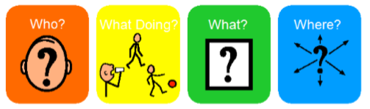

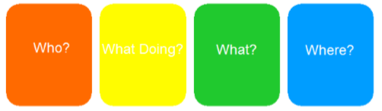

Word Bank
Who?
   |  | 
What doing?
  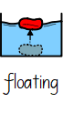 |  | 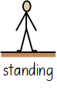
What?
   |  | 
Where?
   |  | 

