Healthy Eating Lunch
LI: I understand which types of food and drink are healthy.

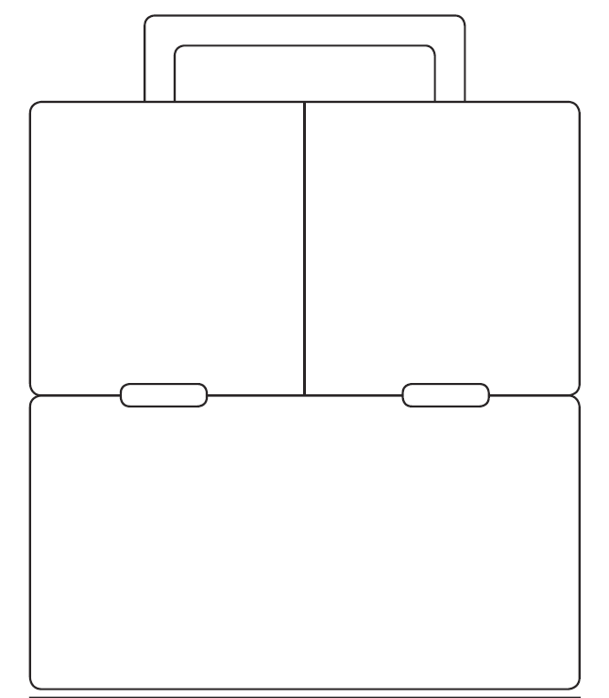
Cut out the healthy food t put into your lunchbox..



