Antarctic Explorers: What Would You Take?
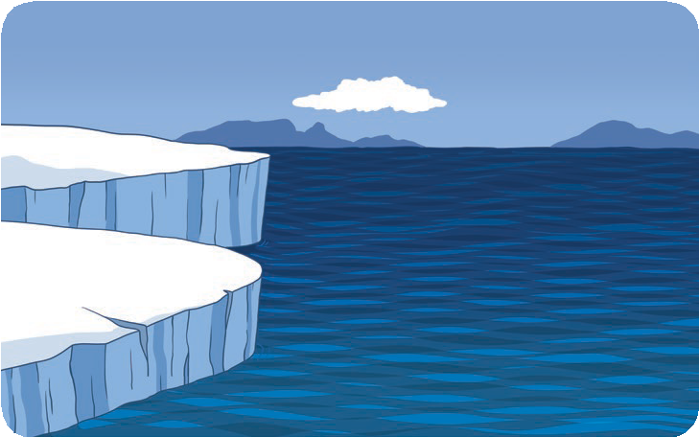
It’s 1908. You are about to go on an expedition to the South Pole.
What would you take with you? What would you need to survive?
Food

Clothes

Special Item

Equipment



