Ladybird Doubles

Write the number sentence for each ladybird double.

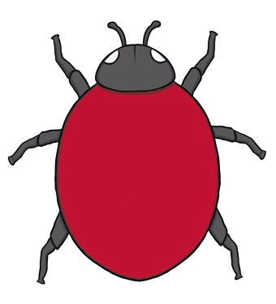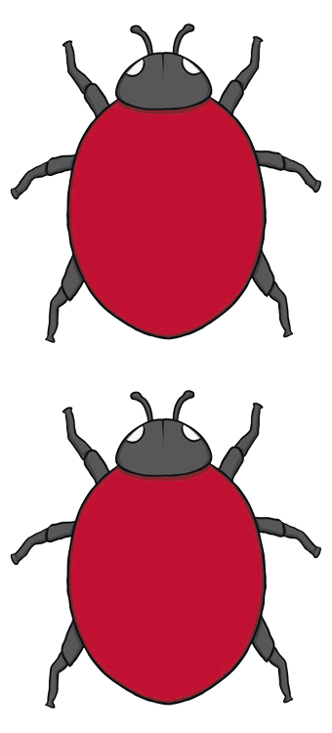1+1=

2+2=

3+3=

4+4=

5+5=

Dice Doubles

Write the number sentence for each dice double.

+ 1+1=

+ 2+2=

+ 3+3=

+ 4+4=

+ 5+5=

Butterfly Doubles

Write the number sentence for each butterfly double.

1+1=


 2+2=
3+3=
4+4=

5+5=

Doubles to 10
Number Shape Doubles

Write the number sentence for each number shape double.

+ 1+1=

+ 2+2=

+ 3+3=

+ 4+4=

+ 5+5=



