3 Times Table Activities
1 | 2 | 3 | 4 | 5 | 6
7 | 8 | 9 | 10 | 11 | 12
13 | 14 | 15 | 16 | 17 | 18
19 | 20 | 21 | 22 | 23 | 24
25 | 26 | 27 | 28 | 29 | 30
31 | 32 | 33 | 34 | 35 | 36
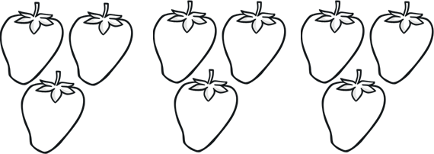
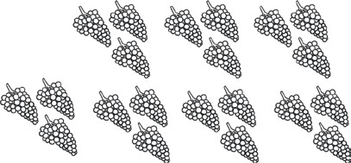
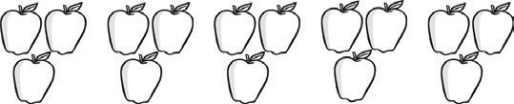

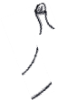




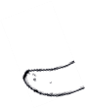

c)
d)
×
=
×
=
b)
a)
×
=
×
=
How many pieces of fruit are there?
- 4 × 3 =
- 3 × 3 =
- 5 × 3 =
- 2 × 3 =
- 9 × 3 =
- 6 × 3 =
- 7 × 3 =
- 1 × 3 =
- 11 × 3 =
- 8 × 3 =
- 10 × 3 =
- 12 × 3 =
Work out these answers:
Count in 3s and colour in the grid:

