Count in 10s and colour in the grid:
10 Times Table Activities
Work out these answers:
1 | 2 | 3 | 4 | 5 | 6 | 7 | 8 | 9 | 10 | 11 | 12
13 | 14 | 15 | 16 | 17 | 18 | 19 | 20 | 21 | 22 | 23 | 24
25 | 26 | 27 | 28 | 29 | 30 | 31 | 32 | 33 | 34 | 35 | 36
37 | 38 | 39 | 40 | 41 | 42 | 43 | 44 | 45 | 46 | 47 | 48
49 | 50 | 51 | 52 | 53 | 54 | 55 | 56 | 57 | 58 | 59 | 60
61 | 62 | 63 | 64 | 65 | 66 | 67 | 68 | 69 | 70 | 71 | 72
73 | 74 | 75 | 76 | 77 | 78 | 79 | 80 | 81 | 82 | 83 | 84
85 | 86 | 87 | 88 | 89 | 90 | 91 | 92 | 93 | 94 | 95 | 96
97 | 98 | 99 | 100 | 101 | 102 | 103 | 104 | 105 | 106 | 107 | 108
109 | 110 | 111 | 112 | 113 | 114 | 115 | 116 | 117 | 118 | 119 | 120
121 | 122 | 123 | 124 | 125 | 126 | 127 | 128 | 129 | 130 | 131 | 132
133 | 134 | 135 | 136 | 137 | 138 | 139 | 140 | 141 | 142 | 143 | 144
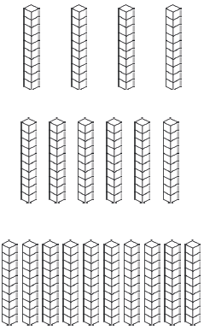
How many stacks are there? There 10 cubes per stack.
a) 2 × 10 =
b) 10 × 10 =
c) 5 × 10 =
c)
b)
a)
×
=
×
=
×
=
d) 6 × 10 =
e) 12 × 10 =
f) 9 × 10 =

