Doubles to 20
Ladybird Doubles
Write the number sentence for each ladybird double.



1+1=



2+2=

3+3=



4+4=

5+5=

Doubles to 20
Ladybird Doubles
Write the number sentence for each ladybird double.

6+6=

7+7=

8+8=

9+9=

10+10=


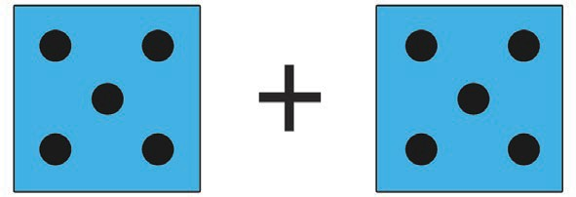
Doubles to 20
1+1=
Write the number sentence for each dice double.
Dice Doubles


2+2=

 3+3=


4+4=
5+5=

Dice Doubles
Doubles to 20

Write the number sentence for each dice double.


6+6=

7+7=

8+8=

9+9=
10+10=


Doubles to 20
Butterfly Doubles
Write the number sentence for each butterfly double.


1+1=
 2+2=

 3+3=

4+4=
5+5=
Doubles to 20
Write the number sentence for each butterfly double.
Butterfly Doubles

6+6=

7+7=

8+8=

9+9=
10+10=

Doubles to 20
Number Shape Doubles
Write the number sentence for each number shape double.

 + 1+1=

 +  2+2=

 +  3+3=


+ 4+4=
5+5=
+


Doubles to 20
10+10=
Write the number sentence for each number shape double.
Number Shape Doubles


+ 6+6=

 + 7+7=

 + 8+8=

+ 9+9=
+

