Pine and Rowan Home tasks for week 3

Below are the activities which can be completed at home. We have suggested subjects to do on certain days which correspond with what we will be doing at school. But if you want to do the activities in a different order that’s fine! We have sent home packs with phonics resources and your child’s logins for the online library and Gooseberry Planet as well as a book which can be used for activities that don’t require a worksheet or to stick in completed work. Some of the activities require access to a computer. If your child is unable to access a computer, please let me know and we can discuss how we can help.

If you have any trouble accessing the resources or if you have any questions, please feel free to contact me at school.

We are also having Zoom calls weekly. If your child wants to join in, they are as following:
Monday 10am- Social session
Tuesday 10am- Explanation session
Friday 10am- Sharing session.

If you are planning to join, please can you make sure you are ready for when it starts and if you are having any problems please let us know. You can access each of the three Zoom sessions via the following single link:
https://zoom.us/j/93878252793?pwd=UTRZczZJbEI1VWtyZFNJMXIHSU5Wdz09

Meeting ID: 938 7825 2793
Passcode: psKN9v

Monday
Subject | Activities that can be completed at home
Physical activity | Joe Wicks or Cosmic Yoga
Reading/ Phonics | Pupils can read a book at their level or complete phonics activities.  Review flashcards of sounds. Do they recognise all of the sounds? Can they think of any words that use the sounds?  Pupils can also do activities on Phonics Play.  https://www.phonicsplay.co.uk/  You may log in with the following details:  username: jan21  password: home
English | Journal Writing.  Pupils can write a sentence or more about what they have done either over the last weekend. This can be done either independently, copying a sentence or overwriting a sentence that has been written for them.
Maths | This week we will be focusing on Multiplication. Some pupils may need objects to support them in this.  A set of worksheets for your child will be on the website under Maths Week 3 (child’s initials)
PHSE | This week we will be looking at healthy eating. Using the worksheet provided pupils can wither draw and label or cut and stick the healthy food in their lunchbox. What other healthy foods can they think of?
Art | Over the term in Art, we would like pupils to make a solar system. This can be done as a model or a picture and you or your child can choose how they would like to do it. Pupils can then build on their model/picture each week as they learn more about the different planets. Below are some examples you can use for inspiration but feel free to use your imagination!  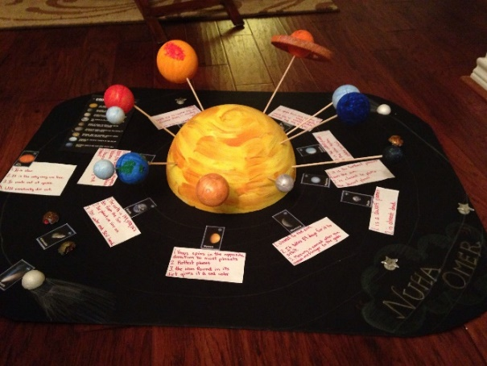  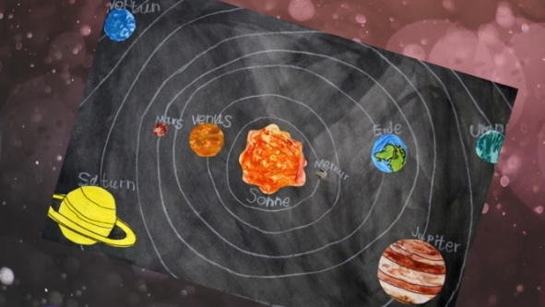  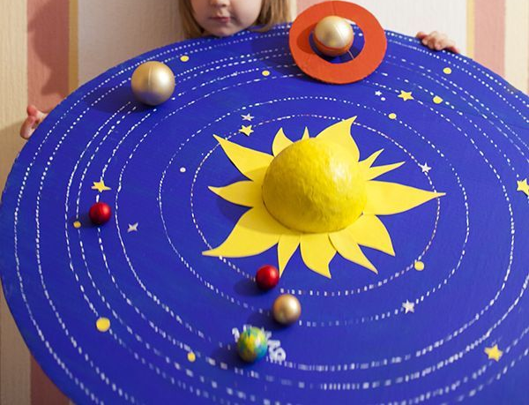
Tuesday
Subject | Activities that can be completed at home
Physical activity | Joe Wicks or Cosmic yoga
Reading/ Phonics | Pupils can read a book at their level or complete phonics activities from pack that has been sent home.  Pupils can also do activities on Phonics Play.  https://www.phonicsplay.co.uk/  You may log in with the following details:  username: jan21  password: home
Handwriting | Complete handwriting worksheets found on website.  Either continue Pencil control workbook or ‘O’ worksheets  Extension- Pupils can write a few sentences of their choosing, ensuring they are forming their letters correctly and keeping them on the line.
Maths | This week we will be focusing on Multiplication. Some pupils may need objects to support them in this.  A set of worksheets for your child will be on the website under Maths Week 3 (child’s initials)
RE | This week we will be looking at the miracle of Jesus feeding the 5000.  What the video of the story and complete the worksheet  https://www.youtube.com/watch?v=S6rj9cAJrWE
PE | Go for a walk/Bike ride/Run/complete a kid’s aerobic workout/just dance

Wednesday
Subject | Activities that can be completed at home
Physical activity | Joe Wicks or Cosmic Yoga
Reading/ Phonics | Pupils can read a book at their level or complete phonics activities from the pack that has been sent home.  Pupils can also do activities on Phonics Play.  https://www.phonicsplay.co.uk/  You may log in with the following details:  username: jan21  password: home
English | This term, pupils will be making a fact book about planets. Using the fact book template saved as English fact book week 2  Today, pupils can write a page and draw a picture about the planet Mercury. It can range from a sentence to a paragraph with facts they have learnt about Mercury.
Maths | This week we will be focusing on Multiplication. Some pupils may need objects to support them with this activity..  A set of worksheets for your child will be on the website under Maths Week 3 (child’s initials)
Music | Watch the orchestra version video on the BBC website using the link below  http://www.bbc.co.uk/programmes/p02b14ld  Listen to ‘Mars’ and recap on the use of the 5 beat ostinato (repeating pattern) at the start which suggests something evil and dangerous. Make sure you use the word ‘ostinato’ and remind students that it means ‘a repeating pattern’.  Demonstrate playing/clapping the ostinato with the chant ‘We shall be marching everyday.’ Chant it over and over again then try chanting and clapping it.  Listen to the piece of music again and point out that it uses brass instruments such as the trumpet and trombone which sound like armies or the military playing a very aggressive fanfare. They create a dark mood with their low notes. When it is put together with the ostinato it has a very scary effect. Put a chant to that as well: We….will need…..our sword….and shield.  Listen to the recording and join in with the chant as the brass lines are played.
History | This week we will be learning about Robert Falcon Scott and his exploration of Antarctica. Read through the slides on the different expeditions to the south pole. Pupils can then complete the worksheet saved as history worksheet week 3. They can either draw a picture of, or write about, what items they would take on an expedition to Antarctica.

Thursday
Subject | Activities that can be completed at home
Physical activity | Joe Wicks or Cosmic Yoga
Reading/ Phonics | Pupils can read a book at their level or complete phonics activities from the pack that has been sent home.  Pupils can also do activities on Phonics Play.  https://www.phonicsplay.co.uk/  You may log in with the following details:  username: jan21  password: home
English | This term, pupils will be making a fact book about planets. Using the fact book template saved as English fact book week 3  Today, pupils can write a page and draw a picture about the planet Venus. It can range from a sentence to a paragraph containing facts they have learnt about Venus.
Maths | This week we will be focusing on Multiplication. Some pupils may need objects to support them with this activity.  A set of worksheets for your child will be on the website under Maths Week 3 (child’s initials)
Computing | This term Pupils will learn about e-safety. We will be doing this through the Gooseberry Planet website. Each pupil has their own individual login which has been sent through the post. We will be working through the Gooseberry Playground section, completing one level each week.  Complete Level 3 this week. First, read through the supporting slides which are saved as Computing week 3. Students will then complete activities on the website as instructed throughout the slides.
Science | This week we will be looking at Earth and Mars. Read through the slides on Mars and Pupils can complete the worksheet describing the similarities and differences between Earth and Mars.

Friday
Subject | Activities that can be completed at home
Physical activity | Joe Wicks or Cosmic Yoga
Reading/ Phonics | Pupils can read a book at their level or complete phonics activities from the pack that has been sent home.
English | Journal Writing.  Pupils can write a sentence or more about what they have done either over the last week. This can be done either independently, copying a sentence or overwriting a sentence that has been written for them.
Cooking | Pupils can help prepare a meal at home. If possible, focus on asking your child to help measure out the ingredients.  At school we will be making frozen yoghurt this week. The recipe is on the website if you would like to make it as well!
Geography | This week we are learning about Antarctica, linking to our work in History. Read through the slides on Antarctica. Choose an Antarctic animal to find out more information on using the worksheet saved as geography worksheet week 3. Pupils can either research the animal themselves or use the factsheets provided.
Free reading | Pupils can explore a book of their choice either independently or share a story together.

