Maple and Beech Home Learning Curriculum for Term 3 2021
Dinosaurs
Week Commencing 25th January
Here are your Wider Curriculum activities for Week four of this term. Your English and Maths packs should be coming home to you once again.
We highly encourage you to take pictures of the work you are completing. You can email these to school, and we can print them and send them back for you to keep.

Where appropriate do continue to use the below timetable to help you provide some structure for the children at home. It can be adapted to fit your family circumstances, it is not set in stone.
8-9am  Get up, dressed and ready for learning including a healthy breakfast. | 9-9.30am  Active Movement:  Cosmic Yoga, take a walk or bike ride, complete a PE challenge. | 9.30-10.15am  Focused activity 1: Story Time – Writing/reading, fine motor skills and mark making or activities from you English packs.
10.15-11am  Break and free time including a healthy snack. Try to get a bit of fresh air! | 11-11.45am  Focused activity 2: Maths Activity packs, jigsaw puzzles, gams such as snakes and ladders or some ‘shopping’ role play – allowing your children to explore any coins you might have. | 11.45-13.00  Lunch time  Help to prepare, share and tidy up lunch. Enjoy some time relaxing and chatting!
13-13.30pm  Relaxation:  Either engage with a relaxation video, Reading, mindful colouring, TACPAC (see school website for details of how to access this at home). | 13.30-14.30pm  Focused activity 3: Wider curriculum activities (Art, Music, Science, Horticulture, Cookery) share a story linked to our class topic. | 14.30- 15.10pm  Free-time, Relaxation/ Meditation before the end of the day tidy up.  Good choices could be jigsaws, colouring, word searches and listening to music.

Good luck with your home learning! We will be in touch to make check-in phone calls. Keep reading below for this week’s suggested wider curriculum activities.
Best Wishes,
Becky Allen and Jess Cox

Maple and Beech Class Teachers

Topic/History:
This week we are continuing to work labelling the body parts of our dinosaurs. On some cardboard draw the outline of your favourite dinosaur including some front and back legs, similar to the picture below. If your child is able to help you with the drawing let them get creative here! Carefully cut out the pieces, which can then be put together to make a dinosaur which stands up. Before you put it all together decorate your dinosaur using pens, paint or collage. Make them as colourful as you can! Support your child to name the different parts of the dinosaur as you build your creation.
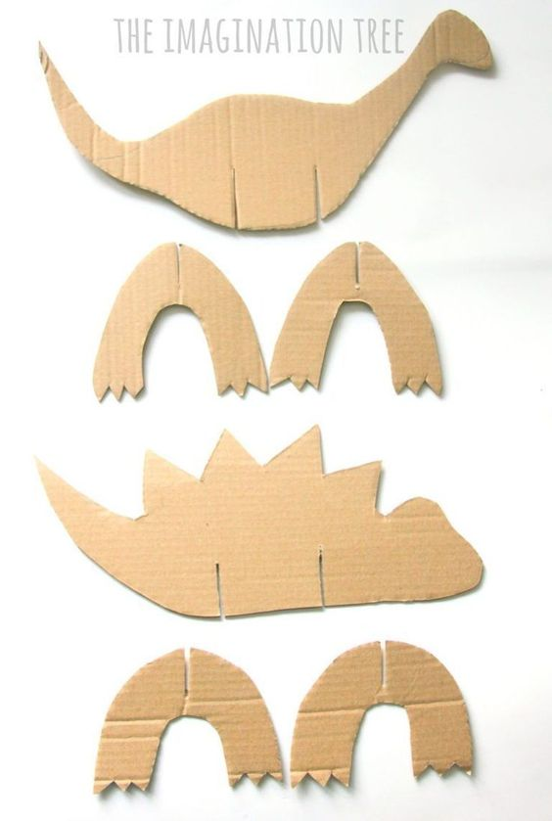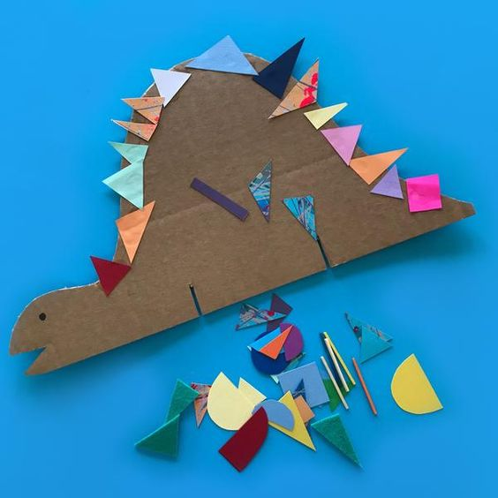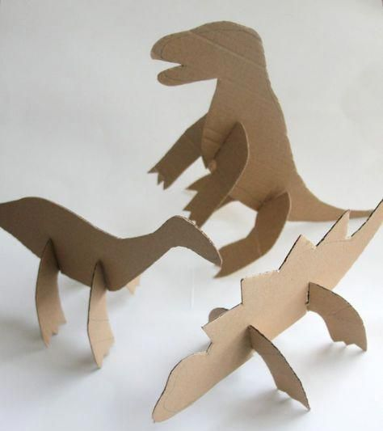

Science Activity:
In Science this term we will be learning about the human body. This week we are continuing to label the parts of our body.
Some of you will have some ‘jigsaws’ to complete which will help you to identify the main parts of the body, you will then also have a worksheet where you can cut out the labels and stick them on to the correct parts of the body. An extra challenge this week is to begin to explore your 5 senses. This week we will start with touch and our hands. Using a piece of cardboard such as a cereal box or maybe you have had some post that came in a box, draw around your child’s hand and cut this out, leaving you with a hand shaped hole in our cardboard. Use this as a sensory template to guid your child to explore different textures around you house. Search for different textures around your house: soft, smooth, rough, scratchy, etc and guide your child to touch these things through your handprint template. For an added exploration of the senses complete this activity using a cut out of your child’s foot. Do these different textures feel different on your feet compared to your hand?
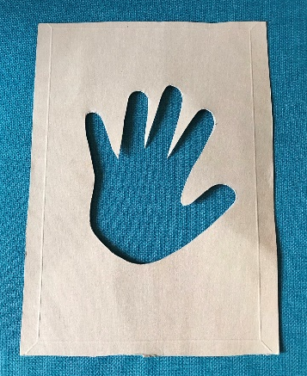

Music:
This week I encourage you to take a musical walk when out for your daily exercise. Support your child to listen to the different sounds when out and about in nature, the rustling leave, the wind blowing the rain falling or maybe you can hear some traffic on the roads or birds singing or people talking.
Your challenge is then to try to use your body to create these sounds. Rubbing your hands together could be the wind. Stamping your feet quickly could be thunder and tapping your fingers or toes on the ground could be the sound of the rain.
Explore as many different ways as possible for you to make different sounds using your body.
Continue to practice the body percussion actions to our favourite Shakira song too: Try Everything by Shakira (body percussion): https://www.youtube.com/watch?v=64M44FYz5d4
Support your child to clap and stomp in time to the music!

PE Activities:
In School this term our PE focus is ball skills and coordination. Your PE challenge this week is to throw a ball into a container. You can use whichever size ball you have available and try and find a container which is big enough to throw your ball into from a distance. You could use a storage tub, delivery box or washing basket. Try throwing the ball with two hands or one hand. For an extra challenge trying to stand on two feet then only on one foot.
For some of you, you might just want to continue to focus on rolling a ball across the floor between you and a parent or sibling focussing on carefully rolling it to your partner and carefully catching it when they roll it back.

Art:
I hope you all enjoyed making your dinosaur fossils last week! This week in art you will need more playdough, please use any that you already have at home or make some using the recipe from last week. The task is to create different shapes using the playdough. You might want to make sausage shapes, spheres, triangles or any other 2D or 3D shape you and your child want to try. This is in preparation for next week when we’re going to make our very own dinosaurs out of playdough by putting these shapes together!

PSHCE
For PSHCE this week, we are focusing on exercise. With your child, you may want to think of all the different ways you can exercise. Some people like to jog, others like yoga and some like to play team games. Explain that it doesn’t matter what you do so long as you’re moving and being active!
Have a go at doing a physical activity with your child, in school we’re going to have a game of ‘Stuck in the Mud’ but do whatever activity your child is interested in! Before you do your exercise, encourage your child to notice their breathing, is it slow or is it fast? If appropriate, also support them in finding their pulse, how does it feel? Is the pulse fast or slow? Once you have completed your physical activity, encourage your child to again notice their breathing and pulse. Has it changed? What is it like now?

RE
We will be focusing on the Jewish religious festival Tu BiShvat. Explain to your child that this festival celebrates the nature found on Earth and people of the Jewish faith might donate to charities that support nature, plant trees and acknowledge that we are caretakers of the Earth. Take your child outside or on a walk to observe some trees, use these as inspiration for the artwork your child will do to celebrate Tu BiShvat! In class, we are going to mix up natural colours and use our hands to create the leaves of trees. But if you have other creative ways to make ‘tree inspired’ artwork, please do!

Horticulture
In Horticulture this week, we are going to be making bird feeders! Here is a video of children creating a bird feeder. Wildlife Watch - How to make a pine cone birdfeeder
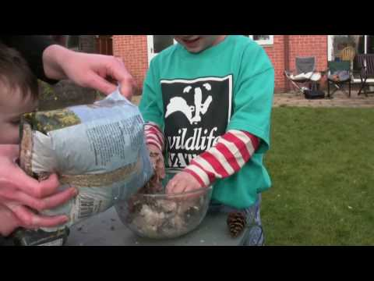
In your home learning packs you will find a guide to making the bird feeders. Please follow these instructions to make your bird feeders! We love to see the work the children have done so please send in your pictures!
Also, don’t forget about your beans! They need lots of watering, care and attention!
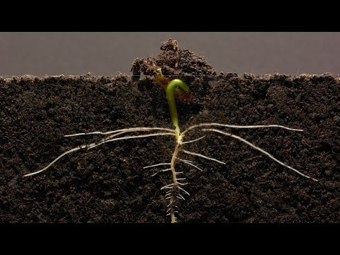

Computing
Again, in computing, we are asking you to take a photo of your plant! We are sending home some booklets where you can store your photos in to create a photo album! Please email in photos if you can’t print at home and we can return them to you printed in your home learning pack. Encourage your child to reflect on the changes between the photos and be proud of the work they have done!

