Couscous Salad
Ingredients
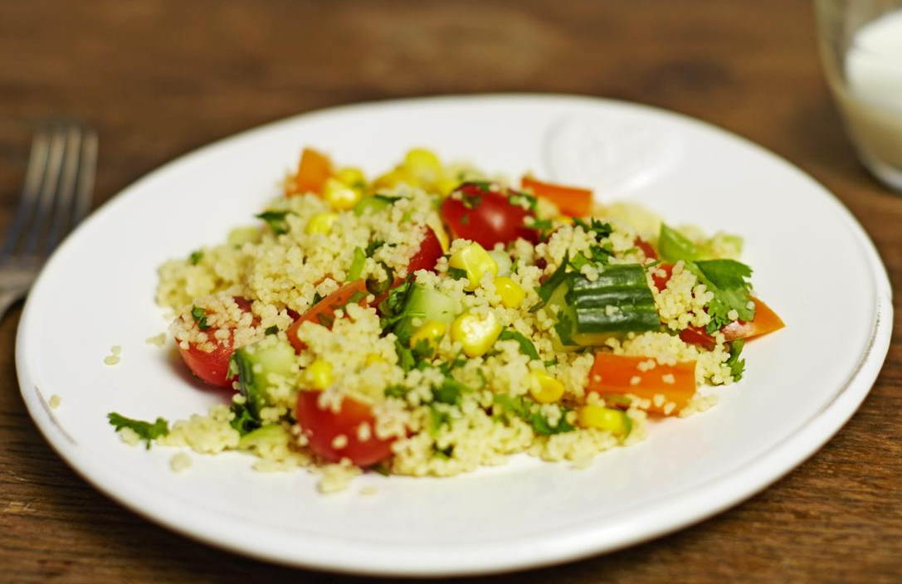
- 1/4 cucumber
- 10 cherry tomatoes or 3 larger tomatoes
- 1 pepper, any colour
- 2 spring onions
- Sweetcorn
- Feta cheese
- 150g/5½oz couscous
- small lemon, juice only
- 1 tbsp olive oil
- 200ml/7fl oz boiling water
Method
- Chop all of the vegetables into really small pieces.
- Place the couscous in a large heat proof bowl and then squeeze in the lemon or orange juice and a drizzle of olive oil.
- Pour the boiling water onto the couscous, cover with cling film, then set it aside to stand for five minutes.
- Use a fork to stir up the couscous until it looks fluffy.
- Add the chopped vegetables and stir well.

