Maple and Beech Home Learning Curriculum for Term 3 2021
Dinosaurs
Week Commencing 18th January
Here are your Wider Curriculum activities for Week three of term. The children in school will be completing very similar activities so see what you can try at home. You will continue to receive your packs through the post with additional Maths and English work, as well as some resource to help you with the wider curriculum activities where appropriate.
Below is a suggested timetable to help you provide some structure for the children at home. It can be adapted to fit your family circumstances, it is not set in stone.
8-9am  Get up, dressed and ready for learning including a healthy breakfast. | 9-9.30am  Active Movement:  Cosmic Yoga, take a walk or bike ride, complete a PE challenge. | 9.30-10.15am  Focused activity 1: Story Time – Writing/reading, fine motor skills and mark making or activities from you English packs.
10.15-11am  Break and free time including a healthy snack. Try to get a bit of fresh air! | 11-11.45am  Focused activity 2: Maths Activity packs, jigsaw puzzles, gams such as snakes and ladders or some ‘shopping’ role play – allowing your children to explore any coins you might have. | 11.45-13.00  Lunch time  Help to prepare, share and tidy up lunch. Enjoy some time relaxing and chatting!
13-13.30pm  Relaxation:  Either engage with a relaxation video, Reading, mindful colouring, TACPAC (see school website for details of how to access this at home). | 13.30-14.30pm  Focused activity 3: Wider curriculum activities (Art, Music, Science, Horticulture, Cookery) share a story linked to our class topic. | 14.30- 15.10pm  Free-time, Relaxation/ Meditation before the end of the day tidy up.  Good choices could be jigsaws, colouring, word searches and listening to music.

Don’t forget to take pictures of your children completing activities or their work, this is important evidence of their learning and progress but can also be used to create a journal to look back on as well as to help you reflect on the great work you have completed. If you want to email pictures to school, we will be happy to print them for you and send them back home.
Good luck with your home learning! We will be in touch to make check-in phone calls. Keep reading below for this week’s suggested wider curriculum activities.
Best Wishes,
Becky Allen and Jess Cox

Maple and Beech Class Teachers

Topic/History:
This week we will be learning about the different parts of a dinosaur’s body. This week we will be using a great resource from the BBC website where there is an interactive game to help children explore the parts of a dinosaur.
Follow this link: https://www.bbc.co.uk/bitesize/topics/zdp4382/articles/znc3y9q Then Click on the Triceratops and there is a lovely interactive game all about the different parts of different dinosaurs. Next week we will build upon this with a labelling activity.

Science Activity:
In Science this term we will be learning about the human body. This week we will focus on exploring and labelling the parts of our body. Begin with a quick round of heads, shoulders, knees and toes to cue your child into thinking about their body.
The BBC Bitesize website has a great introduction video to the different parts of the body: https://www.bbc.co.uk/bitesize/topics/z9yycdm/articles/zqhbr82 there is also a labelling activity although this is quite tricky!
A wonderful website for further exploration of this topic is also the Dorling Kindersley Website. This link should take you to a good place to start: https://www.dkfindout.com/uk/human-body/
Resources:
Chalk
Outside space (floor or wall outside)
Activity:
Your challenge this week is to try and draw around the whole of your body, or your parents body using chalk. You can do this on the floor in your garden if you have a patio area, or you could do this up against a fence panel or the outside walls of your house. Once you have drawn around your body try to name some different parts of your body – arm, leg, knee etc. You can also draw in some clothes and facial features such as your eyes, nose, mouth etc. If you have any left-over wrapping paper which is long enough you could also do this on paper inside if the weather is bad!

Music:
This week I encourage you to take a musical walk when out for your daily exercise. Support your child to listen to the different sounds when out and about in nature, the rustling leave, the wind blowing the rain falling or maybe you can hear some traffic on the roads or birds singing or people talking.
Your challenge is then to try to use your body to create these sounds. Rubbing your hands together could be the wind. Stamping your feet quickly could be thunder and tapping your fingers or toes on the ground could be the sound of the rain.
Explore as many different ways as possible for you to make different sounds using your body.
Continue to practice the body percussion actions to our favourite Shakira song too: Try Everything by Shakira (body percussion): https://www.youtube.com/watch?v=64M44FYz5d4
Support your child to clap and stomp in time to the music!

PE Activities:
In School this term our PE focus is ball skills and coordination. Your PE challenge this week is to try rolling a ball in and around some obstacles using your hands. It doesn’t matter what size ball you have but you mustn’t let it roll away! Place 4 obstacles in a square in your lounge or in your garden and using your hands try to roll the ball around all 4 obstacles in different directions and looping the loop just try not to let it get away from you!
For some of you, you might just want to focus on rolling a ball across the floor between you and a parent or sibling focussing on carefully rolling it to your partner and carefully catching it when they roll it back.

Art:
For art this week, we are going to be making our own Dinosaur Fossils! In school, we are going to be using clay to create our fossils, but if clay isn’t available at home playdough will do a great job too. To create an extra challenge, you can make your own playdough too! Below is recipe for ‘Mud’ playdough (don’t worry – it smells like chocolate not mud!) Once you have your clay/playdough create the fossil by using toy dinosaurs and pressing them into the playdough. You can do their whole body, their feet or just parts of their body – it is entirely up to you and your child! It might be helpful to share the below video with your children about how fossils are made to engage their interest. Like last week, we love to see what you are up to at home so please share your photos with us! How do dinosaur fossils form? | Natural History Museum
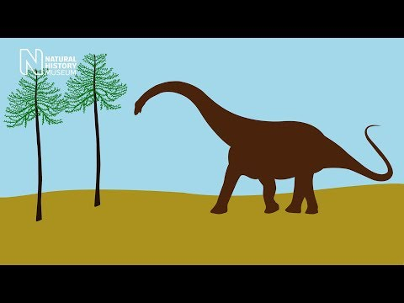
Ingredients
1 1/2 cup all purpose flour
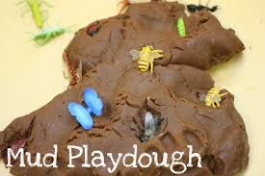
1/4cup salt Share on Facebook
1/2cup cocoa
1 tsp cream of tartar
2 tbsp vegetable oil
1 cup water

Instructions
Mix all ingredients in a large saucepan.
Cook over medium-low heat until a soft dough forms and the play dough looks more dry than wet.
Remove from heat, allow to cool for about 2 minutes, then knead.
Store in an air-tight container.

PSHCE
We are continuing to look at healthy foods again this week. In school, we are firstly going to have a class discussion about how we need food to keep us healthy and have a think about some healthy foods the children like. Next, we are going to make a fruit salad, with the children doing as much of the work as possible. Again, some children will only sniff and touch the fruit and vegetables and that’s okay!

RE
This week in RE, we will again be focussing on our wellbeing and mindfulness. At home, take a mindfulness walk in your local area. The idea is for it to be a peaceful activity, where you and your child can pay attention to the scenery and smells. You may even want to collect natural items and/or encourage your child to touch things in their surroundings such as grass, trees and stones. Once the activity has finished, it’s great to reflect on the how the activity has made them feel, any answer they give is okay!

Horticulture
Hopefully you will have received your bean in the post and possibly planted it! Now you need care for your plant! Encourage your child to observe their plant and water it when necessary. Below is a time-lapse video you can share with your child, perhaps you can support your child to match the stage their plant is at to the correct stage in the video! Bean Time-Lapse - 25 days | Soil cross section
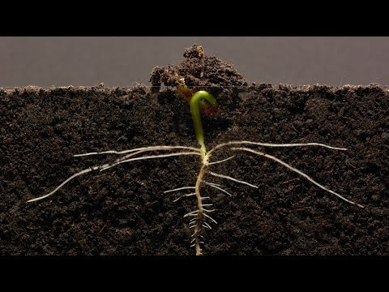

Computing
Again in computing, we are asking you to take a photo of your plant! We are sending home some booklets where you can store your photos in to create a photo album! Please email in photos if you can’t print at home and we can return them to you printed in your home learning pack. Encourage your child to reflect on the changes between the photos and be proud of the work they have done!

