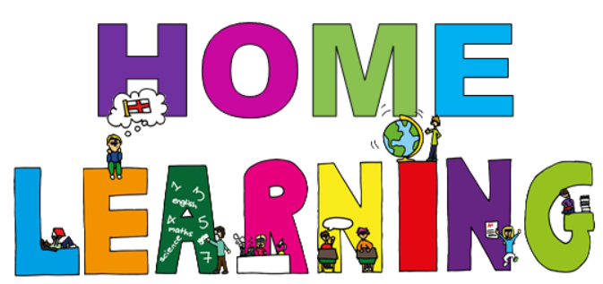

Week beginning 18th January 2021
Dear parent(s)/carers,
We hope you and your family are staying safe and well during this ‘lockdown’, we look forward to seeing all the children again soon.
Timetable -
Here is a copy of our timetable at school, which has been slightly adapted to suit home learning:
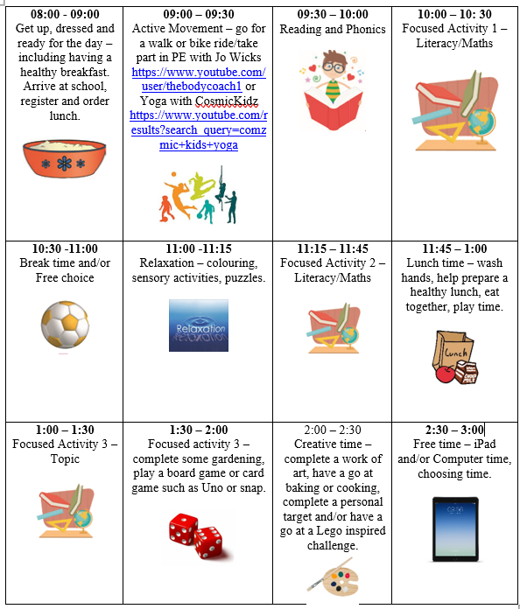

Week beginning 18th January home learning activities -
Below are the activities which can be completed at home alongside the work being done at school. If you have and questions, please feel free to contact us at school.
Over the next 6 weeks, for Art, we would like the children to use their imagination and creativity skills to design and make a 3D model of our solar system. We would like the children to take as much ownership over their project as possible by deciding how they would like to present their work and how much detail they would like to go into, this should be a fun and enjoyable project for them to complete whilst at home. Here are a few examples:
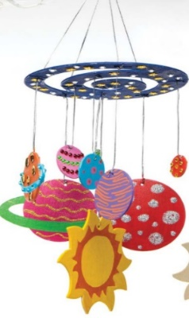
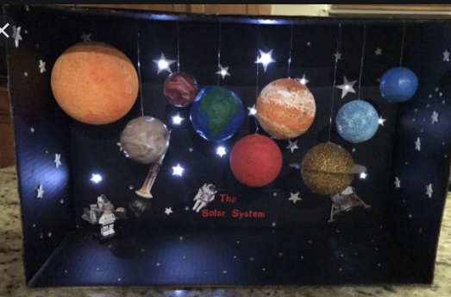
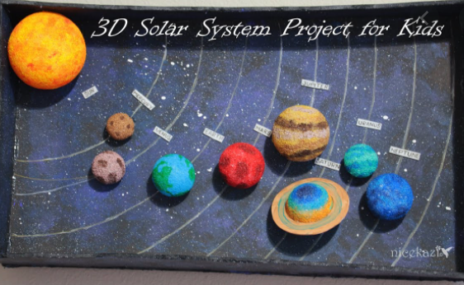

Subject | Activities that can be completed at home.  Resources needed: computer, internet, magnetic letters, whiteboard and pen, books, solar system pictures, writing word mat, 2D shapes, worksheets
Phonics | Letters/sounds to focus on this week – ‘ur’  Tricky word to focus on this week – ‘are’  Using your computer, login to phonicsplay.co.uk - PhonicsPlay  Username: jan21  Password: home  Select the resources section of a wide variety of fun but educational games to play.  - Recap phase 2/3 sounds by blowing up a balloon and writing the sounds on them, hit the balloon up in the air and call out a sound that you can see.  - Recap tricky words – play trick words trucks (resource section on phonics play)  - Teach focus sound/tricky word – watch alphablocks – how to pronounce ‘ur’ Alphablocks - Word Magic "S-UR-F" & "T-UR-F" (Yellow Level Step 10) - YouTube  - Listen to and sing along - Tricky Words and Sight Words Song - YouTube  - Make tricky words using playdough and take a picture.
Reading | Oxford Owl ebook Library – see separate leaflet for details –  https://www.oxfordowl.co.uk/login?active-tab=students  Ask & Willow –  Username: fitzwarynashwillow  Password: askwillow  - Read a level appropriate book with your child.  - Share your favourite picture/chapter novel with them.
English/Science | Learning intention:  To recall facts about space and the earth  Success criteria:  - I can remember key facts about space/earth  - I can write a sentence incorporating that fact  Starter: on google earth – find school and then pan out to see world and then space
  https://www.youtube.com/watch?v=ASQkz4XaphU&ab_channel=HappyLearningEnglish
  Watch clip
  Children use the picture to write about. Discuss with adult what they want to write. If needed, adult to write sentence for them to copy. Remember capital letters and full stops. Use word mat sentences (pre-cut) for children to create their own sentence for those that need it.
Maths | learning intention:  To recognise and sort 2D shapes.  Success criteria:  - pupils will name common 2D shapes  - pupils will recognise and match 2D shapes.  Starter:  Play counting to 100 song on youtube - Let's Get Fit | Count to 100 | Count to 100 Song | Counting to 100 | Jack Hartmann - YouTube  Activity 1:  -listen to and sing The Shapes Song - Bing video  -Play shape monster game and encourage chn to name the shapes they are sorting - Shape Monsters - 2D Shapes Matching Game (topmarks.co.uk)  -complete the 2D shape colouring sheet.  Activity 2:  - listen to and sing The Shapes Song - Bing video  - Play the shape pattern game - Shape Patterns (topmarks.co.uk)  - complete the 2D shape pattern sheet.
PE/Active movement | Go outside –  - Ride a bike  - Have a walk around your local nature park and look for signs of winter
Topic | History  *There is information on the Explorers BBC Teach website https://www.bbc.co.uk/teach/class-clips-video/ks2-explorers/zjh8bdm  Learning Intention:  -I can recall facts about Christopher Columbus  Success Criteria:  -pupils will recall facts about a famous explorer.  -pupils will understand how the explorer has affected history.  Activity:  - Watch video from Explorers for Kids: Christopher Columbus (ducksters.com) and discuss key facts about Christopher Columbus. What did the child/children find interesting?  - complete a simple fact file all about Christopher Columbus – use word mat for support (see separate sheet) – child/children can cut and stick the key words onto the fact file writing frame (see separate sheet).
Horticulture | Learning intention: To explore outside looking for growth and change  Success criteria:  - I can observe signs of change in the environment  - I understand why there are changes  Explore outside – in the garden, park, woods, anywhere – looking for signs of change. These could be frost, floods, dead leaves but also any new growth (bulbs, buds on plants, etc.). Discuss how weather and seasons affects growth.  Talk about needs of birds – eat insects, insects need flowers. Are there any flowers, if not how can birds find food?
DT - Cookery | BBC Food - Rocky road recipe - BBC Good Food  See recipe sheet for full instruction. Enjoy!

Relaxation/mindfulness:
Guided Meditation for Children | Your Secret Treehouse | Relaxation for Kids - YouTube
Relax Music for Stress Relief, Study Music, Sleep Music, Meditation Music 💜 528Hz - YouTube
Guided Meditation for Kids | Spaceship to the Moon | Relaxation for Children - YouTube

Active movement:
Just Dance 2018 • Waka Waka (Football Version) - YouTube
Banana Banana Meatball - Blazer Fresh | GoNoodle - YouTube

Other helpful websites:
Home - GoNoodle
ictgames
PhonicsPlay
Welcome | Numeracy Warm Up
– username: fitzwaryn
-password: story
HelpKidzLearn
Writing warm ups - dough disco for children - YouTube
Counting song - Let's Get Fit | Count to 100 | Count to 100 Song | Counting to 100 | Jack Hartmann - YouTube
Phonics song - Phonics Song 2 (new version) - YouTube
Jolly Phonics A-Z - YouTube
Space/planets song - The Solar System Song - YouTube

Face to face Zoom sessions –
We would like to invite you to join us for 3 zoom sessions each week – details will be sent via email before each session, including login details and passwords.
Session 1 – Monday morning at 9:45 – 10:15 – to include pupils at home and in school, to give them an opportunity to see their friends and share their weekend news, ready for their journal writing English session on a Monday.
Session 2 – Monday afternoon 1:30 – 2:00 - explanation session for parents however, pupils are welcome to join, to give you an opportunity to ask any questions or discuss home learning packs.
Session 3 – Thursday – one to one face to face zoom session will be held to give your child an opportunity to speak with their class teacher and show off their work. Times to be confirmed during our weekly phone calls or via email prior to the sessions.

Stay safe and well!
All the best,

Ash and Willow Class teachers

