Jonah and The Whale
Event in story | Feelings
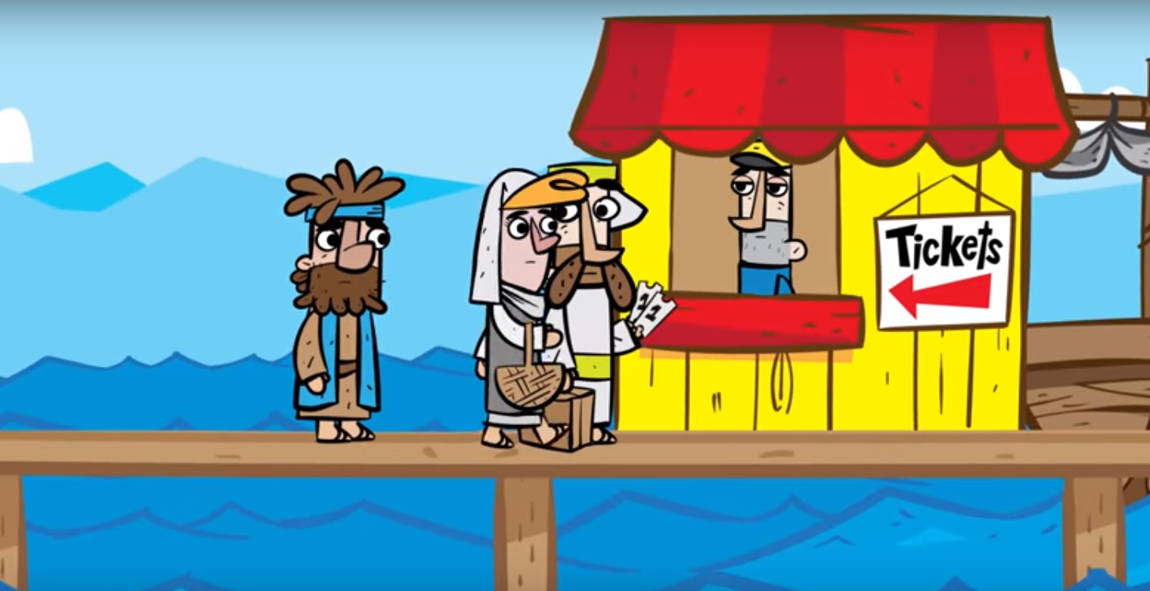 | Jonah feels
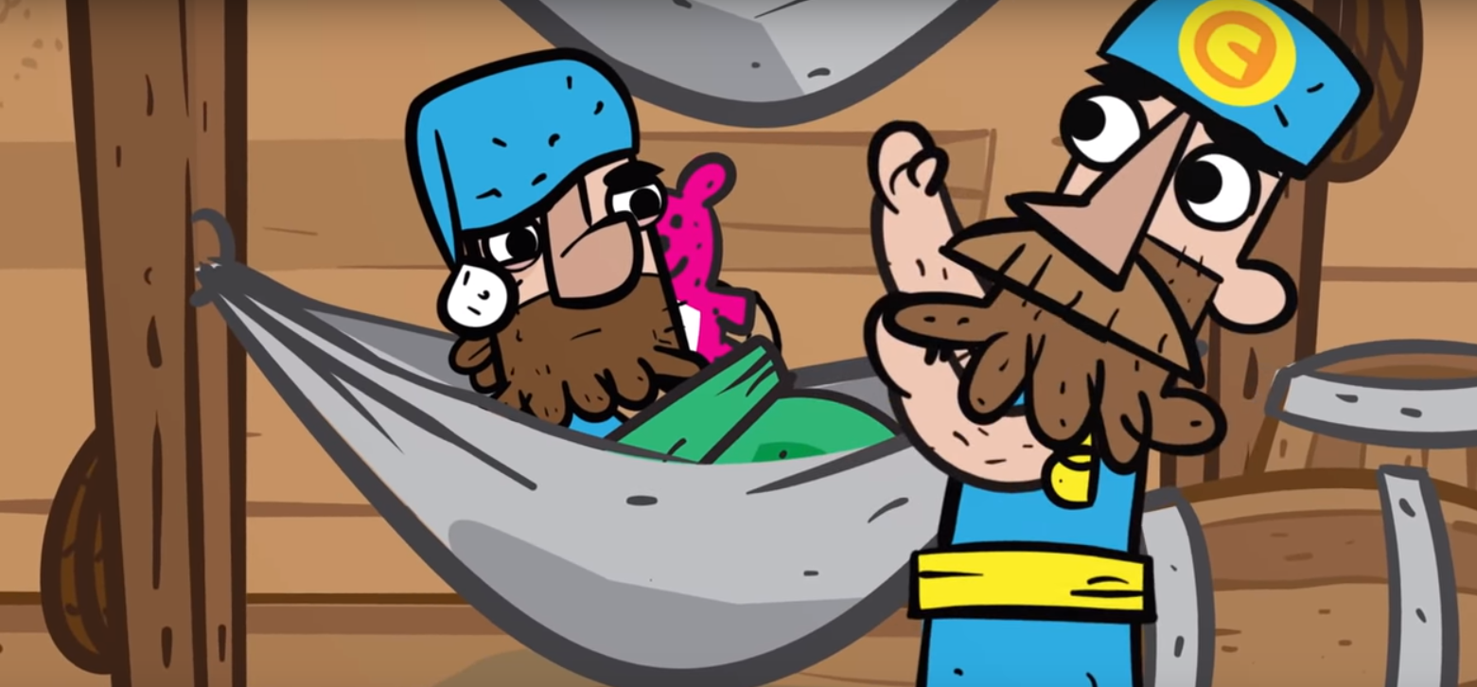 | The Captain feels
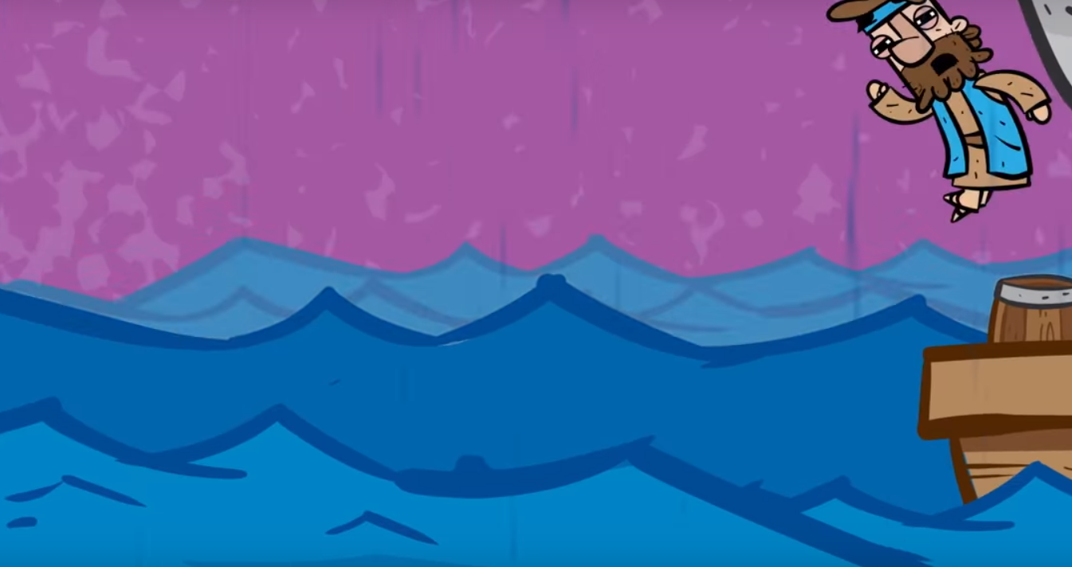 | Jonah feels
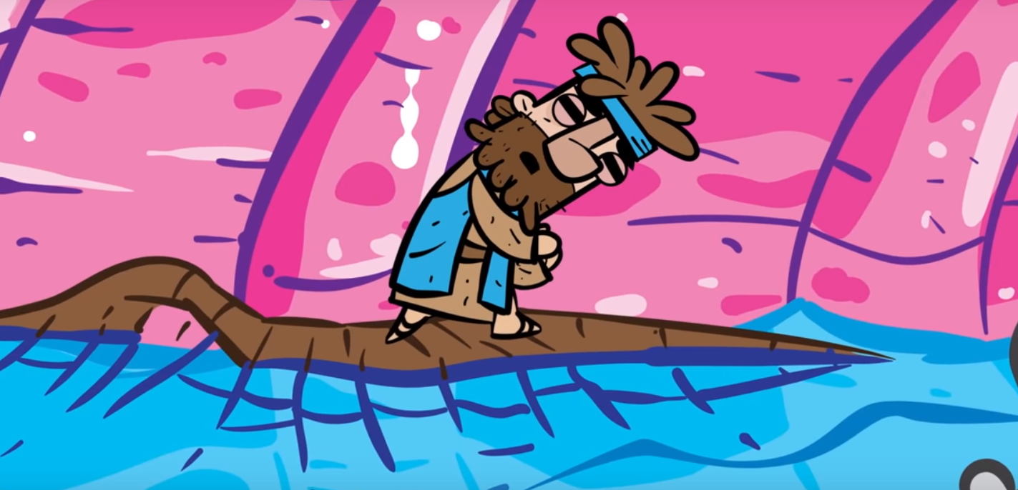 | Jonah feels
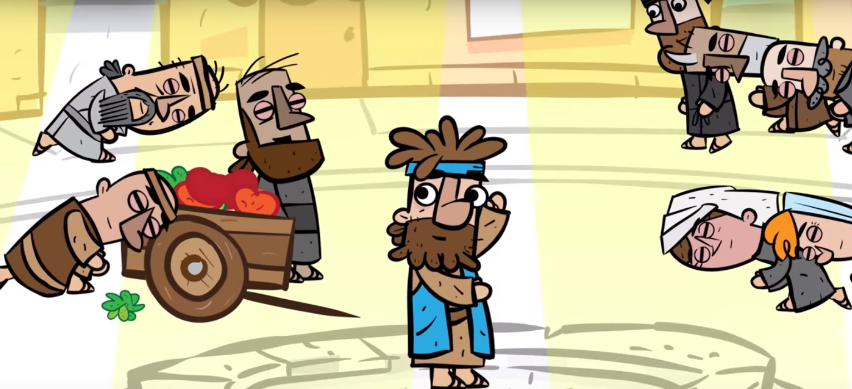 | Jonah feels

Jonah and The Whale
Event in story | Feelings
Jonah feels ________________
because ____________________ ___________________________ ___________________________
 | Jonah
The Captain feels _____________
because ____________________ ___________________________ ___________________________
 | The Captain
Jonah feels ________________
because ____________________ ___________________________ ___________________________
 | Jonah
Jonah feels ________________
because ____________________ ___________________________ ___________________________
 | Jonah
Jonah feels ________________
because ____________________ ___________________________ ___________________________
 | Jonah

Jonah and The Whale
Event in story | Feelings
 | Jonah
 | The Captain
 | Jonah
 | Jonah
 | Jonah

