Pine and Rowan Home tasks for week 2
Below are the activities which can be completed at home. We have suggested subjects to do on certain days which correspond with what we will be doing at school. But if you want to do the activities in a different order that’s fine! We have sent home packs with phonics resources and your child’s logins for the online library and Gooseberry Planet as well as a book which can be used for activities that don’t require a worksheet or to stick in completed work. Some of the activities require access to a computer. If your child is unable to access a computer, please let me know and we can discuss how we can help.

If you have any trouble accessing the resources or if you have any questions, please feel free to contact me at school.

Resources needed for this week- Paper, pencil, colouring pens/ pencils, worksheets (provided on website), access to a computer.

Monday
Subject | Activities that can be completed at home
Physical activity | Joe Wicks or cosmic yoga
Reading/ Phonics | Pupils can read a book at their level or complete phonics activities.  Review flashcards of sounds. Do they recognise all of the sounds? Can they think of any words that use the sounds?  Pupils can also do activities on Phonics Play.  https://www.phonicsplay.co.uk/  You may log in with the following details:  username: jan21  password: home
English | Journal Writing.  Pupils can write a sentence or more about what they have done either over the last weekend. This can be done either independently, copying a sentence or overwriting a sentence that has been written for them.
Maths | This week we will be focusing on Subtraction. Some pupils may need objects to support them in subtracting.  A set of worksheets for your child will be on the website under Math Week 2 (child’s initials)
PHSE | This week we will be looking at the importance of exercise. What are the different ways we exercise? Pupils can list as many as they can think of on their worksheet.  Ask pupils to find their pulse either on their wrist or neck. Is it slow or fast? Pupils can then perform some exercise of their choice e.g. run on the spot, star jumps etc. for 2 minutes. Pupils can check their pulse again, how does it feel this time?  Pupils can fill in the table on their worksheets.
Art | Over the term in Art, we would like pupils to make a solar system. This can be done as a model or a picture and you or your child can choose how they would like to do it. Pupils can then build on their model/picture each week as they learn more about the different planets. Below are some examples you can use for inspiration but feel free to use your imagination!  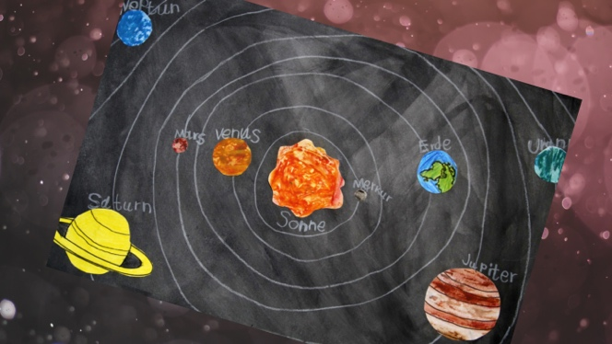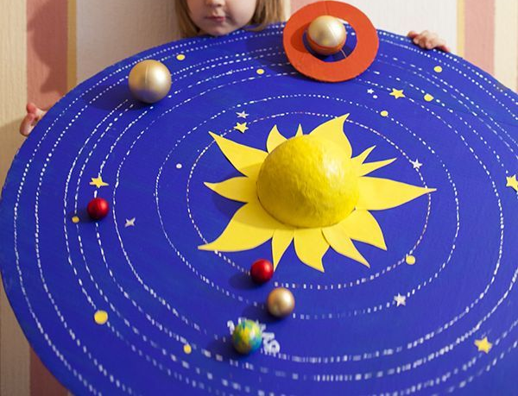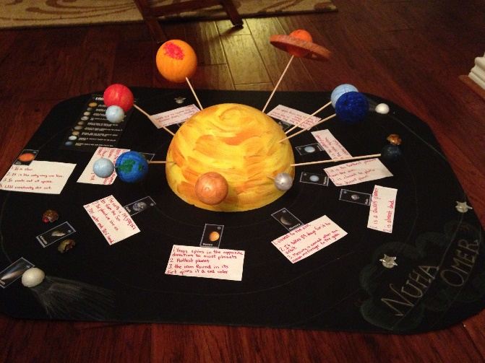

Tuesday
Subject | Activities that can be completed at home
Physical activity | Joe Wicks or Cosmic yoga
Reading/ Phonics | Pupils can read a book at their level or complete phonics activities from pack that has been sent home.  Pupils can also do activities on Phonics Play.  https://www.phonicsplay.co.uk/  You may log in with the following details:  username: jan21  password: home
Handwriting | Complete handwriting worksheets found on website.  Either continue Pencil control workbook or ‘O’ worksheets  Extension- Pupils can write a few sentences of their choosing, ensuring they are forming their letters correctly and keeping them on the line.
Maths | This week we will be focusing on Subtraction. Some pupils may need objects to support them in subtracting.  A set of worksheets for your child will be on the website under Math Week 2 (child’s initials)
RE | Watch the video of Jonah and the Whale  https://www.youtube.com/watch?v=WOSadLyqshg  Pupils can then complete worksheet on Jonah and the Whale, explaining how the characters might be feeling. Pupils can either just say how they are feeling or as an extension explain why they might be feeling that way.
PE | Go for a walk/Bike ride/Run/complete a kid’s aerobic workout/just dance

Wednesday
Subject | Activities that can be completed at home
Physical activity | Joe wicks or cosmic yoga
Reading/ Phonics | Pupils can read a book at their level or complete phonics activities from pack that has been sent home.  Pupils can also do activities on Phonics Play.  https://www.phonicsplay.co.uk/  You may log in with the following details:  username: jan21  password: home
English | This term, pupils will be making a fact book about planets. Using the fact book template saved as English fact book week 2  Start with creating the title page. Ask pupils to think of an appropriate title for their factbook about planets and to draw an eye catching picture for the front cover.
Maths | This week we will be focusing on Subtraction. Some pupils may need objects to support them in subtracting.  A set of worksheets for your child will be on the website under Math Week 2 (child’s initials)
Music | Watch the orchestra version video on the BBC website using the link below  http://www.bbc.co.uk/programmes/p02b14ld  Discuss that Holst wrote Mars based on the idea that he was the Roman God of war. Mars also has two moons which are named ‘Fear’ and ‘Terror.’  Demonstrate the 5 beat ostinato (repeating pattern) at the start which suggests something evil and dangerous. Can they clap along to the repeating pattern at the beginning? Pupils can then try and create their own five beat repeating pattern.
History | This week we are learning about Christopher Columbus. Read through the story of Christopher Columbus PowerPoint. Then look at the history worksheet and sort the images into either Christopher Columbus or Neil Armstrong

Thursday
Subject | Activities that can be completed at home
Physical activity | Joe Wicks or Cosmic yoga
Reading/ Phonics | Pupils can read a book at their level or complete phonics activities from pack that has been sent home.  Pupils can also do activities on Phonics Play.  https://www.phonicsplay.co.uk/  You may log in with the following details:  username: jan21  password: home
English | Pupils can create a contents page for their factbook. Think about what order the pages should be in and plan out your book. You may need to print out the second page more than once!
Maths | This week we will be focusing on Subtraction. Some pupils may need objects to support them in subtracting.  A set of worksheets for you child will be on the website under Maths Week 2 (child’s initials)
Computing | This term Pupils will learn about e-safety. We will be doing this through the Gooseberry Planet website. Each pupil has their own individual login which has been sent through the post. We will be working through the Gooseberry Playground section, completing one level each week.  Complete Levels 1 & 2 this week. First, read through the supporting slides which are saved as Computing week 1 and week 2. Students will then complete activities on the website as instructed throughout the slides.
Science | This week the pupils will be learning about Mercury and Venus.  Pupils can look through the Mercury and Venus PowerPoint saved as Science PowerPoint Week 2. Pupils can then complete the worksheet Science Worksheet Week 2

Friday
Subject | Activities that can be completed at home
Physical activity | Joe Wicks or Cosmic yoga
Reading/ Phonics | Pupils can read a book at their level or complete phonics activities from pack that has been sent home.
English | Journal Writing.  Pupils can write a sentence or more about what they have done either over the last week. This can be done either independently, copying a sentence or overwriting a sentence that has been written for them.
Cooking | Pupils can help prepare a meal at home. If possible, focus on asking your child to help measure out the ingredients.
Geography | This week we are going to learn about America, as that is where Christopher Columbus explored. Read through the PowerPoint on the USA, saved as Geography PowerPoint Week 2. Pupils can then complete the fact file (saved as Geography Worksheet Week 2) either by using the information on the PowerPoint or researching online.
Free reading | Pupils can explore a book of their choice either independently or share a story together.

