Maths
Week 2 – sorting coins instructions sheet
Need a quick and easy math game to teach money skills? Try this Counting and Sorting Coins in Pots of Gold Game! This game only takes a matter of minutes to set up and can be adapted to fit the needs of children from various ages and ability levels.
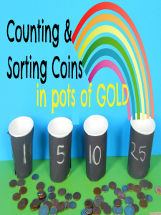

How to Construct
Make the “pots of gold” by wrapping small paper cups with black construction paper
Write the value of the “pot of gold” on the black paper with white chalk (i.e. 1, 5, 10, 25 cents)
Place several coins in front of the “pots of gold” for your child to sort
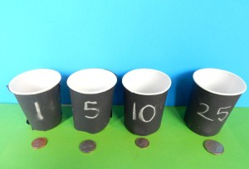

How to Play
Place a large pile of coins in front of the pots of gold and then ask the child to begin sorting the coins into the pots
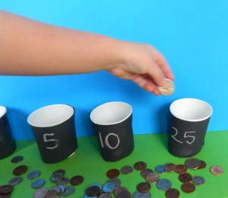
Take the opportunity to teach your child about the coin names and values
After all of the coins have been sorted into each pot, take them out and count them with your child. This is a great chance to teach your child how to count by 1, 5, 10, and 25s.
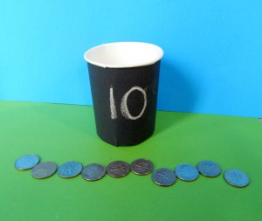
(For Beginners)- Place a sample of each coin in front of the pot of gold to make sorting easier
Advanced- Try adding/subtracting the different coins to make change

