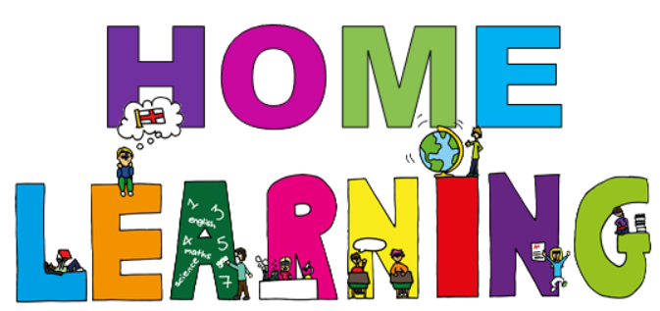

Date 8th January 2021
Dear parent(s)/carers,
We hope you and your family are staying safe and well during this ‘lockdown’, we look forward to seeing all the children again soon. In the meantime, we would like to set the children activities based on our topic this term which is ‘Explorers’. These activities will give the children an opportunity to show off their creative skills whilst tapping into their curiosity and imagination.
Planning overview -
Included in this pack is a copy of our planning for this term. It outlines the work the children will be doing this term and we encourage you do as ‘much’ or as ‘little’ as you can at home with your child/children:
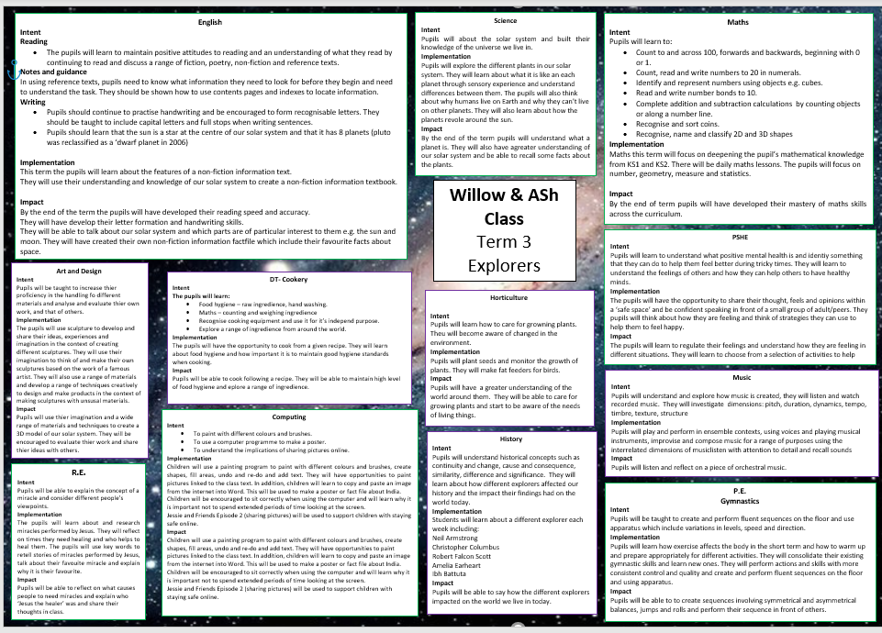

Timetable -
Here is a copy of our timetable at school, which has been slightly adapted to suit home learning:
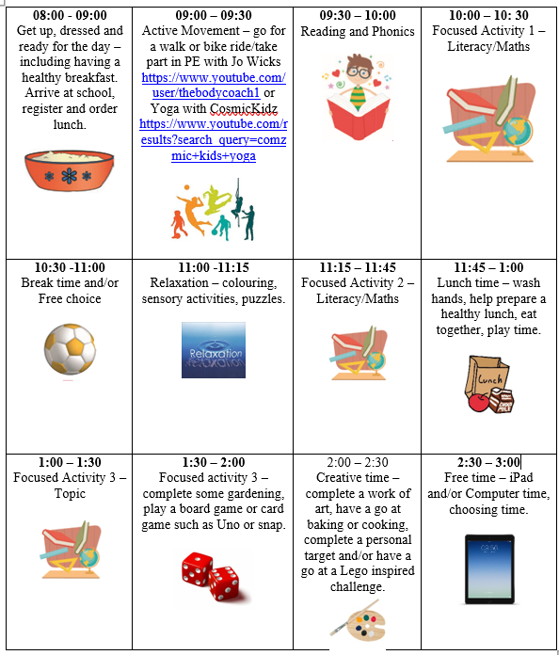

Week 2 home learning activities -
Below are the activities which can be completed at home alongside the work being done at school. If you have and questions, please feel free to contact us at school.
Over the next 6 weeks, for Art, we would like the children to use their imagination and creativity skills to design and make a 3D model of our solar system. We would like the children to take as much ownership over their project as possible by deciding how they would like to present their work and how much detail they would like to go into, this should be a fun and enjoyable project for them to complete whilst at home. Here are a few examples:
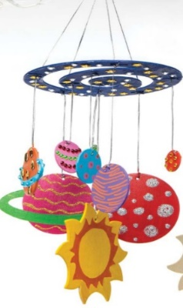
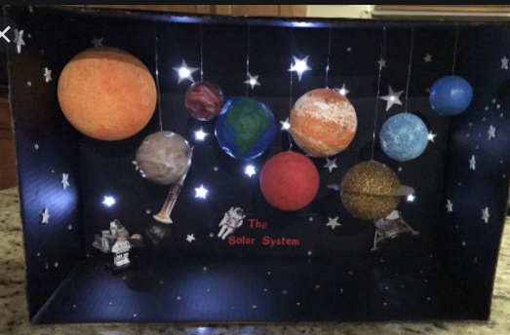
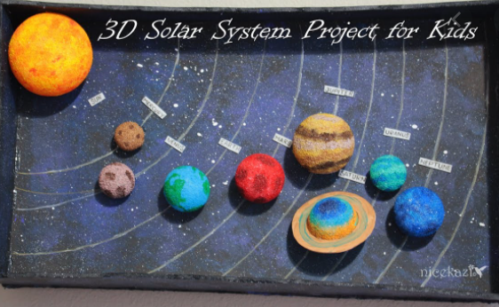

Subject | Activities that can be completed at home.  Resources needed: computer, internet, magnetic letters, whiteboard and pen, books, coins, cups/jars, bean seeds, flowerpots, compost, non-fiction books
Phonics | Letters/sounds to focus on this week – ‘igh’  Tricky word to focus on this week – ‘all’  Using your computer, login to phonicsplay.co.uk - PhonicsPlay  Username: jan21  Password: home  Select the resources section of a wide variety of fun but educational games to play.  - Recap phase 2/3 flashcards or gab a giggling grapheme (resources section on phonicsplay)  - Recap tricky words – play trick words trucks (resource section on phonics play)  - Teach focus sound/tricky word – watch alphablocks – how to pronounce ‘igh’ Phonics - How to Pronounce 'igh' | Alphablocks | Learn to Read | Wizz Learning - YouTube  - choose a game to play, buried treasure, dragons’ den, pick a picture (resources section on phonicsplay)  - order the letters of the alphabet using magnetic letters  - spell simple words using the magnetic letters  - write up to 4 words on a whiteboard and ask the child to rub off a given word e.g. rub off night, and wait for the child to read and find the correct word before rubbing it off, repeat until all words have been rubbed off.
Reading | Oxford Owl ebook Library – see separate leaflet for details –  https://www.oxfordowl.co.uk/login?active-tab=students  Ask & Willow –  Username: fitzwarynashwillow  Password: askwillow  - Read a level appropriate book with your child.  - Share your favourite picture/chapter novel with them.f
English/Science | Learning .Intention. To explore features of non-fiction books  Introduction  Explain a non-fiction book tells you facts and information about the world around you. You use the book to look up something and find out about it. It is different from a fiction book/story book because that has made up stories in them, whereas non-fiction is always about something that has happened.  Activity 1  Look through the book/pictures with your child, looking at the examples. There are different features to a non-fiction book – cover, contents, index, heading, captions, photographs.  See separate pages for pictures and more information.  Activity 2  To write a sentence about the picture explaining what they can see. Encourage your child to use capital letters and full stops.
Maths | learning intention: understand the value of 1p, 2p, 5p and 10p coins.  Set the scene-  Ask children/child to imagine they are going to a shop with a purse/wallet filled with coins to buy different food items.  Empty a purse filled with coins and ask the children/child to select a coin to explore. Feel the coin. Talk about the shape, size colour and introduce the value of that coin e.g. 1p is worth 1, 2p is worth 2, you could show this visually using cubes.  Compare similarities and differences between each coin. Show the children/child 1p/penny and agree that it is the lowest value coin because 1 is the lowest number.  Sort a selection of coins into pots/cups or jars – see separate sheet for instruction/guidance.
PE/Active movement | Go outside –  - Ride a bike  - Have a walk around your local nature park and look for signs of winter
Topic | History  *There is information on the Explorers BBC Teach website https://www.bbc.co.uk/teach/class-clips-video/ks2-explorers/zjh8bdm  - Watch video – who was Neil Armstrong? History of Neil Armstrong for Kids - YouTube  Or  - Watch video – things you want to know about Apollo 11, the first man on the moon Apollo 11 - The First Moon Walk | Things You Wanna Know - YouTube  Activity  Create a simple poster about Neil Armstrong – include a picture and a few key words or simple sentences which include their favourite facts about Neil Armstrong or the Apollo 11 mission  Notes and guidance  You can:  - Ask the child to recall their favourite facts after watching the video.  - Share your favourite facts with your child.  - Write words/ simple sentence down for them to copy on their poster.
Horticulture | Learning intention: To plant seeds and care for growing plants  Plant broad beans in soil. Talk about needs of plants – soil, sun and water. Take photo to compare different growth rates over time.
DT - Cookery | BBC Food - Crumpet pizzas recipe - BBC Good Food  See recipe sheet for full instruction. Enjoy!

Relaxation/mindfulness:
Guided Meditation for Children | Your Secret Treehouse | Relaxation for Kids - YouTube
Relax Music for Stress Relief, Study Music, Sleep Music, Meditation Music 💜 528Hz - YouTube
Guided Meditation for Kids | Spaceship to the Moon | Relaxation for Children - YouTube

Active movement:
Just Dance 2018 • Waka Waka (Football Version) - YouTube
Banana Banana Meatball - Blazer Fresh | GoNoodle - YouTube

Other helpful websites:

Home - GoNoodle
ictgames
PhonicsPlay
Welcome | Numeracy Warm Up
– username: fitzwaryn
-password: story
HelpKidzLearn
Writing warm ups - dough disco for children - YouTube
Counting song - Let's Get Fit | Count to 100 | Count to 100 Song | Counting to 100 | Jack Hartmann - YouTube
Phonics song - Phonics Song 2 (new version) - YouTube
Jolly Phonics A-Z - YouTube
Space/planets song - The Solar System Song - YouTube

Face to face Zoom sessions –
We would like to invite you to join us for 3 zoom sessions each week – details will be sent via email before each session, including login details and passwords.
Session 1 – Monday morning at 9:45 – 10:15 – to include pupils at home and in school, to give them an opportunity to see their friends and share their weekend news, ready for their journal writing English session on a Monday.
Session 2 – Monday afternoon 1:30 – 2:00 - explanation session for parents however, pupils are welcome to join, to give you an opportunity to ask any questions or discuss home learning packs.
Session 3 – Thursday – one to one face to face zoom session will be held to give your child an opportunity to speak with their class teacher and show off their work. Times to be confirmed during our weekly phone calls or via email prior to the sessions.

Stay safe and well!
All the best,

Ash and Willow Class teachers

