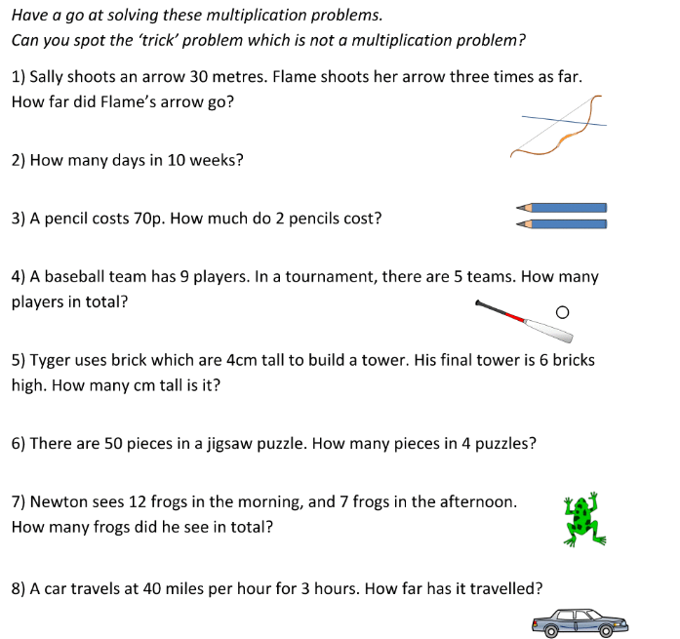
I can use multiplication to solve word problems
https://www.bbc.co.uk/bitesize/topics/z36tyrd/articles/z2fkwxs

