Open Module
Create a scrapbook on a chosen topic

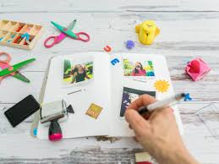

1 credit
Completed in Lockdown
Term 3 2020/21

In this challenge you will need to (tick when complete):

Choose a topic from a list
To make a plan
To provide reasons for your decision
To make a list of equipment
Days 4 - 9
Collect pictures from different sources
Include writing to your scrap book
To write a review

Your challenge is to create a scrap book. It will count as one ASDAN credit and be added to your portfolio when you hand it in. You should include pictures (you can take them from the internet, magazines, newspapers etc.), drawings and writing. There are no right or wrong answers; we want you to be as creative as possible! Here are some examples to help you get started. It is absolutely fine to ask an adult to help you but you should aim to do some of it independently.
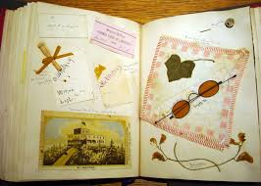
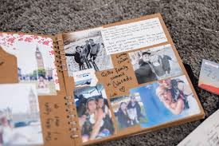

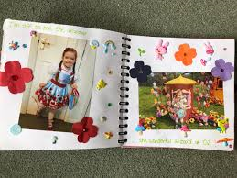
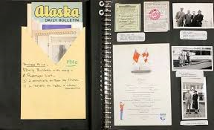

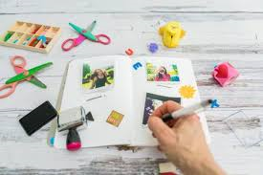


L.I: To choose a topic
Success Criteria | Achieved?  Me Adult
- To make decisions
- To explain why you have chosen your topic
- To brainstorm ideas

Choose a topic from a list below. Tick the topic that you have chosen.

Family and friends
Aspirations (future jobs, things you would like to learn etc.)
The environment
Animals
My hobbies/interests

Why have you chosen your topic? (You can ask an adult to help you to write your answer)

L.I: To make a plan`
Success Criteria | Achieved?  Me Adult
- To describe the activity
- To plan how I going to do my activity
- To list what I need
- To identify people to help me

For ASDAN, we need to complete ‘Skills Sheets’. There is one at the beginning of the module to help you to plan your task and then there is one at the end to help you to review how you think it went. There are no right or wrong answers!
We have already completed our 3 bronze sheets in school so this time we are asking you to complete a silver sheet. I have provided a completed form as an example on the next page. You can ask an adult to help you make and write your plan.
Leave the ‘Tutor signature’ box and ‘When it will be done by’ blank and I will fill it in when you hand in your work.

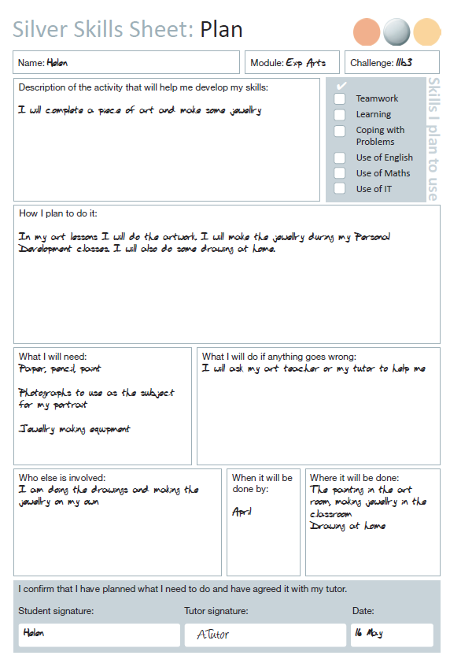

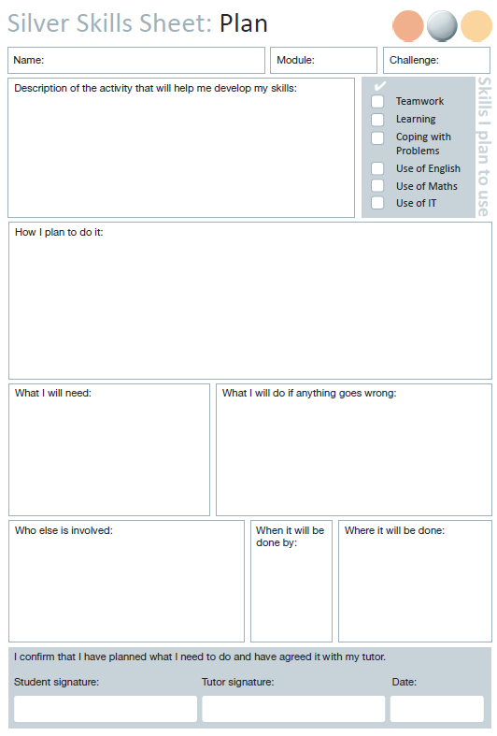
Open
1

L.I: To create a scrap book
Success Criteria | Achieved?  Me Adult
- To include pictures / photos on my chosen topic
- To include writing
- To present my work nicely

This part of the module will take you a number of lessons. I would like you to start to create a scrap book on your chosen area. There must be at least eight pages worth of clippings, writing etc. Make is as colourful and bright as you can – it is your chance to get really creative.

L.I: To review my learning
Success Criteria | Achieved?  Me Adult
- To write what you did
- To identify what went well and what could have gone better
- To identify what changed I made

Now that you have completed your scrap book, it is time to complete your review.
Just like the plan, there are no right or wrong answers. I have added an example of the next page to help you. Think carefully about what could have gone better; there is always something that could be improved!

Leave the ‘Tutor signature’ and ‘Evidence I have for my portfolio’ boxes empty. I will complete these when you hand in your work.

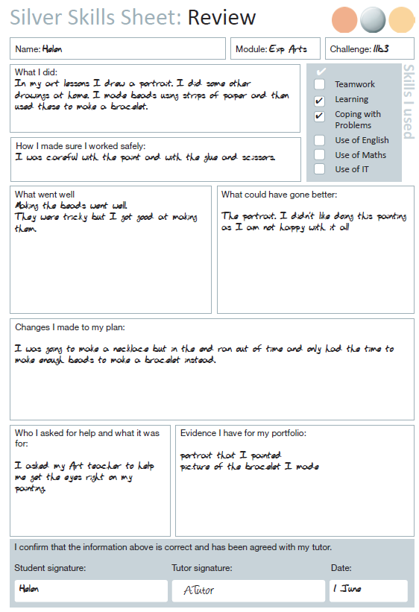

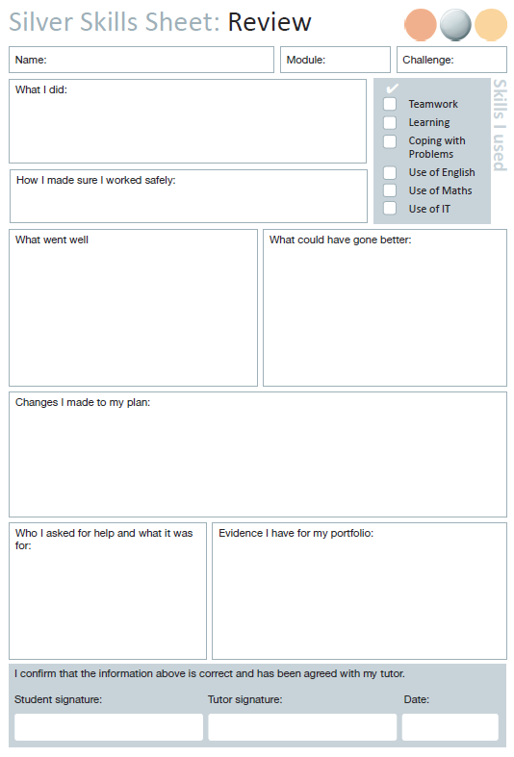
Open
1

