Number Handling
Module 6A1

Make a weekly shopping list containing at least 20 items. Compare prices between two supermarkets. Calculate the total coast and the difference between the two.

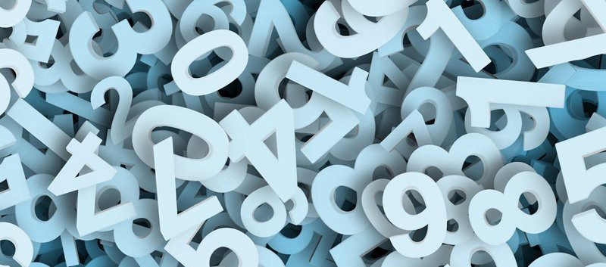

Term 3 2020/21

Completed in Lockdown
In this challenge you will need to (tick when complete):

Make a list of 20 items that would be in your weekly shopping list
Compare the prices between two supermarkets
Use a calculator
Calculate the total cost
Calculate the difference between the two supermarket prices
Review and reflect on your learning

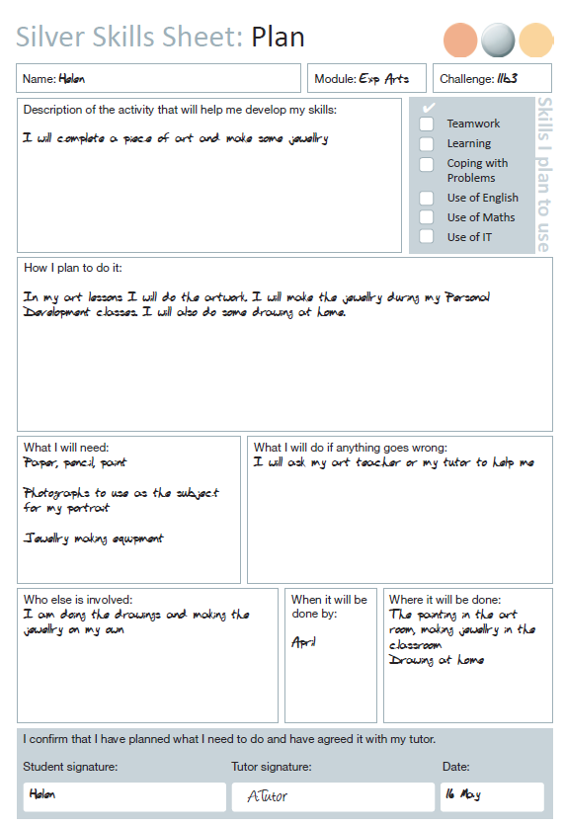

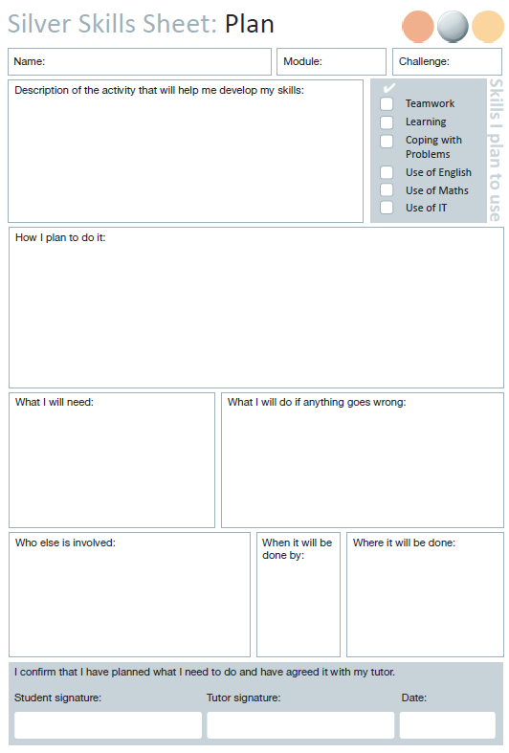
Open
1

L.I. To make a list of 20 items you would buy in a supermarket.
Success Criteria | Achieved?  Me Adult
- Have a look for items in your home
- Use the internet
- Research 20 common items people buy when shopping
- Make a list

Using the table below, create a list of 20 common items that you would find in a household.
1
2
3
4
5
6
7
8
9
10
11
12
13
14
15
16
17
18
19
20

L.I. To compare the prices of items in two supermarkets
Success Criteria | Achieved?  Me Adult
- Research the price of the items
- Identify the price of the item in Sainsbury’s
- Identify the price of the item in Tesco
- Write the prices

In the table below, write the name of the product, and the prices from both Sainsbury’s and Tesco’s.
Item | Sainsbury’s | Tesco

Item | Sainsbury’s | Tesco

Looking at the list above, make an estimation into which supermarket you think is going to be the most expensive.

L.I. Calculate the total cost of the items and work out the difference
Success Criteria | Achieved?  Me Adult
- Add up the total cost of each supermarket shop
- Use a calculator if needed
- Compare the two prices
- Work out the difference between the two

Supermarket | Total Cost
Sainsbury’s
Tesco’s

If you can, do this without a calculator, but if you need to use a calculator to work out the difference, that is ok.
Take the smaller total cost away from the biggest and you will get the difference between the two supermarkets.

Difference between the supermarket’s total costs



