Fitz Kids Activity Pack
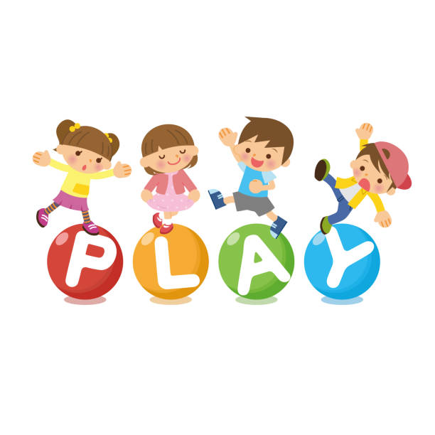

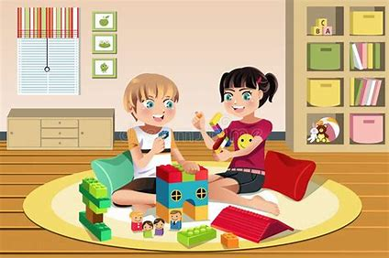

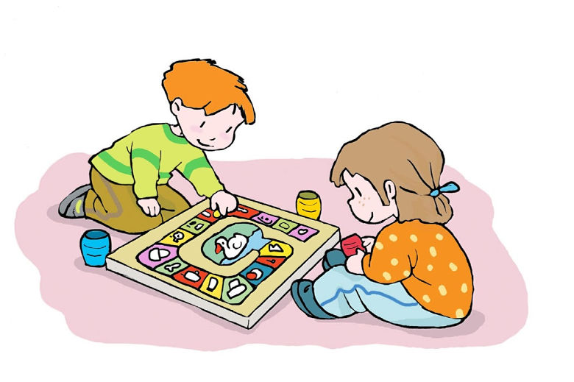

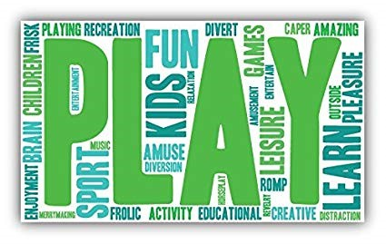

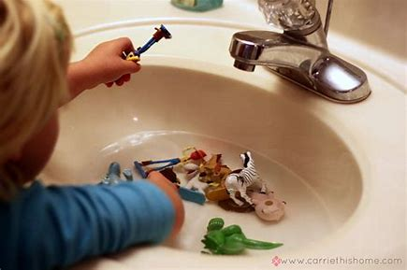
Sensory Play Ideas;
Water play
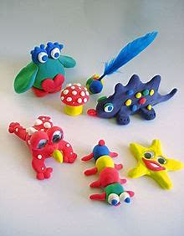
Sand
Shaving foam
Play dough

Get Creative;
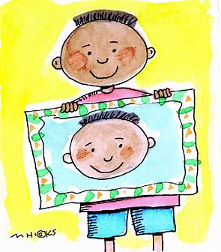
Draw pictures of each other or yourself
Junk Modelling
Make paper snowflakes
Make cards for friends/family/neighbours
Paint with; fingers, sponges, cotton buds or just brushes

Make paper aeroplanes
Make a collage
Upcycle something old
Create a comic book
Make a poster for your favourite song/nursery rhyme

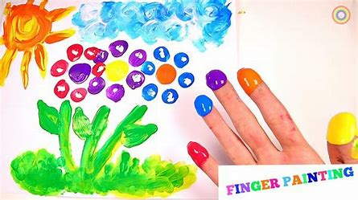
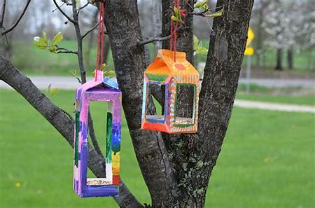

Stay Active;
Indoor or garden obstacle course
Circuits- touch toes, jumping jacks, jog on spot, balance on one leg etc.
Balloon tennis/ volleyball
“Just Dance” on you tube or have a dance party to favourite music.

Waste paper shoot out- roll up paper balls and see who can get the most shots into the bin
Bowling- using empty bottles and a ball
Hopscotch
Musical statues

Musical pillows- like musical chairs but with pillows
Parachute games- using a sheet and balled up paper or small soft toys
Can you move like a… dog, rabbit, crab, seal etc.

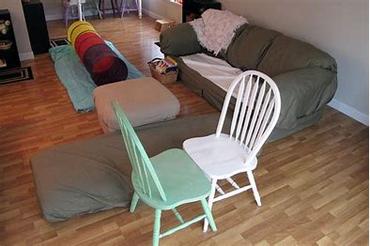

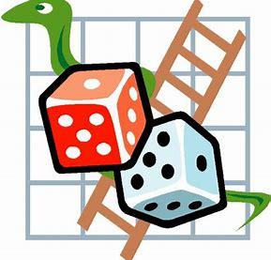
Play a Game;
Play noughts & crosses
Do a puzzle together
Play/make board games
Make faces in the mirror; silly, scary, happy, sad etc.
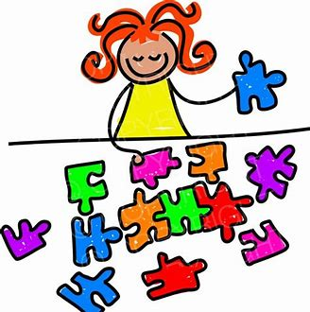
Create a scavenger hunt; indoors or in the garden
Play schools/shops
Have a dressing up session
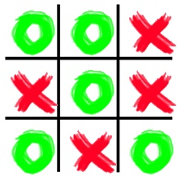
Play “Simon says…”



When you need some quiet;
Plan a lazy/pamper day; bubble bath, hand massages, face masks

Watch a movie or kids TV
Play on computer, tablet or games console



Other Activity Ideas;

Lego challenge
Make a blanket den
Do a puppet show
Sock fight- throwing balled up socks
Teddy bears picnic
Make a mud kitchen outside

Share a book
Help make lunch/dinner
Make a photo diary
Learn a new song/nursery rhyme
Birdwatch from your window/garden
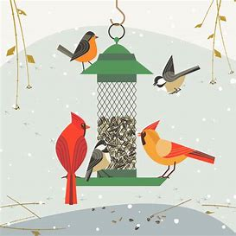
Go on a bug hunt in the garden
Play with cars/trains
Have an indoor camping day

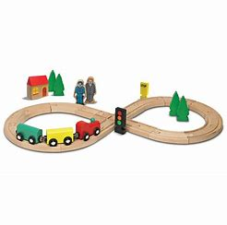

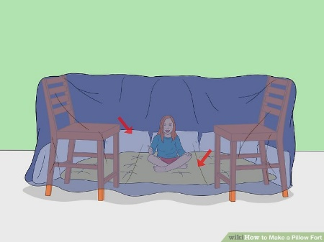

Advice and Support;
Keep to a daily routine, where possible; set times to get up, eat meals, be active, bath and bed times.
Keep your child’s favourite activities and screen times for those times when you need a break or need to get something done.
Boundaries need to be clear
Journal your thoughts and feelings
Practise self care (even if it’s only 5 mins to yourself before you go to bed or before children get up)
Twinkl, the online resource centre, are offering a month open access for free- there are thousands of activities and resources to ensure your child doesn’t get bored, for every age group too.
Go to; www.twinkl.co.uk/offer
register as a new user, choose age group required and add code- CVDTWINKLHELPS

Helplines/support are invaluable; if things are getting too much talk to someone, whether it’s a friend, family member or support group, sharing concerns/worries really does help.
NHS- www.NHS.uk or 111 for health advice (999 for emergencies only)
Oxfordshire Mind- www.oxfordshiremind.org.uk 01865 247788
Oxfordshire Safeguarding Children Board- www.oscb.org.uk If you have a concern about a child, please call MASH on 0345 050 7666 during office hours (8.30am – 5pm, Monday to Thursday, 8.30am – 4pm, Friday)
Outside office hours call the Emergency Duty Team on 0800 833 408



