

Fitzwaryn School
Calculation Policy

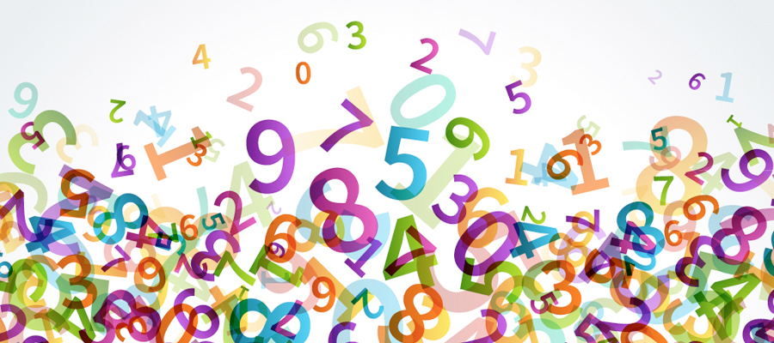

Policy created September 2021
To be reviewed September 2023
Hannah Gordon Maths Coordinator
Introduction
At Fitzwaryn School we believe that pupils should be introduced to the processes of calculation through practical, oral, and mental learning opportunities. As pupils begin to understand the underlying ideas; they develop ways of recording to support their thinking and calculation methods, use methods that apply to special cases and learn to interpret and use the signs and symbols involved.

Choosing the appropriate strategy, recording in mathematics and in calculation is an important tool both for the furthering and understanding of ideas and communicating those ideas to others. A useful written method is one that helps pupils carry out a calculation and can be understood by others.

Written methods are complimentary to mental methods and should not be seen as separate. The aim is that pupils use mental methods when appropriate, but for calculations that they cannot do mentally, they use an efficient written method accurately and with confidence. It is important that pupils acquire secure mental methods of calculation and one efficient written method of calculation for addition, subtraction, multiplication and division which they know they can rely on when mental methods are not appropriate.

This policy identifies progression in calculation strategies.

Children should not be made to progress to the next stage if:
- They are not ready.
- They are not confident.

By the end of KS5, pupils should be able to choose the most appropriate approach to solve a problem: making a choice between using jottings (an extended written method), an efficient written method or a mental method.

This policy contains the key pencil and paper procedures that will be taught within our school alongside practical resources. It has been written to ensure consistency and progression throughout the school and reflects a whole school agreement.



Addition
Vocabulary: hundreds, tens, ones, add, more, and, make, total, altogether, double, one more, two more, ten more…, how many more to make..?, how many more is… than…?
Method | Example/Representation
A1. Using a range of practical resources and real life contexts, pupils develop their understanding of the concept of addition through counting activities. | How many dinosaurs are there?    What about if I give you two more? How many are there now?  
A2. Pupils are introduced to the addition symbol (+) and use pictures/diagrams to represent the calculation. | There are 2 birds. Another bird flies in. How many are there altogether?  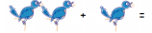
A3. Store the larger number mentally and use fingers to count on. | Count on from the larger number. A child will choose the larger number, even when it is not the first and count on from there; (5 in your head) ‘six, seven, eight’ using their fingers:  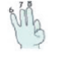  3 + 5 = 8
A4. Pupils represent an addition number sentence in picture form and are able to solve simple addition number sentences using objects or fingers.  Pupils might be able to begin to explain their reasoning. | 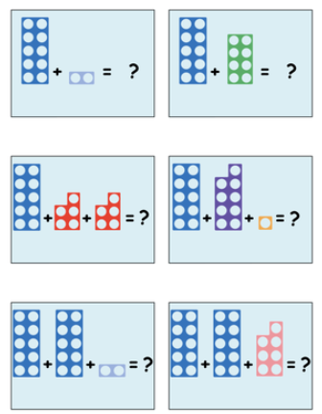
A5. Pupils will be taught to use a number track, bead strings, number lines, 100 squares and blank number lines to support addition. | 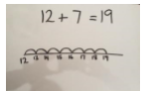  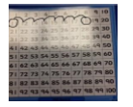  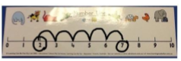    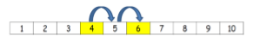
A6. Pupils will partition numbers into tens and ones when adding two-digit numbers that lie within the tens boundary. | 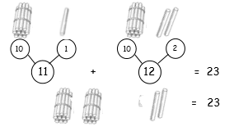
A7. Pupils will solve one-step addition problems using concrete objects and/or pictorial representations | 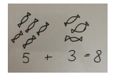
A8. Pupils will solve simple addition problems using concrete objects and pictorial representations, including those involving number, quantities and measures. | George has 14 strawberries and Jess has 12 strawberries. How many strawberries are there altogether?  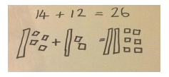
A9. Pupils begin to set out TO + TO (that cross the tens boundary) in columns and record as column addition. | 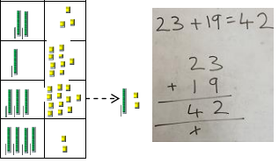
A10. Pupils begin to set out TO + TO (that cross the hundreds boundary in columns and record as column addition. | 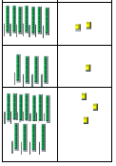  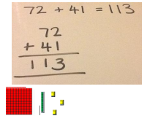
A11. Pupils set out  - HTO + O (that lie within the tens boundary)  - HTO + TO (that lie within the tens boundary)  - HTO + TO (that cross the tens boundary)  - HTO + TO (that cross the hundreds boundary)  - HTO + TO (that cross the hundred and tens boundaries)  In columns and record as column addition. | 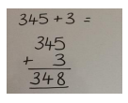  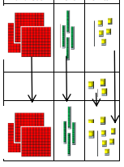  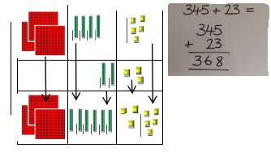  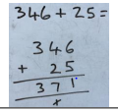  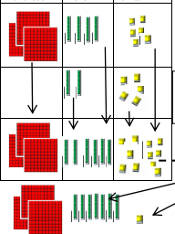  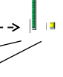  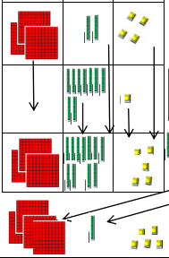  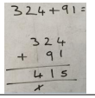  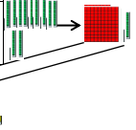  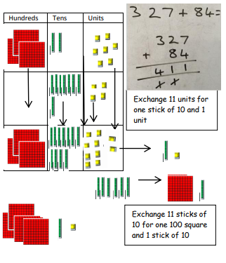
A12. Pupils set out HTO + HTO (that cross the tens boundaries) in columns and record as column addition | 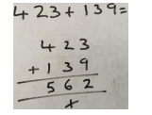
A13. Pupils set out HTO + HTO (that cross the tens and hundreds boundary) in columns and record as column addition | 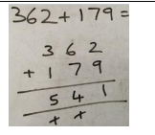
A14. Pupils will add decimal numbers with the same number of decimal places using the formal method column addition | 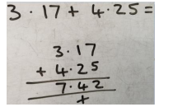
Mental Strategies
- Develop a mental image of the number system
- Understand the value of number
- Counting forwards and backwards
- Recall of number bonds to 10
- Know that addition can be carried out in any order
- Add 1 and 2 digit numbers to 20 including 0
- Doubles of numbers up to and including double 10
- Adding 10 to a single digit number
- Identify 1 more than a given number
- Know that addition is the inverse of subtraction
- Add numbers mentally (TO + O, T + TO, TO + TO, O + O + O)
- Use knowledge of inverse to check calculations and solve missing number problems

Subtraction
Vocabulary: hundreds, tens, ones, add, more, and, take (away), leave, how many are left/left over?, how many have gone?, one less, two less, ten less, how many fewer is… than…?, difference between, is the same as, subtract, minus, equals, sign, is the same as, partition, count back
Method | Example/Representation
S1. Using a range of practical resources and real life contexts, pupils develop their understanding of the concept of subtraction as taking away through counting activities. | How many dinosaurs are there?  What about if I give you two? How many have I got left?
S2. Pupils will use counting objects, toys or their fingers to answer simple subtraction number sentences. | Example: 6-3 = 3
S3. Pupils will listen to a subtraction story and draw a set of objects (or an adult will) on whiteboards and cross some off – drawing a picture helps children to visualise the subtraction. | 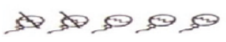
S4. Pupils will use their fingers to help with subtraction, e.g. 5 – 2 = 3.  A pupil will start with the biggest number in their head ‘5’ and hold 5 fingers up  They will count back saying ‘5’ (touching their head_ ‘4,3’ (curling one finger down at a time), then count how many fingers are left. | 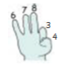
S5. Pupils can use characters like ‘Suzie the subtractor’ to help develop their understanding of subtraction. | 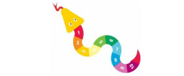
S6. Pupils will be taught to use a number track, bead strings, counting sticks, number lines and 100 squares to support subtraction by counting backwards. | 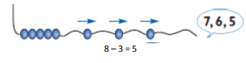  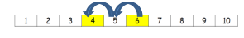  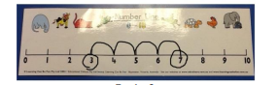  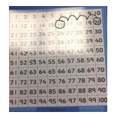
S7. Pupils will be taught how to use a blank number line for subtraction (counting backwards) and then encouraged to draw their own number line to help solve problems.  S8. Pupils will begin with TO – O that lie within the tens boundary then move on to TO – O that cross the tens boundary. | 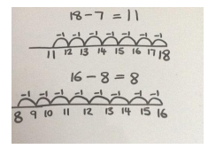
S9. Pupils will solve one-step subtraction problems using concrete objects and pictorial representations, including those involving number, quantities and measures. | 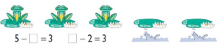
S`10. Pupils are encouraged to use a blank number to solve TO – O and count back in tens and then ones by:  - Positioning the first number in the number sentence at the end of the number line  - Partitioning the second number into tens and ones  - Counting back in 10s, or multiples of 10s  - Counting back in units | 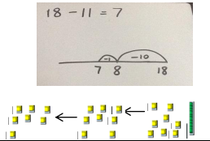
S11. Pupils will use their knowledge of difference and use a blank number line to count on from the smallest number to the largest number (in tens and ones) to solve subtraction number sentences (TO – TO). | 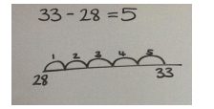
S12. Pupils will be encouraged to draw their own number line and begin to decide on the most efficient strategy; whether to start with the smaller number and count on or start with the larger number and count back. | 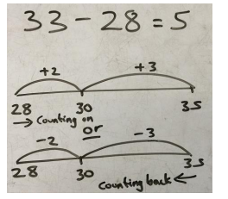
S13. Recognise and use inverse relationship between addition and subtraction and use this to check calculations and solve missing number problems. | 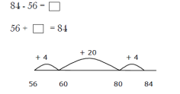
S14. Pupils begin to set out TO – TO (that lie within the tens boundary) in columns and record as column subtraction. | 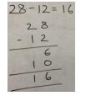  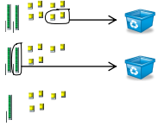  Then subtract tens  Subtract ones first
S15. Pupils begin to set out TO – TO (that cross the tens boundary in columns and record as column subtraction with decomposition. | 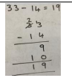  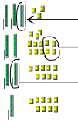  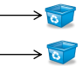  Exchange 1 stick of 10 for 10 ones  Subtract the tens  Subtract the ones
S16. Pupil begin to set out HTO – TO (that lie within the tens boundary) in columns and record as column subtraction. | 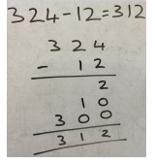
S17. Pupils begin to set out HTO – TO (that cross the tens boundary) in columns and record as column subtraction with decomposition. | 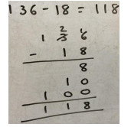
S18. Pupils begin to set out HTO – TO (that cross the hundreds boundary) in columns and record as column subtraction with decomposition. | 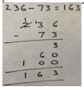  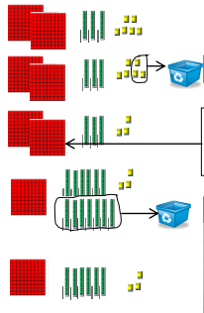  Subtract the tens  Exchange 1 square of 100 for 10 sticks of 10  Subtract the ones
S19. Pupils begin to set out HTO – TO (that cross the hundreds and tens boundary) in columns and record as column subtraction with decomposition. | Use the same method as shown above including exchanging the tens stick for ones
S20. Pupils will subtract numbers with up to 4-digits using the formal written method of column subtraction with decomposition. | 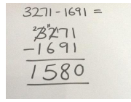
S21. Pupils will subtract decimal numbers with the same number of decimal places with decomposition. | 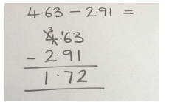
Mental Strategies
- Pupils count backwards using familiar number rhymes (e.g. 10 green bottles, 5 sizzling sausages)
- Count backwards from different starting points
- Subtract 1 and 2 digit numbers to 20 including 0
- To know that subtraction is not commutative and that the larger number must always come first
- To know that subtraction is the inverse of addition
- Use knowledge of inverse to check calculations and solve missing number problems
- Subtract numbers mentally including TO – O, multiple of 10 from TO, TO – TO
- Recall and use subtraction facts to 20 fluently
- Use knowledge of number bonds to 100 (multiples of 10) to reason (40 + 60 = 100 so 100 – 60 = 40 and 100 – 40 = 60).

Multiplication
Vocabulary: groups, lots of, double, odd, even, count in twos, fives, count in tens (forwards/backwards from), how many times?, groups of, multiple of, multiply by, array, row, column, repeated addition
Method | Example/Representation
M1. Pupils will count groups of the same number of objects and add them together. The pupils learn about grouping in practical contexts and through pictorial representation | Count in groups of 2 and then count all objects to add them together  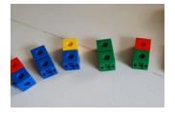
M2. Pupils will solve simple problems involving doubling | 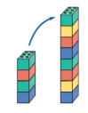  Double 4 is 8!
M3. Pupils will count groups of the same number of objects and add them together. The pupils learn about grouping in practical contexts, through pictorial representations.  Bead strings and counting sticks will be used to support counting in sequences of 2’s, 5’s and 10’s. | I have 5 pairs of socks in the bag. How many socks are there?  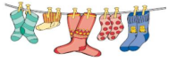
M4. Pupils will recognise and complete patterns and sequences involving multiples of 2, 5, and 10. | 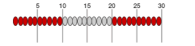
M5. Pupils will be given one-step word problems to solve, involving counting in multiples of 2, 5 and 10 and doubles. Pupils will use concrete objects and pictorial representations to support their ideas. | Alfie, Joseph and Ben all have a pair of socks. How many socks are there altogether?  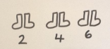
M6. Pupils will be introduced to an array to support multiplication and to support the understanding that multiplication is repeated addition. | 5 + 5 + 5 = 15  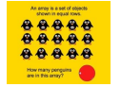
M7. Pupils will understand the operation of multiplication as repeated addition on a blank number line and will use practical resources to support this. | 4 x 5 = 20  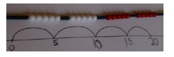
M8. Pupils will be able to represent a multiplication calculation using an array and write the multiplication symbol within a number sentence. Pupils will also understand that multiplication can be carried out in any order (commutative). | 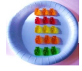  5 x 3 = 15  3 x 5 = 15
M9. Pupils will solve one-step multiplication problems (including missing number problems) using concrete objects and pictorial representations. | I have 3 ladybirds with 5 spots each. How many spots do they have altogether?  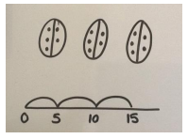
M10. Pupils will learn to calculate doubles of 2-digit numbers through portioning. | 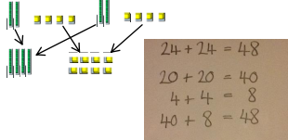  Double 24 = 24 + 24 = 48
M11. Pupils will be taught to multiply numbers (TO x O) through partitioning and the formal written method of grid multiplication. | 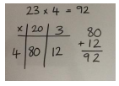
M12. Pupils will be taught to multiply numbers (TO x O) using the formal written method of expanded column multiplication and make the link to grid method. | 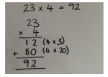
M13. Pupils will be taught to multiply numbers (TO x O) by partitioning the 2-digit number and using two short multiplications along with addition to solve the problem (Distributive Law). | 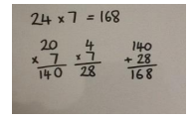
M14. Pupils will be taught to multiply numbers (TO x O) using the formal written method of short multiplication and will link with the Distributive Law method. | 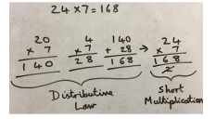
M15. Pupils will be taught to multiply numbers (HTO x O) by partitioning the 3-digit number and using three short multiplications along with addition to solve the problem. | 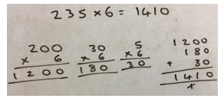
M16. Pupils will be taught to multiply numbers (HTO x O) using the formal written method of short multiplication and will link with the Distributive Law method. | 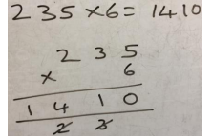
M17. Pupils will be taught to multiply numbers (TO x TO) by partitioning the second 2-digit number and using two short multiplications along with addition to solve the problem. | 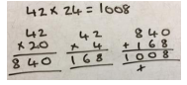
M18. Pupils will be taught to multiply numbers (TO x TO) by using the formal written method of long multiplication. | 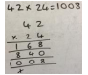
M19. Pupils will be taught to multiply numbers (HTO x TO) by using the formal written method of long multiplication. | 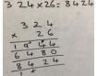
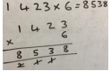
M20. Pupils will be taught to multiply numbers (ThHTO x TO) by using the formal written method of long multiplication.

M21. Pupils will learn how to multiply one-digit numbers with up to two decimal places by whole numbers using:  - Short multiplication when multiplying by a single digit  - Long multiplication when multiplying by a 2-digit number | 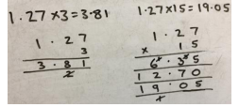
Mental Strategies
- Count forwards and backwards in multiples of 2s, 5s and 10s.
- Recall doubles of numbers up to and including 10.
- Count forwards and backwards in multiples of 4, 8, 50 and 100.
- Know the 3, 4 and 8 times tables (in and out of order).
- Connect the 2, 4 and 8 times tables through doubling.
- Use knowledge of place value to calculate multiplication (e.g. 2 x 2 = 4, 2 x 20 = 40, 2 x 200 = 400).
- Know all times tables up to and including 12 x 12

Division
Vocabulary: halve, half, share, share equally, groups, equal groups of, divide, divided by, left over, repeated subtraction, inverse, divided into, short division, remainder
Method | Example/Representation
D1. Pupils experience early division by sharing objects and counting how many in each group. | 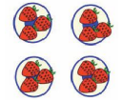
D2. Pupils will solve simple problems including halving and sharing. | What is half of 8? Half of 8 is 4.  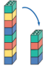
D3. Pupils will understand equal groups and share items out in play scenarios. | Share 12 cakes between 3 people equally:  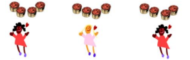
D4. Pupil will be taught to associate ‘half’ with dividing by two and recognise, find and name a half as one of two equal parts. | Can you cut the pizza in half?  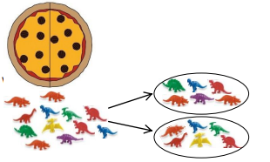
D5. Pupil will be given a word problem to complete either practically or using pictorial representations. | Can you share 6 apples between 3 plates?  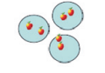
D6. Pupils will recognise and write the division symbol (÷) in mathematical statements, calculating the answer with the teacher using concrete objects. | 8÷2=4  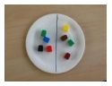
D7. Pupils will understand the operation of division as grouping using repeated subtraction on a prepared number line. | 15 ÷ 3 = 5    -3  -3  -3
D8. Pupils will be able to represent a division calculation using an array and write the division within a number sentence. | How many groups of 3 are in 12?  12 ÷ 3 = 4  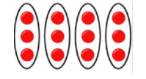
D9. Pupils will use a blank number line to carry out repeated subtraction to solve a division number sentence. | 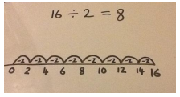
D10. Pupils will be taught to understand the difference between sharing and grouping. Pupils will also connect unit fractions to equal sharing and grouping. | 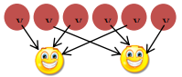  If 6 sweets are shared between 2 people, how many do they get each?  Sharing  If there are 6 sweets, how many people can have 2 sweets each?  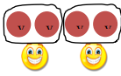    Grouping
D11. Pupils will solve one-step division problems (including missing number problems) using concrete objects and pictorial representations. | 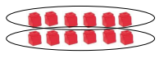  12 ÷ = 6
D12. Pupils will use practical resources to support the short division method and will be encouraged to use multiples of the divisor to assist (TO ÷ O). | 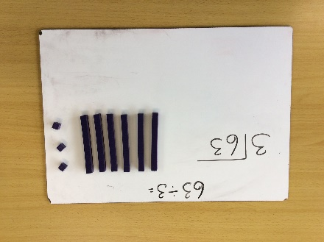  Group the tens according to the divisor and write the number of groups above the line in the tens column  Create the dividend using Base 10 resources  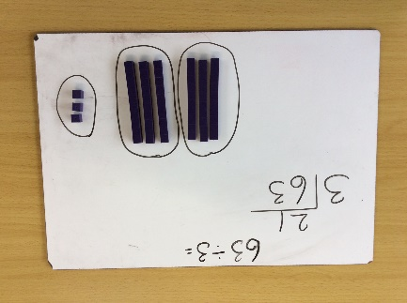  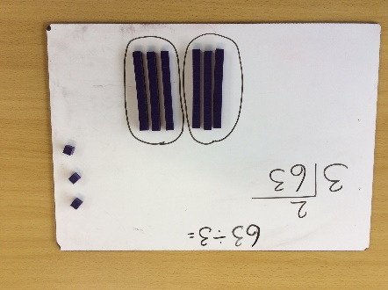  Group the ones according to the divisor and write the number of groups above the line in the ones coloumn
D13. Pupils will use practical resources to support the short division method and will be encouraged to use multiples of the divisor to assist (HTO ÷ O). | 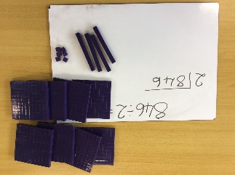  Create the dividend using Base 10 resources  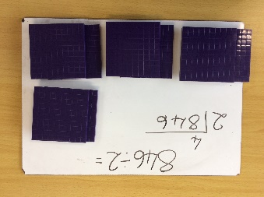  Group the hundreds according to the divisor and write the number of groups above the line in the hundreds column  Group the tens according to the divisor and write the number of groups above the line in the tens column  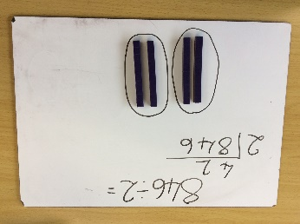  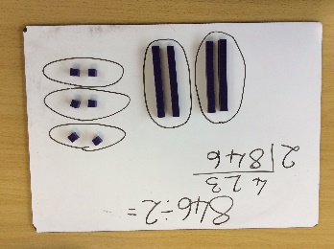  Group the ones according to the divisor and write the number of groups above the line in the ones coloumn
D14. Pupils will use practical resources to support solving division number sentences with remainders (TO ÷ O). | 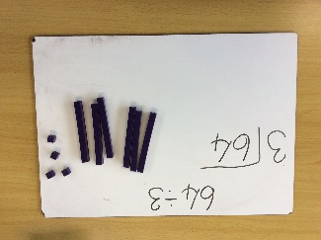  Create the dividend using Base 10 resources  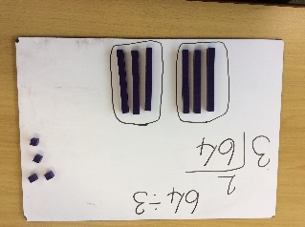  Group the tens according to the divisor and write the number of groups above the line in the tens column  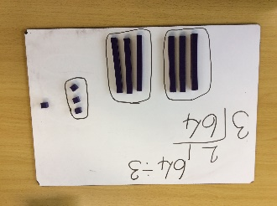  Group the ones according to the divisor and write the number of groups above the line in the ones column  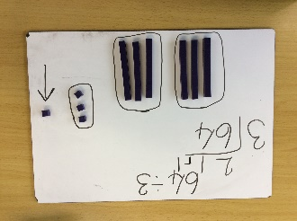  Any ones that cannot be grouped are the remainder. Write this at the end as ‘r1’.
D15. Pupils will use practical resources to support solving division number sentences with remainders (HTO ÷ O). | 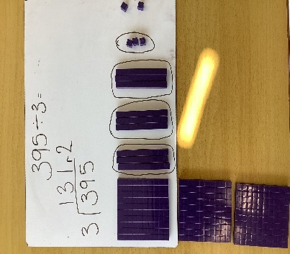
D16. Pupils will use practical resources to support the short division method where exchange across place value columns occurs (HTO ÷ 0). | 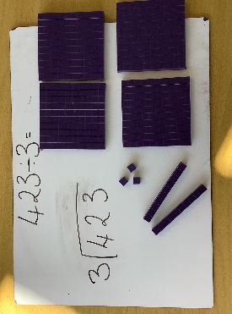  Create the dividend using Base 10 resources  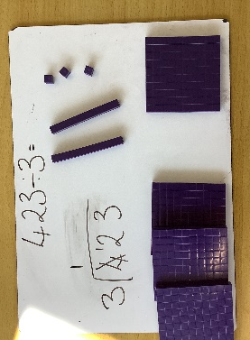  Group the hundreds according to the divisor and write the number of groups above the line in the hundreds column  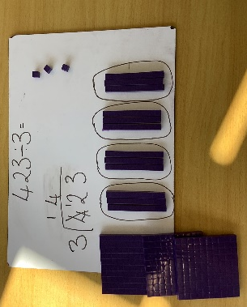  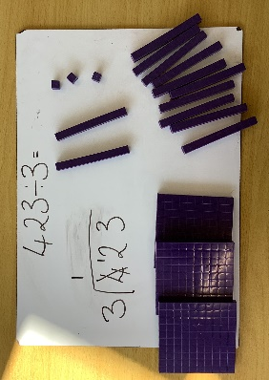  Exchange the left over 100s for tens and represent this beneath the line in the tens column  Group the tens according to the divisor and write the number of groups above the line in the tens column  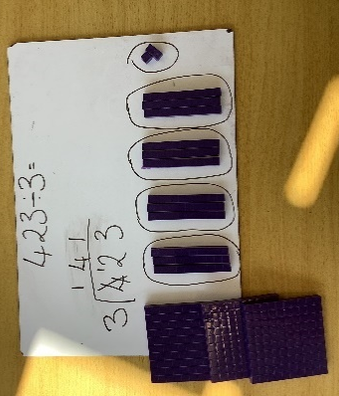  Group the ones according to the divisor and write the number of groups above the line in the ones coloumn
D17. Pupils will use long division method where exchange across the place value column occurs. Pupils will be encouraged to use multiples of the divisor to assist (HTO ÷ O) | 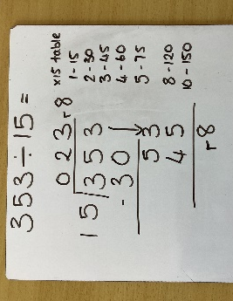
D18. Find the effect of dividing a 1 or 2-digit number by 10 and 100; | 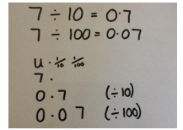
Mental Strategies
- Count forwards and backwards in multiples of 2s, 5s and 10s.
- To know that division is the inverse of multiplication
- Recall division facts for the 2, 5 and 10 times tables
- Recall halves for even numbers up to and including 20
- Know the division facts from the 3, 4 and 8 times tables
- Use knowledge of place value to calculate division (e.g. 14 ÷ 2 = 7, 140 ÷ 2 = 70, 1400 ÷ 2 = 700
- Multiply and divide numbers mentally drawing upon known facts
Recommended Maths Websites:

BBC KS1 Maths:
KS1 Maths - England - BBC Bitesize

BBC KS2 Maths:
KS2 Maths - BBC Bitesize

Singaport Maths
Thinking Blocks | Model and Solve Math Word Problems (mathplayground.com)
(also available as free iPad apps)

General Curriculum Games Sites – with Maths
Crickweb | Welcome to Crickweb

Key Stage 1 Maths - Topmarks Search

Problem Solving and Reasoning

Nrich KS1
http://nrich.maths.org/9077

Nrich KS2
http://nrich.maths.org/9084

L6 Maths – KS3 Videos
Key Stage 3 (mathswebsite.com)

