My Duke of Edinburgh expedition by Sophie Bennett

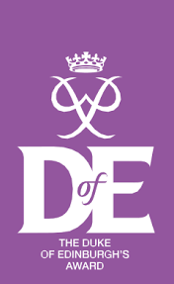

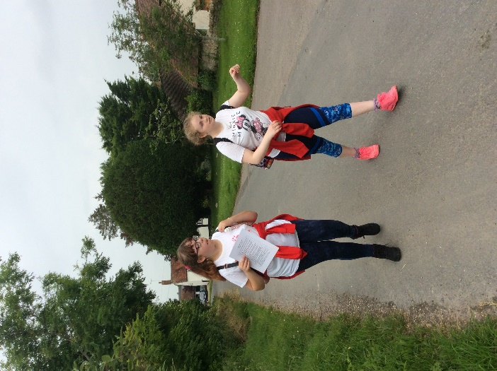
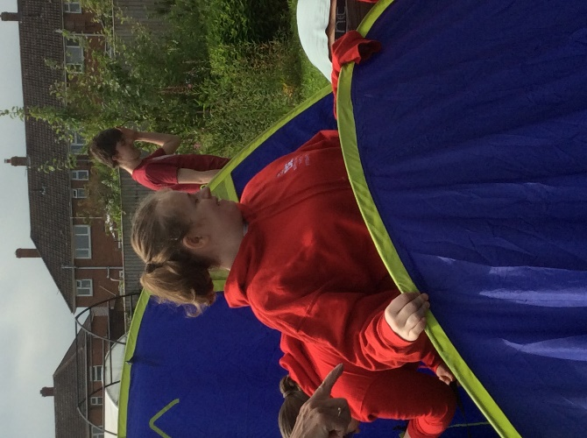
Putting up the tents with my team.
Off we went on our walk. I found the hill really tricky but I was very proud of myself when I reached the top.

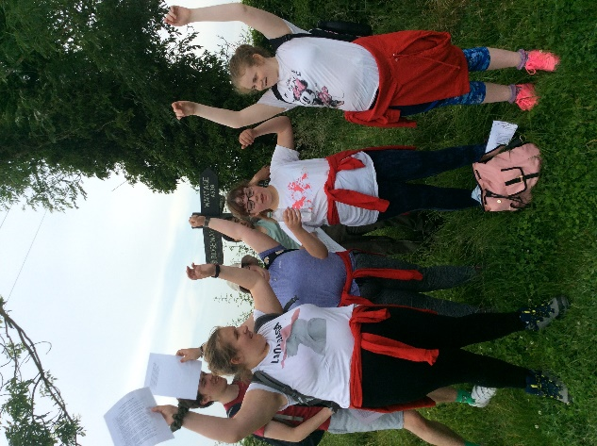

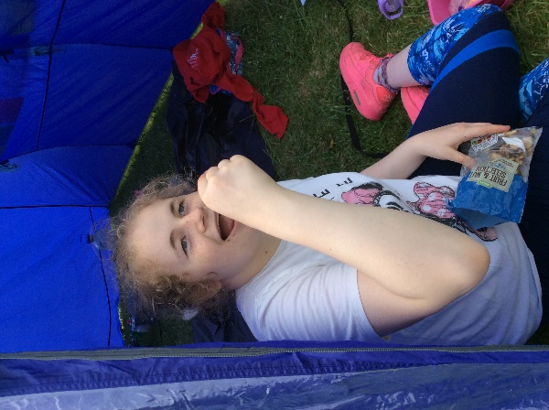
I needed plenty of snacks to keep my energy up!

We did it!!!

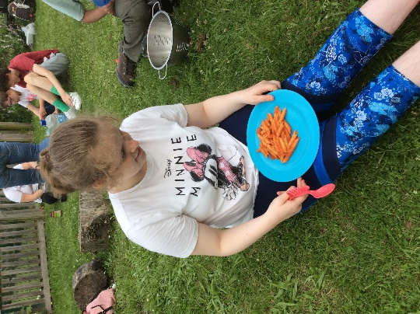
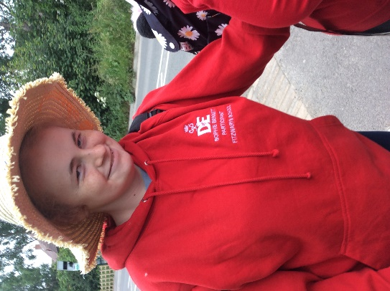

Day 2, time for another walk using our maps.
Time for dinner! We made pasta in sauce on the camping stoves. It was yummy.

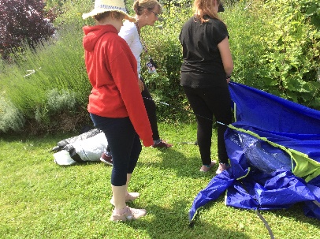
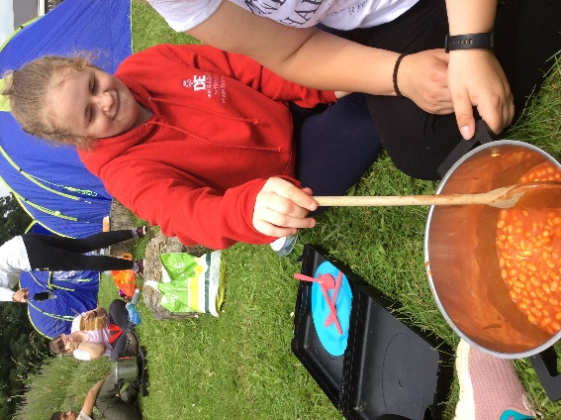

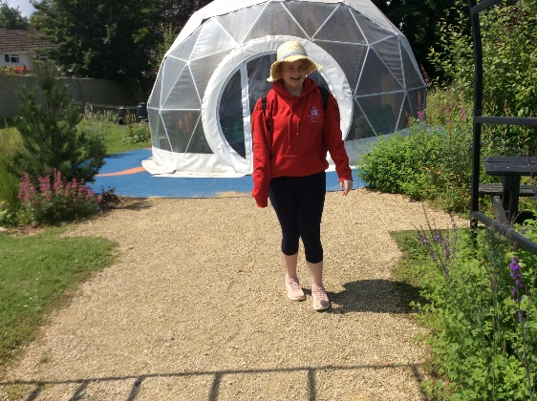
Back to camp to make lunch. We had sausage and beans
I helped to pack away the tent and camping equipment.

My D of E expedition has come to an end. It was very hard but I did every challenge with a smile on my face!

