Share a story, anytime, anywhere!
Thursday 4th March
This year we would like to celebrate our love of reading everywhere, every day and are inviting everyone to come to school dressed in their pyjamas, onesies, dressing gowns or as a character from their favourite book.

In this pack, we have put together a range of exciting activity ideas for you to complete on World Book Day 2021. Don’t forget to take LOTS of pictures of your class having fun!
World Book Day pack for teachers 2021

Our exciting line-up includes:
For 7+ Tuesday 2nd March, 10:30am - David Walliams VIP Book Club.
For 7+, Wednesday 3rd March, 10.30am – Books that Make you LOL!
Starring: Humza Arshad, Alex Bellos & Ben Lyttleton (Football School), Jonny Duddle and Zanib Mian
Hosted by Kenny Baraka, motivational speaker
For 4+, Thursday 4th March, 10.30am – World Book Day special – Bringing Reading to Life
Starring: Joseph Coelho & Fiona Lumbers, Tom Fletcher and Lydia Monks and special guest Rob Biddulph
Hosted by Nigel Clarke, TV presenter
For 9+, Friday 5th March, 10.30am – Books and the Real World
Starring: Sita Brahmachari, Jess French and Katherine Rundell
Hosted by Jessie Cave, actor and podcaster

Happy World Book Day!
We are delighted to celebrate this year with you, with some extra special FREE digital events. And what an amazing line-up it is too. You can watch them LIVE right here, Events (worldbookday.com), or our YouTube channel – and they’ll remain on YouTube for you to watch back time and time again!

Each event will last approximately 30 minutes.

Look forward to a star-studded cast of authors, illustrators, and hosts – all here to help you celebrate the most exciting booky day of the year!

SHARE A STORY LIVE EVENTS

Secondary Five-Sentence story
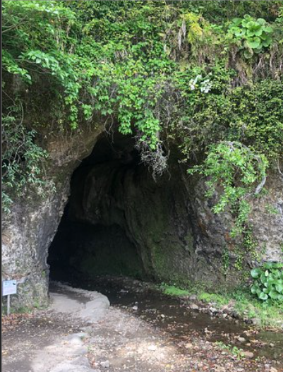
Starter activity: Based the picture, give the pupils a few minutes to discuss the picture as they can see. The class teacher or TA should write down the pupils’ thoughts and ideas to create a vocabulary list.

Main activity: Then ask the pupils to use their senses to imagine that they are inside the picture. Challenge them to use the image to think about what they might experience with all five sense, e.g., I can see, I can feel, I can taste, I can hear, I can smell. Add these ideas to your list.
Using the story starters below, create a story using five sentences only.

Opening  On a dark and stormy night…  At a minute past midnight…  At the top of a very tall mountain…  Somewhere in deepest space… | Build up  One day…  One cold morning…  The very next morning…  After Breakfast… | Problem  The trouble was…  Unfortunately…  In the blink of an eye…  Unexpectedly… | Resolution  Luckily…  With all their strength…  Without hesitating…  Thankfully… | Ending  Finally…  At long last…  After a while…  Eventually…

Five-sentence story example,
The Flooded Ogre
At the top of a very tall mountain, there lived an ogre named Chuck. One cold morning, Chuck awoke to find his cave filled with water. Unfortunately, it had rained all night and the rain had flooded his home. Without hesitating, Chuck grabbed a bucket from under the sink and began emptying the water out into the valley below. Eventually, Chuck managed to move all the water out of his cave and in no time his home was warm and dry.

Primary five-sentence story

Starter activity: Based the picture, give the pupils a few minutes to discuss as many objects from the picture as they can see. The class teacher or TA should write down the pupils’ thoughts and ideas to create a vocabulary list.

Main activity: create a five-sentence story using the example story starters below:
Opening  One day…  Once upon a time…  One morning...  One evening… | Build up  After that…  In the middle of the…  In the distance…  Nearby… | Problem  Unfortunately…  However…  Despite…  All of a sudden… | Resolution  Luckily…  Then…  A moment later…  Suddenly… | Ending  Eventually…  Finally…  In the end…  At last…

For example,
Once upon a time, there was a treasure hunter called Jack. One day, Jack decided he wanted to hunt for buried treasure on the Island of Wonder. Unfortunately, he got lost. Luckily, his friend Jacob gave him a secret map. Eventually, Jack arrived at the Island of Wonder and found diamonds of every colour.

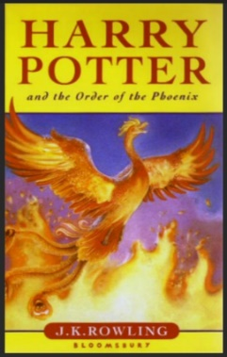

Reading for Pleasure

Share your favourite story
Guess the adult’s favourite book challenge -
behind each book an adult from school hiding. Your challenge is to guess which book belongs to which adult.

Reading and sharing stories is for everyone, every day.

Let’s celebrate


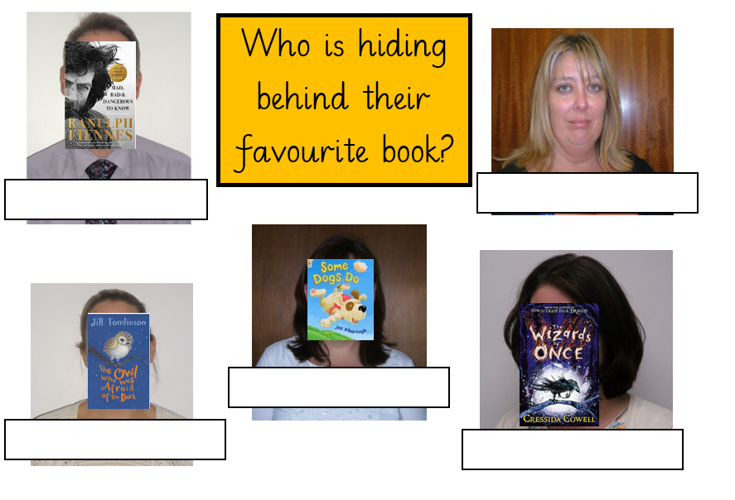

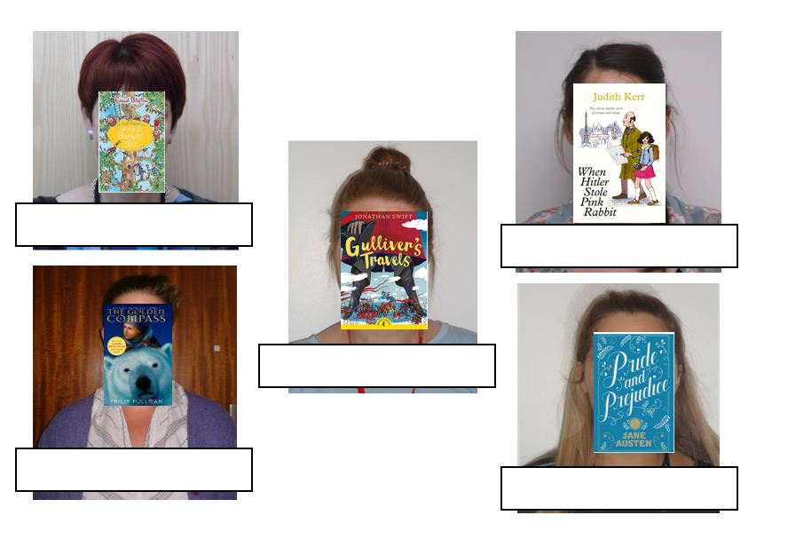

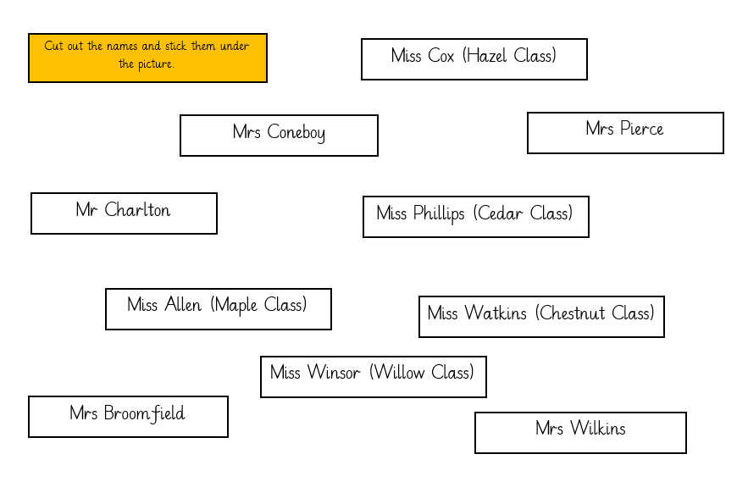

We would love to hear what everyone’s favourite books are! Please record a short video of the pupils and staff in each class saying what their favourite book is (“My favourite book is…”). If they can have a copy of the book with them, even better! If not, you might like to film in the library in front of one of our lovely new murals.

Have fun and we can’t wait to hear the name of everyone’s favourite book!

The aim is to put all of the clips together to make a video that we can put onto the school website and Facebook page.
- Please can each pupil / adult be filmed separately (one video for each person speaking) so that it is easier to clip together.
- Please upload to the World Book Day 2021 folder in the English folder (curriculum resources) by the end of Monday 8th March.
- If you have any pupils who can’t be on the website or social media, please don’t upload their video.
- The whackier the better! The pupils could be jumping, hanging upside down, running past the camera, be creative! We want to show off out love of reading here at Fitzwaryn.

My Favourite Book is…

