Design a Pictish Symbol Stone
L.I. to understand who the Picts were
Pictish Symbol Stones are standing stones that have been engraved with symbols. Many of these stones can still be seen throughout Scotland. Although we do not know for sure what the symbols mean, it is possible that they represent family names or status.
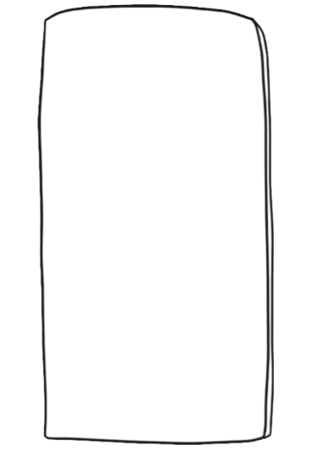
Design you own Pictish Symbol stone, thinking about the meaning of your symbols.

