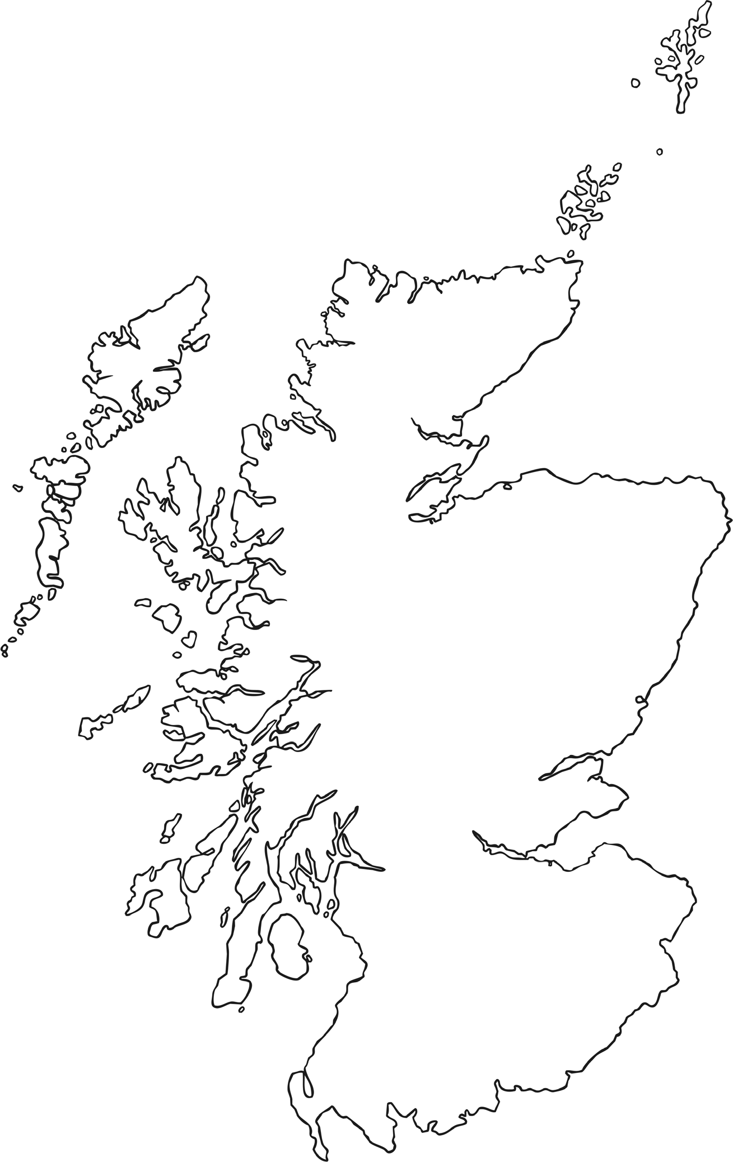
Extension: Now use the map to locate Scottish towns and add them too.
Map of Scotland
L.I. I can locate Scottish cities on a map of Scotland.
Add the following Scottish cities to the map. Use a map to help you.
Glasgow
Edinburgh
Perth
Dundee
Stirling
Aberdeen
Inverness

