L.I. to know different Scottish mythical creatures

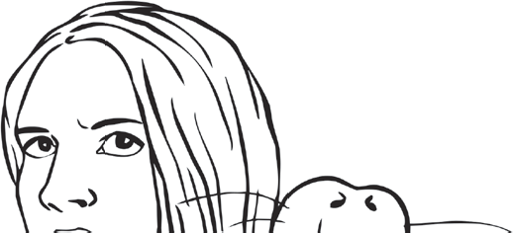
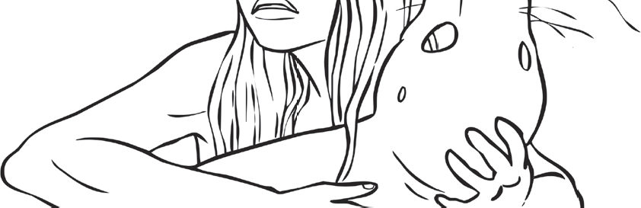
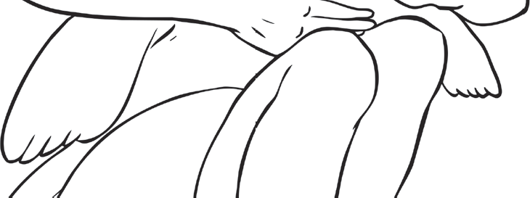
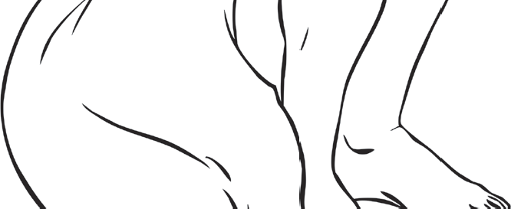
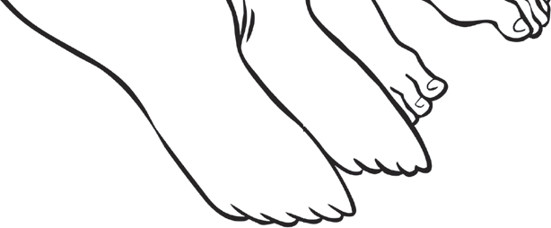
Myth File - Selkies
Describe these mythical creatures.

Where can these mythical creatures be seen?

What does legend say about these mythical creatures

