L.I. to know different mythical creatures





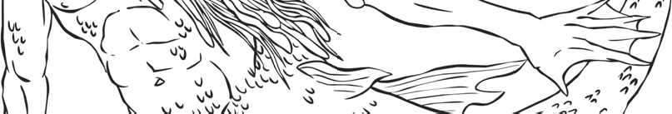

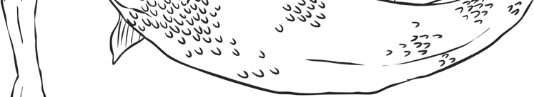

Myth File – The blue Men of Minch
Describe these mythical creatures.

Where can these mythical creatures be seen?

What does legend say about these mythical creatures

