LI: to write a correctly punctuated sentence
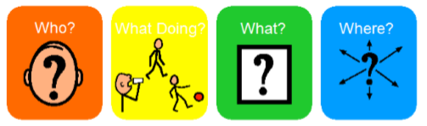

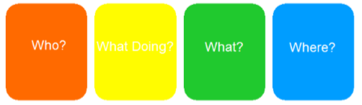

Word Bank
Who?
   |  | 
What doing?
   |  | 
What?
   | 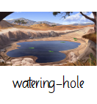 | 
Where?
   |  | 

