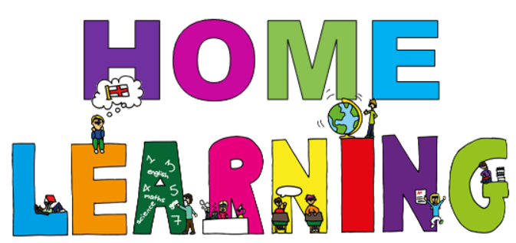

Week beginning 1st March 2021

Dear Willow & Ash parent(s)/carers,
We would like to set the children activities based on our topic this term which is ‘Africa’. Below are activities which can be completed at home. We have suggested subjects to be completed on certain days, which correspond with what we are completing at school. This said, if you would like to change the order of the lessons then you are welcome to do so. If you have any trouble accessing resources or if you have any questions, please do not hesitate to get in contact with us at school. Some of the activities will require access to a computer. If your child is unable to access a computer, please let us know and we can discuss how we can help.
Face to face Zoom sessions –
We would like to invite you to join us for a zoom session each week – details will be sent via email before each session, including login details and passwords.
Monday morning at 10:00 – 10:20 –Social session; pupils will have an opportunity to see their friends and share their weekend news.
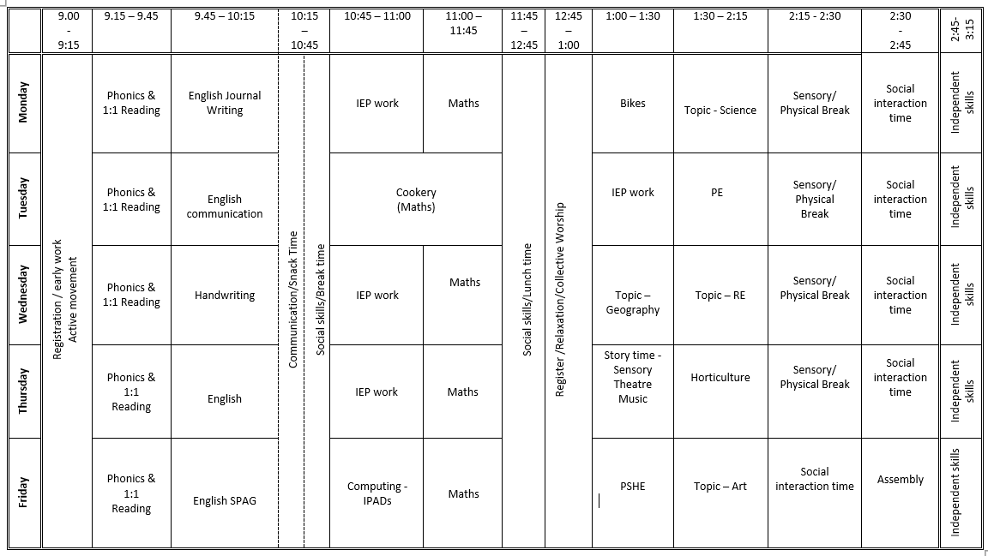
Timetable - Here is a copy of our timetable at school:

Monday home learning activities -
Subject | Activities that can be completed at home.
Active movement | Just Dance 2018 • Waka Waka (Football Version) - YouTube  Just Dance 2015 "Happy" - YouTube
Phonics | (If you need support with the pronunciation of the sounds you can listen to them on the following link Phonics Phase 3 Sounds for Pronunciation - YouTube)  Login to phonicsplay.co.uk - PhonicsPlay Username: jan21 Password: home  Starter: Play phonics song – Phonics Song 2 (new version) - YouTube  Pupils to write the alphabet.  Introduce: We are learning a new phoneme qu and how to read and write it.  Revisit Practise: s, a, t, p, i, n, m, d, g, o, c, k, ck, e, u, r, h, b, f, f, l, ll, ss, j, v, w, x, y, z  Sing the alphabet song – all pupils point to letters as you sing.  Flashcards: Speed Trial, Flashcards: Time Challenge on phonicsplay.co.uk.  Teach: Introduce the phoneme qu with actions.  Practise: Play Quick write. Words: quiz, quit, quick, liquid, quack, yap, buzz, zip, yes, yell.  Apply Play Yes/No questions – get pupils to use thumbs up and thumbs down to show whether the answer is yes or no.  Can a duck quack?  Is a zebra a pet?  Can a hen peck?  Is a lemon red?  Can a fox get wet?  Can a web buzz?
Reading | Oxford Owl ebook Library – see separate leaflet for details –  https://www.oxfordowl.co.uk/login?active-tab=students  Ash & Willow –  Username: fitzwarynashwillow  Password: ashwillow  - Read a level appropriate book with your child.  - Share your favourite picture/chapter novel with them.
English  Learning intention:  - I can share my weekend news. | Weekend News Journal Writing.  You are welcome to join us on zoom at 10am for our weekly news social session. Details will be emailed prior to the session. Encourage your child to share their weekend news with the other pupils; encourage your child to ‘show and tell’ the other children something they have completed/made during the week, a picture they have painted in Art or a photo of them that you have taken of them having fun outside. Please can we ask that your mic is muted when your child is not speaking to the group. Then ask your child to draw a picture of what they did at the weekend.  Extension: Ask your child to write a simple sentence or a few key words to accompany their picture. This can be done by copying a sentence you have written for them after they have told you what to write or overwriting a sentence that has been written for them in a felt tip pen.
Individual Education Plan targeted work | Choose an activity to complete from the pupils’ individual education plan.
Maths  Learning intention:  - I can find half of number using objects.  Success criteria:  -pupils will use mathematical language such as fraction, objects, quantity, half, equal.  -pupils will share objects equally between 2. | You will need: cake, candles, blunt knife, plates, smarties/sweets, plate/pots  Fractions! | Mini Math Movies | Scratch Garden - YouTube  Main teaching: Bring in a big cake, explain to the pupils that you have made this cake for an 8yr old so there needs to be 8 candles. Count out 8 candles and position them so there are 2 on each quarter. Ask the pupils ‘how could we cut the cake in half so there are 2 equal pieces?’ ask the pupils ‘how many candles would be on each half?’ model cutting the cake in half and counting how many candles are on each half.  Activity: pupils to work in small groups or with a partner and an adult. Adult to give the pupils an even number of sweets (2, 4, 6, 8, 10, 12) and ask them to share the sweets in half, complete this practically by sharing the given number of sweets onto 2 plates/pots. Encourage the pupils to share one at a time and say ‘one for you and one for me, one for you and one for me’ etc.
Bikes/Physical movement | Go outside –  Ride a bike or walk around your local nature reserve or country park or play a game in your garden e.g., bat and ball, football, catch.
Topic – Science  Learning intention:  - I can identify and name African animals from the Savannah. | You will need:  African animal pictures  African animal PowerPoint  African animals writing frame  African Animals sym writing aid  Starter: Listen to and sing along to Animals in Action | Movement Song for Kids | Jack Hartmann - YouTube  Main Teaching: Explain that as Africa is so large it has many different habitats, so we are just going to focus on the Savannah. Watch first part of the ‘Lion King’ DVD Lion King Opening Scene - Circle of Life 1440p 60 fps - YouTube  Discuss climate.  Listen to and watch Animals of Africa - 10 WILD ANIMALS from the African savanna - YouTube  Look through the PowerPoint images of different African animals. Discuss what they eat, physical features etc.  Activities: Look at pictures of African animals. Pupils to choose their favourite African animal, draw a picture and write some sentences to accompany their picture (animal facts).

Tuesday home learning activities -
Subject | Activities that can be completed at home.
Active movement | Just Dance 2015 - Happy Pharrell Williams Gameplay - 5 Stars Rating [ HD ] - YouTube  You tube – Joe Wickes PE session
Phonics | Starter: Listen to alphabet song – Jolly Phonics A-Z - YouTube  Pupils to write the alphabet on their whiteboards.  Introduce: We are learning a new phoneme or and how to read and write it.  Revisit: Practise s, a, t, p, i, n, m, d, g, o, c, k, ck, e, u, r, h, b, f, f, l, ll, ss, j, v, w, x, y, z, qu, sh, ch, th, ng, ai, ee, igh, oa, oo, ar  Play: Quickwrite Sing the alphabet song – all pupils point to letters as you sing.  Flashcards: Speed Trial, Flashcards: Time Challenge (phonicsplay.co.uk)  Teach Introduce the phoneme or with actions.  Practise: Play Quickwrite Words: for, fork, sort, born, worn, torn, hard, park, cook, boot. Rocket Rescue, Space Race.  Apply: Play Yes/No game – get pupils to use thumbs up and thumbs down to show whether the answer is yes or no.  Is a fork sharp?  Will a fish forget things?  Will a fort be big?  Is a boot short?  Is a tail for wagging?  Can a coat get torn on a thorn?  Is a torch bright?  Is corn red?
Reading | Oxford Owl ebook Library – see separate leaflet for details –  https://www.oxfordowl.co.uk/login?active-tab=students  Ash & Willow –  Username: fitzwarynashwillow  Password: ashwillow  - Read a level appropriate book with your child.  - Share your favourite picture/chapter novel with them.
English – communication  Learning intention:  - I can communicate effectively with others. | Starter: Listen and sing along to CBeebies: Something Special - Hello Song - YouTube  Main activities:  Listening skills: Play fruit salad – pupils to swop places if they are wearing…, if they have…, if they like…,  Giving instructions: practical activity – make and do using lego bricks. Give the pupils instructions using expressive language such as next to, on top of, in the middle etc.  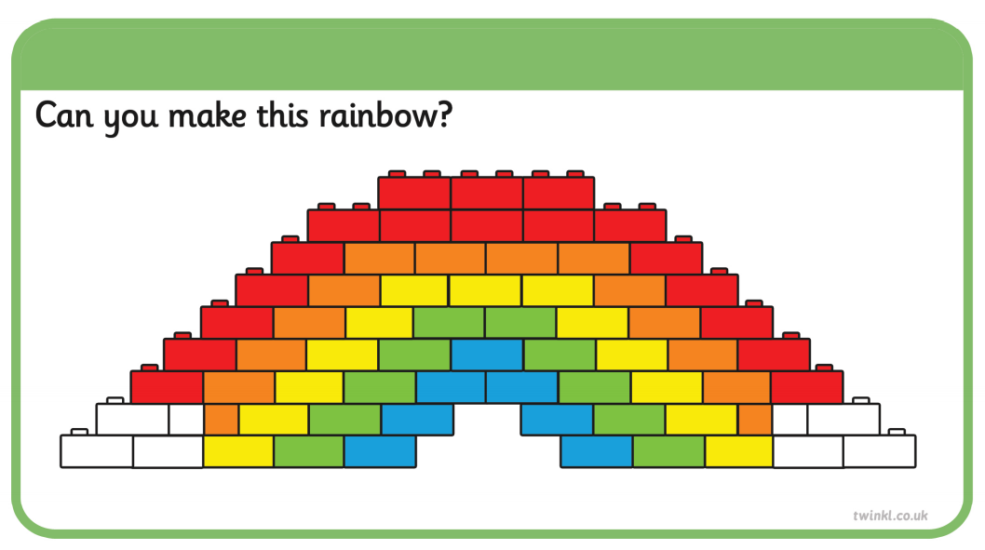
Cooking/Maths  Learning intention:  To measure out ingredients correctly. | Encourage your child to help you prepare a meal this week. If possible, concentrate on your child helping to measure out the quantities. It’s good to model the mathematical vocabulary when measuring, for example grammes, litres, tablespoon etc.  At school we are making African banana bread.
Individual Education Plan targeted work | Choose an activity to complete from your child’s individual education plan.
PE  Learning intention:  - To move with increased agility | Starter: Pupils to get dressed for PE independently.  Outside: Go for a walk, run, bike ride, scooter ride.  Inside: Inside: Warm up (5 mins): Warm up (5 mins): Captain’s coming. Adult give different commands – port, starboard, scrub the decks, climb the rigging, captains coming.  Main teaching: Ball skills – reaction times. Standing, hold a ball out to your side at arms length then drop it. Can the pupil catch the ball before it bounces? Or let it bounce once and then catch it? Play throw and catch. Throw the ball and let it bounce, can the pupil catch it after 1 bounce or 2? Roll the ball along the floor , can the pupil retrieve the ball before it gets to a set point?  Cool down (15 mins) cosmic yoga  https://www.youtube.com/watch?v=dnwHDN6Dw7Q&ab_channel=CosmicKidsYoga  sit and stretch yoga

Wednesday home learning activities -
Subject | Activities that can be completed at home.
Active movement | Just Dance Kids 2 Jump Up - YouTube  Just Dance Kids 2014 A Pirate You Shall Be - YouTube
Phonics | Starter: Listen to alphabet song – The Alphabet Song | Phonics Song for Kids | Kindergarten Alphabet song | Jack Hartmann - YouTube  Revisit: writing and spelling phase 3 tricky words Phase 3 Tricky Words Song Say Hello To - YouTube  Play: Tricky word trucks Tricky Word Trucks (phonicsplay.co.uk) pupils to read the tricky words.  Teach: High frequency/sight words Sight Word Rap 1 | Sight Words | High Frequency Words | Jump Out Words | Jack Hartmann - YouTube  Pupils to listen to and sing along.  Apply: Pupils to write the words from the sight rap on their whiteboards.
Reading | Oxford Owl ebook Library – see separate leaflet for details –  https://www.oxfordowl.co.uk/login?active-tab=students  Ash & Willow –  Username: fitzwarynashwillow  Password: ashwillow  - Read a level appropriate book with your child.  - Share your favourite picture/chapter novel with them.
English & handwriting  Learning intention:  - I can practise my handwriting. | (support/information for parents Nelson guide for parents | Oxford Owl)  Starter: 'I like to' playdough action song - YouTube – warm up ready for handwriting using play-dough.  Main teaching: Handwriting for kids | learn to write lowercase c, a, d, o, g q with the Handwriting Heroes - YouTube  Teach pupils how to correctly form the ‘cannon pop’ letters. Pupils to listen to and write along to the video above.  Activity: Ask pupils to practise writing the letters shown in the video in their exercise books. They can copy the adult’s example (use felt tip pen for pupils to trace over) and then continue to write the letter on their own.
IEP Work | Choose an activity to complete from the pupils’ individual education plan.
Maths  Learning intention:  - I can find half of a number using objects.  Success criteria:  - pupils will use and understand mathematical language such as fractions, equal, share, half.  -pupils will find half of a number using objects. | You will need: Plates/pots, sweets/cubes, even numbers only numbered cards  Listen to Give Me Half! by Stuart J. Murphy - YouTube  Adult to choose an even number from the number cards and ask the pupils to make a tower of that many cubes (could use lego bricks). Ask the pupils to break their tower in half. Ask ‘How could they check they have managed to break them exactly in half? Explain that they have to make sure each side has the same number of cubes.  Demonstrate breaking a tower of 10 in half but count 4 on one side and 6 on the other. Ask ‘have I managed to split my tower in half exactly? No, as one side has more that the other. They’re not equal.’  Ask the pupils to re-check their towers and one they are happy they have broken them exactly in half they say their sentence ‘half of X is X’  Repeat this activity by choosing a new number card.  Activity: Give pupils 2 plates/pits. Their job is to make sure that each plate/pot has the same number of cubes. Place number cards face down in a pile (even numbers only) challenge the pupils to pick up a number card and count out that number of cubes. Then work out half of that number by placing the cubes evenly on each plate/pot. Pupils then say their sentence ‘half of X is X’
Topic – Geography  Learning intention:  - I can recognise local features on a simple map. | You will need:  Resources  Google Earth  Blank Maps  Pictures of features  New words  Physical  Human  Local  Features  Map  Starter: Listen and sing along to Brain Breaks | Around The World | Brain Breaks Song | Jack Hartmann - YouTube  Main: Using Google Earth in Satellite view show the pupils the local area. Firstly, ask the pupils to locate the school. Use the map to make pupils familiar with the area by finding the church, park, post office, shops, tennis courts, green. Discuss which features are physical (the green, river) and human (buildings, roads). Go back to satellite view of the local area and switch to the road map. Tell the pupils that this map shows the same area but with less detail. Explain to the class that people use maps to help them get to where they need to go. Teacher to model sticking features on a blank map of Wantage.  Activity: ‘making a map’  Pupils to have an A3 blank map of Wantage. Pupils to stick on the human and physical features in the correct places. Encourage them to use the teachers map for Support.  Plenary- Group Activity  Invite pupils to share and discuss their maps. Do the other pupils agree with where they have located the features?
Topic – RE  Learning intention:  I can explain the importance of Jesus’ words at The Last Supper. | You will need:  Friendship flower activity sheet  Art & craft resources  Main Teaching:  The Last Supper: Watch The Last Supper - Bible For Kids - YouTube  Together recall the main events of the story.  Friendship Flowers: People often recognise the need to take care of themselves first before they can care or love others. However, Jesus’ example shows there is a need to also do things for others ahead of yourself. Pupils to make friendship flowers where they write in the petals the things they can do for their friend – use friendship flower activity sheet.

Thursday home learning activities -
Subject | Activities that can be completed at home.  ‘World Book Day’ Activity pack can be found on the school’s website.
Active movement | Just Dance 2018 • Waka Waka (Football Version) - YouTube  Banana Banana Meatball - Blazer Fresh | GoNoodle - YouTube
Phonics | Starter: Listen to alphabet song – Alphablocks - Jolly phonics " ABCD " - YouTube  Introduce: We are learning a new phoneme air and how to read and write it.  Revisit: Practise s, a, t, p, i, n, m, d, g, o, c, k, ck, e, u, r, h, b, f, f, l, ll, ss, j, v, w, x, y, z, qu, sh, ch, th, ng, ai, ee, igh, oa, oo, ar, or, ur, ow, oi, ear Play Quickwrite Graphemes.  Look at an alphabet chart and practise the names of letters that pupils were finding tricky.  Flashcards: Speed Trial.  Teach: Teach the new phoneme air with actions. Pupils write air in the air and on whiteboards.  Practise: Play Buried Treasure. Words: air, hair, pair, hear, fear, year, gair, sair, kair, kear, zeard Buried Treasure, Dragon's Den, Picnic on Pluto.
Reading | Oxford Owl ebook Library – see separate leaflet for details –  https://www.oxfordowl.co.uk/login?active-tab=students  Ash & Willow –  Username: fitzwarynashwillow  Password: ashwillow  - Read a level appropriate book with your child.  - Share your favourite picture/chapter novel with them.
English  Learning Intention:  -I can write a Five-Sentence story. | You will need:  Watch We are going on a Lion Hunt. Encourage the pupils to join in. Pupils to decide on appropriate actions to accompany the story.  Activity: pupils to order five pictures from the story from beginning, middle, to end. Then ask the pupils to write a simple sentence, caption, or key words to accompany their picture.  Challenge: encourage the pupils to use adjectives to add detail to their writing, e.g., long, wavy grass, think, ozzy mud.
IEP work | Choose an activity to complete from the pupils’ individual education plan.
Maths  Learning intention:  I can use a Caroll Diagram | Starter: Listen and sing along to Count Together by 10's | Counting Workout for Kids | Jack Hartmann Counting by 10s - YouTube  Explain that this week we will be looking at Carroll Diagrams, they are similar to Venn Diagrams, except they are presented in a table, so there are more than two options to sort the information. Using the categories 2 legs/4 legs and spots/no spots T to model sorting animals on large Carroll diagram. Work through as whole class.  EXT: children to complete their own African animal Carroll diagrams.  u will need:
Music  Learning intention: To copy and create a simple rhythm  Success criteria:  I can hear a rhythm  I understand that anything can be used to create a rhythm | Starter: https://www.youtube.com/watch?v=aXZWgOf2lSA  ”bim bum” a clapping game which gets progressively faster.  Watch:  https://www.youtube.com/watch?v=lVPLIuBy9CY  Foli there is no movement without rhythm  Discuss: what did they use to create rhythms? What could we use in the classroom that could be used to create a rhythm? See what suggestions they make and then see if they can each create a simple rhythm. Demonstrate it to each other
Horticulture  Learning intention:  To plant seeds and explore the area for seasonal changes  Success criteria: I can handle and plant seeds  I understand what conditions seeds need to grow  I can find signs of growth/change | Starter: Listen and sing along to In the Garden Song [HD] - YouTube  Main activity: explore the area looking for signs of growth – buds, bulbs, new growth. They can also look for plants that have died over the winter, dead leaves, etc. Talk about weather changes and what plants need to grow (sun, rain) and whether it is warm enough for the plants to grow and flower.  Plant seeds in the polytunnel. Read the planting instructions to the pupils and demonstrate how to plant seeds, then let them all plant some seeds. This week plant lettuce and tomatoes. Can plant tomato seeds but can also cut cherry tomato in half, show the seeds in the middle and compare to seeds in packet and then plant that to see which grows the best. This also helps the pupils understand about the life cycle of vegetables. Write labels and discuss when we should first see signs of growth. Write on the planting plan which seeds were planted and what date.

Friday home learning activities -
Subject | Activities that can be completed at home.
Active movement | Just Dance 2018 • Waka Waka (Football Version) - YouTube  Banana Banana Meatball - Blazer Fresh | GoNoodle - YouTube
Phonics & Reading | Starter: Listen to alphabet song – CBeebies | Mr Tumble's Alphabet Song - YouTube  Pupils to write the alphabet on their whiteboards.  Look at an alphabet chart and practise the names of letters that pupils were finding tricky.  Revisit: New phoneme air and how to read and write it.  Flashcards: Speed Trial.  Teach: Recap the new phoneme air with actions. Pupils write air in the air and on whiteboards.  Practise: Quick write words – chair, pair, fair, hair, fairy, chair.  Apply: Mr Thorne Does Phonics - Episode AIR - YouTube  Reading  Oxford Owl ebook Library –  https://www.oxfordowl.co.uk/login?active-tab=students  Ash & Willow –  Username: fitzwarynashwillow  Password: ashwillow  Read a level appropriate book with each pupil.  Share your favourite picture/chapter novel with them.
English spelling, punctuation and grammar & handwriting  Learning Intention:  To write a correctly punctuated sentence | Starter:  Warm up hands ready for writing:  - Shoulder shrugs  - Crocodile snaps  - Butterflies  - Finger press ups  - Pencil Twirls  Main Teaching: Review last week’s work.  Which animal did we look at? What was it doing?  Teacher to share a different image of an African animal. Ask pupils who, what doing, were? Teacher to use information to write a simple sentence with mistakes. Pupils to check for capital letters, full stops and fingers spaces.  Activity: Pupils to use the words on their worksheet to create their own sentence?  Extension: Pupils to write their sentence underneath.
Computing  Learning intention:  Learning intention:  I can use the keyboard to type letters. | Starter: Use https://www.youtube.com/watch?v=JEIHogpVJ1k to introduce each lesson.  Main teaching: Explain that to help us be better at word processing, we need to be able to type quickly. Therefore, we need to know where all the letter keys are. Recap using two hands to help us. Model playing the following game:  https://toybox.tools.bbc.co.uk/activities/id/activity-dance-mat-typing/exitGameUrl/http%3A%2F%2Fwww.bbc.co.uk%2Fguides%2Fz3c6tfr All children to have a go on their own laptops.
Maths  Learning intention:  I can use a Caroll Diagram | Starter: Listen and sing along to Count Together by 10's | Counting Workout for Kids | Jack Hartmann Counting by 10s - YouTube  Repeat activity from previous day to check understanding.  EXT: Carroll Diagram sweets sheet
PSHE & Communication  Learning intention:  Communicate feelings/Show empathy towards others | You will need: Emotions/feelings cards.  Starter: https://www.youtube.com/watch?v=DNZUKm0ApEM to introduce each lesson.  Watch https://www.bbc.co.uk/bitesize/clips/zxgygk7. Discuss what makes a good friend. Complete friendly/unfriendly sorting activity. Discuss how people feel when we use friendly/unfriendly behaviours.
Art  Learning intention: Make a collage using primary colours | You will need:  Pre-cut squares and rectangles in primary colours  Black card  Rulers  Black Pens  Look at the life and work of Mark Rothko . See PowerPoint for more information.

Relaxation/mindfulness:
Guided Meditation for Children | Your Secret Treehouse | Relaxation for Kids - YouTube
Relax Music for Stress Relief, Study Music, Sleep Music, Meditation Music 💜 528Hz - YouTube
Guided Meditation for Kids | Spaceship to the Moon | Relaxation for Children - YouTube
Other helpful websites:
Home - GoNoodle
ictgames
PhonicsPlay
Welcome | Numeracy Warm Up
- username: fitzwaryn
- password: story
HelpKidzLearn
Writing warmups - dough disco for children - YouTube
Phonics song - Phonics Song 2 (new version) - YouTube
Jolly Phonics A-Z - YouTube
Counting song - Let's Get Fit | Count to 100 | Count to 100 Song | Counting to 100 | Jack Hartmann - YouTube
Space/planets song - The Solar System Song - YouTube

Stay safe and well!
All the best,

Ash and Willow Class teachers

