Maple and Beech Home Learning Curriculum for Term 4 2021
On the Farm
Week Commencing 1st March
Here are your Wider Curriculum activities for Week two of this term. Your English and Maths packs should be coming home to you once again, some of the resources for the following activities are also included in your home learning packs.
We highly encourage you to take pictures of the work you are completing. You can email these to school, and we can print them and send them back for you to keep.

Where appropriate do continue to use the below timetable to help you provide some structure for the children at home. It can be adapted to fit your family circumstances, it is not set in stone.
8-9am  Get up, dressed and ready for learning including a healthy breakfast. | 9-9.30am  Active Movement:  Cosmic Yoga, take a walk or bike ride, complete a PE challenge. | 9.30-10.15am  Focused activity 1: Story Time – Writing/reading, fine motor skills and mark making or activities from you English packs.
10.15-11am  Break and free time including a healthy snack. Try to get a bit of fresh air! | 11-11.45am  Focused activity 2: Maths Activity packs, jigsaw puzzles, gams such as snakes and ladders or some ‘shopping’ role play – allowing your children to explore any coins you might have. | 11.45-13.00  Lunch time  Help to prepare, share and tidy up lunch. Enjoy some time relaxing and chatting!
13-13.30pm  Relaxation:  Either engage with a relaxation video, Reading, mindful colouring, TACPAC (see school website for details of how to access this at home). | 13.30-14.30pm  Focused activity 3: Wider curriculum activities (Art, Music, Science, Horticulture, Cookery) share a story linked to our class topic. | 14.30- 15.10pm  Free-time, Relaxation/ Meditation before the end of the day tidy up.  Good choices could be jigsaws, colouring, word searches and listening to music.

Good luck with your home learning! We will be in touch to make check-in phone calls. Keep reading below for this week’s suggested wider curriculum activities.
Best Wishes,
Becky Allen and Jess Cox

Maple and Beech Class Teachers

Topic/History:
This week we will begin to learn how our vegetables grow. You will receive some seeds in the post this week which you can get planting indoors straight away! We are learning about how some foods grow in the soil, some grow above the soil and some grow on trees. Discuss this with your child as your seeds grow over the next few weeks.

Science Activity:
This week your challenge is to take some photographs on your walks of different living things. This could be a plant, an animal or people you meet. See if you can take a picture of 10 different living things. At the bottom of this letter there is a table of suggestions, tick them off if you see them and take a picture of them.

Music:
This term in music we will be learning some signs and some actions to a favourite song in Maple and Beech and will be trying to perform the song altogether. Children will learn the signs for things found on a farm and will perform them at the correct point in a song. Your signs for this week are as follows:

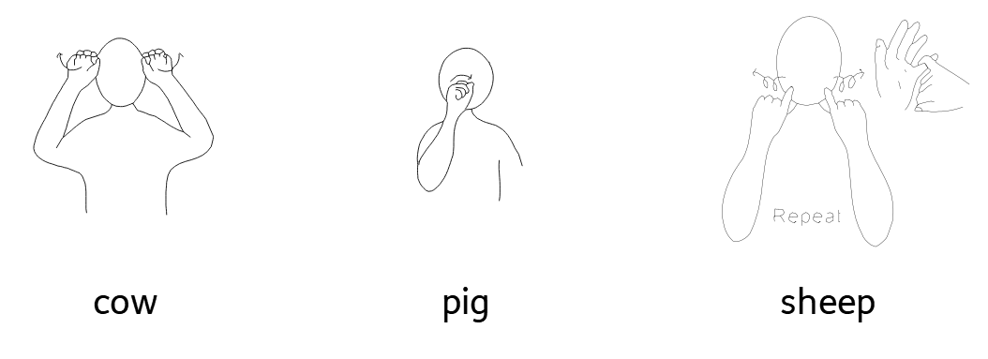
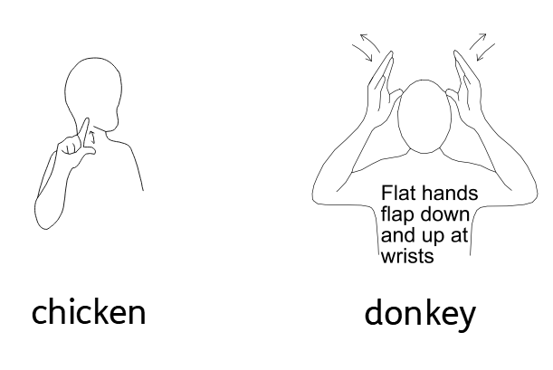
The song we will be learning these actions for is Driving my Tractor by Barefoot Books: Driving My Tractor (UK) | Barefoot Books Singalong Please practice the signs along to the song with your child.
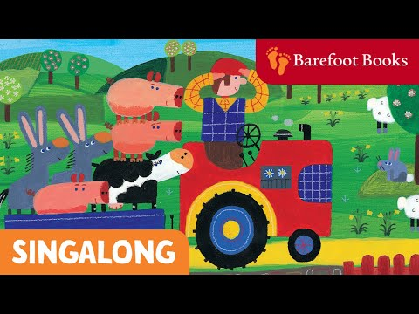
Computing
In computing this term, we will be building on your learning from last term to take pictures and will be learning to take simple videos. Your challenge this week is to take a video of someone else in your house. Can you film someone saying or signing hello? Can you teach someone in your family the signs from music and film them as they do it? Your focus is to make sure the person you are filming is in the middle of the screen.

PE Activities:
In PE this week we your challenge is to move like as many different animals as possible. Can you slither like a snake, op like a frog or gallop like a horse? Try to find 8-10 different ways to move around your house like different animals.

Art:
We are continuing with our theme of ‘On the Farm’ for art this week and are asking you to support you child in helping them make a farm animal mask! You child may choose any farm animal they like, but once they have chosen, they need to stick to it as we will be completing the rest of the costume over the term! You will need: paper plates, string, paper, colouring pencils/paint, scissors. Once you have completed the mask, please send it in with your child as they will need it for the rest of the term!
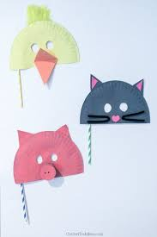

PSHCE
In PSHCE this week we will be continuing to consider our own personal likes and dislikes! Food will be this week's focus! In school, we will be having a taste test and filling out a table to explain what foods we like and dislike! Included in your home pack, you will find a copy of the table of foods we are trying in class. Please don’t feel as though you have to have the same – encourage your child to try new food that you have at home already. They might surprise you and like something new!

RE
In RE this week, we are continuing to look at Christian festivals Lent and Easter. Please share this video with your child: https://www.bbc.co.uk/bitesize/topics/ztkxpv4/articles/z4t6rj6
In class, we will be using drama to re-tell the story of Lent and Easter. As this might be quite tricky for you to achieve at home, instead, you will find cards about the story of Easter for you to support your child in ordering.

Horticulture
For Horticulture this week, we will be looking a little more about handling different equipment and tools in the garden. Our learning intention in school is to handle one tool in the garden, but if your child is confident, please handle as many as you’d like! In school, we are going to be focusing on using watering cans and pouring water over flowers. It’s helpful for your child to see these tools in action so they have a meaningful experience, so model to them using the tools and encourage them to use them too! Using hand-over-hand might be a great way to support your child with this.

Living Things | Picture taken? |  | Picture taken?
A flower  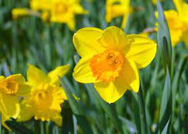 |  | An insect  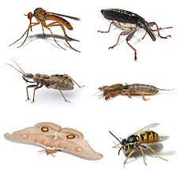
Cat  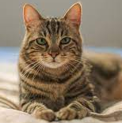 |  | Grass  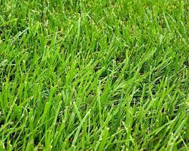
A Tree  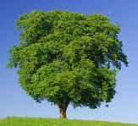 |  | Bird  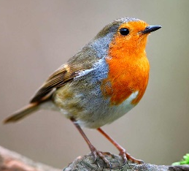
Sheep  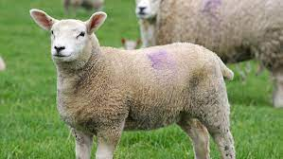 |  | Horse  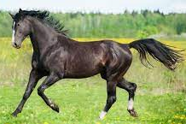
Cow  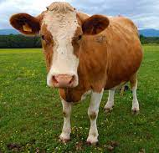 |  | Fish  

