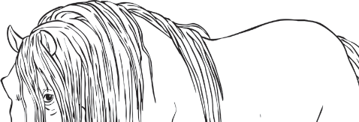
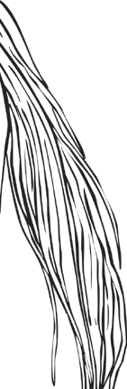
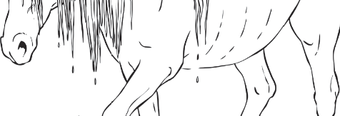
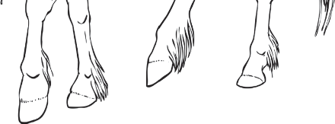
Myth File - Kelpies

Describe these mythical creatures.

_________________________________________________
_________________________________________________
_________________________________________________
_________________________________________________
_________________________________________________
_________________________________________________
_________________________________________________
_________________________________________________

Where can these mythical creatures be seen?

__________________________________________________________________________________
__________________________________________________________________________________
__________________________________________________________________________________
__________________________________________________________________________________
__________________________________________________________________________________
__________________________________________________________________________________

What does legend say about these mythical creatures?

________________________________________________________________________________________________________________________________________________________________________________________________________________________________________________________________________________________________________________________________________
____________________________________________________________________________________________________________________________________________________________________

