
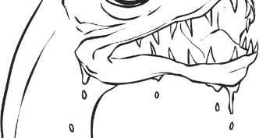
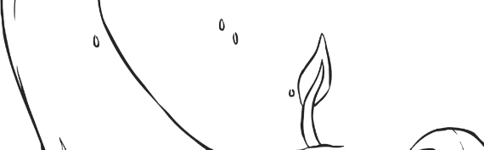
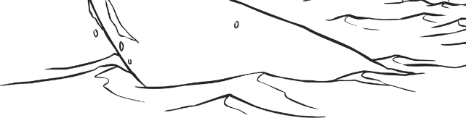
Myth File - The Lochness Monster

Describe this mythical creature.

_________________________________________________
_________________________________________________
_________________________________________________
_________________________________________________
_________________________________________________
_________________________________________________
_________________________________________________
_________________________________________________

Where can this mythical creature be seen?

__________________________________________________________________________________
__________________________________________________________________________________
__________________________________________________________________________________
__________________________________________________________________________________
__________________________________________________________________________________
__________________________________________________________________________________

What does legend say about this mythical creature?

________________________________________________________________________________________________________________________________________________________________________________________________________________________________________________________________________________________________________________________________________
____________________________________________________________________________________________________________________________________________________________________

