Scotch Pancakes
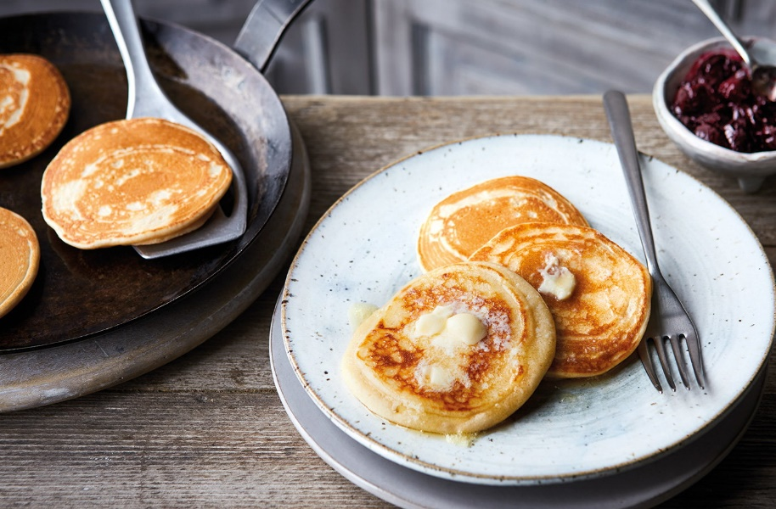
Ingredients
225g self-raising flour
25g caster sugar
40g butter, melted
1 medium egg
250ml milk
2tsp vegetable oil
(Recipe makes 12 pancakes)

Method
- Sift the flour and sugar into a bowl and make a well in the centre. Add the melted butter, the egg and half the milk. Mix together, then slowly stir in the remaining milk to make a smooth, thick batter.
- Heat a large frying pan until hot. Brush lightly with 1/2tsp oil. Spoon 2 tbsp batter on top of each other in the pan to form each pancake (about 8cm wide). Cook in batches of 3 over a medium heat for 1-1 1/2 mins on one side, until small bubbles appear on the surface. Flip and cook for 1 min on the other side until golden, puffed up and crisp on the outside.
- Transfer to a wire rack and cover to keep warm while you make the remaining pancakes. Repeat step 2, oiling the pan each time, until you have made 12 pancakes. Serve warm or cold, with butter and jam if you like.

