Tartan
L.I. to understand what tartan is.
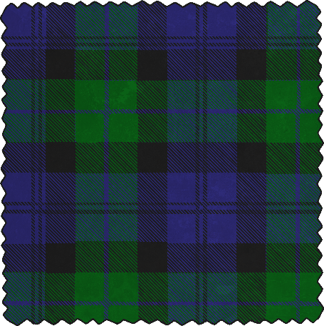
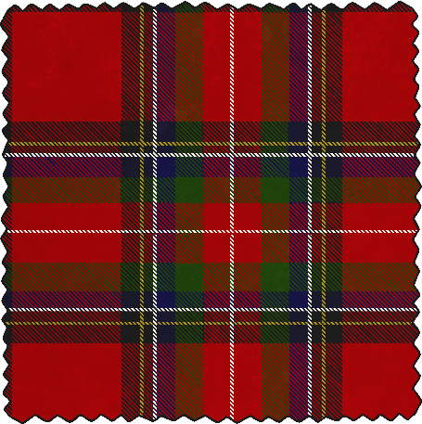
Look at the tartan and try to copy the patterns on the templates below. It doesn’t have to be exactly the same, just make sure to use the right colours and try your best!

