Family Crest
L.I. I understand what a clan is

A Scottish crest badge is worn to show allegiance to an individual or membership in a specific Scottish clan. Crest badges consist of a crest and a motto. They usually feature a shield, a knight’s helmet and often another symbol, sometimes a bird or Scottish animal.

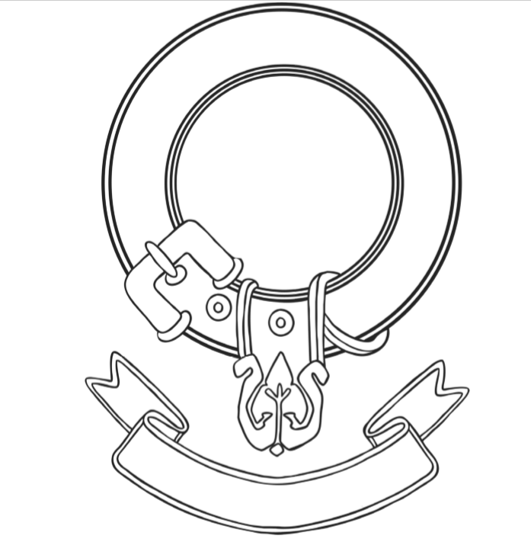
Design your own family crest using the template below

