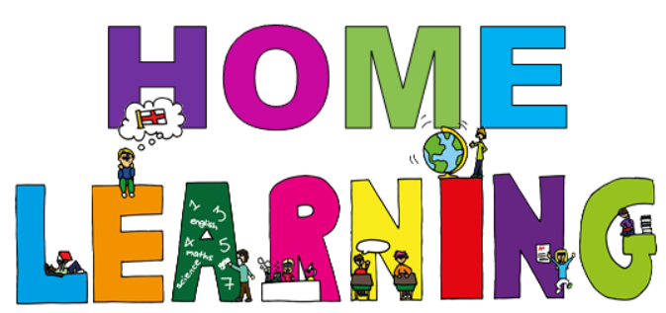

Week beginning 22nd February 2021

Dear Willow & Ash parent(s)/carers,
We would like to set the children activities based on our topic this term which is ‘Africa’. Below are activities which can be completed at home. We have suggested subjects to be completed on certain days, which correspond with what we are completing at school. This said, if you would like to change the order of the lessons then you are welcome to do so. If you have any trouble accessing resources or if you have any questions, please do not hesitate to get in contact with us at school. Some of the activities will require access to a computer. If your child is unable to access a computer, please let us know and we can discuss how we can help.
Face to face Zoom sessions –
We would like to invite you to join us for a zoom session each week – details will be sent via email before each session, including login details and passwords.
Monday morning at 10:00 – 10:20 –Social session; pupils will have an opportunity to see their friends and share their weekend news.
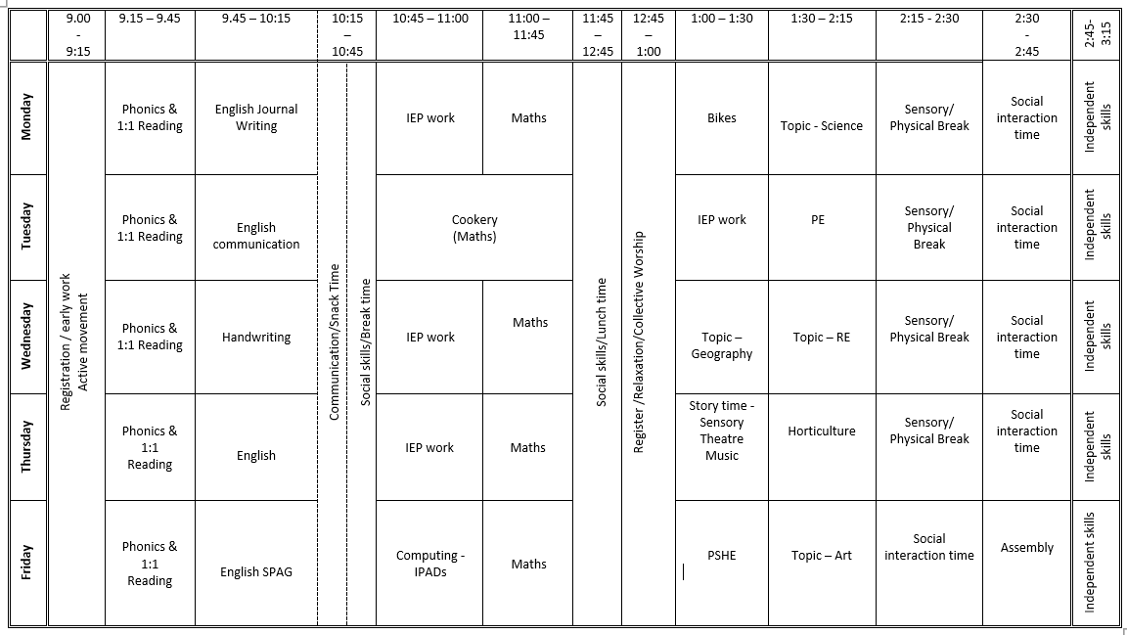
Timetable - Here is a copy of our timetable at school:

Monday home learning activities -
Subject | Activities that can be completed at home.
Active movement | Just Dance 2018 • Waka Waka (Football Version) - YouTube  Just Dance 2015 "Happy" - YouTube
Phonics | (If you need support with the pronunciation of the sounds you can listen to them on the following link Phonics Phase 3 Sounds for Pronunciation - YouTube)  Login to phonicsplay.co.uk - PhonicsPlay Username: jan21 Password: home  Starter: Play phonics song – Phonics Song 2 (new version) - YouTube  Pupils to write the alphabet on their whiteboards.  Introduce: We are learning a new phoneme ur and how to read and write it.  Revisit Practise: Play Flashcards. Look at an alphabet chart and practise the names of letters that pupils were finding tricky.  Flashcards: Speed Trial, Flashcards: Time Challenge on phonicsplay.co.uk  Teach: Teach the new phoneme ur with actions.  Practise: Play Sound buttons writing the words: fur, burn, burp, curl, hurt, surf, turn, turnip.  Apply: Teacher to write a sentence on the whiteboard. Model sentence writing by talking out loud as you write the sentences below, e.g., first word, capital letter at the beginning, remember to write on the line, finger space, second word etc…Read together as a class – encourage the pupils to blend  If I burn my leg, it will hurt.  I can surf or sail a boat.  My dog has fur on his tail.
Reading | Oxford Owl ebook Library – see separate leaflet for details –  https://www.oxfordowl.co.uk/login?active-tab=students  Ash & Willow –  Username: fitzwarynashwillow  Password: ashwillow  - Read a level appropriate book with your child.  - Share your favourite picture/chapter novel with them.
English  Learning intention:  - I can share my weekend news. | Weekend News Journal Writing.  You are welcome to join us on zoom at 10am for our weekly news social session. Details will be emailed prior to the session. Encourage your child to share their weekend news with the other pupils; encourage your child to ‘show and tell’ the other children something they have completed/made during the week, a picture they have painted in Art or a photo of them that you have taken of them having fun outside. Please can we ask that your mic is muted when your child is not speaking to the group. Then ask your child to draw a picture of what they did at the weekend.  Extension: Ask your child to write a simple sentence or a few key words to accompany their picture. This can be done by copying a sentence you have written for them after they have told you what to write or overwriting a sentence that has been written for them in a felt tip pen.
Individual Education Plan targeted work | Choose an activity to complete from the pupils’ individual education plan.
Maths  Learning intention:  - I can count in 10s from 10 to 100.  Success criteria:  - pupils will count from 1-100.  -pupils will be able to find numbers on the 100 number grid. | You will need: 1-100 number grid  Starter: List and sing along to Let's Get Fit | Count to 100 | Count to 100 Song | Counting to 100 | Jack Hartmann - YouTube  Main teaching: show pupils a 1-100 number grid. Explain that the first 10 numbers are on the top line, ask pupils to use objects to cover the first 10 numbers to reinforce the position of the first 10 numbers on the grid.  Then ask the pupils to remove the objects and point to 10 or find an object to cover number 10 only. Explain that we are going to add 10. Count on from 10 to 20 in 1s. Ask pupils what they notice? (20 is under number 10) so, we don’t need to count in 1s to add 10, we can just look at the number below. Keep adding 10, pupils to join in as you count in 10’s to 100. Point or cover each number as you say them.  Listen to and sing along to Count Together by 10's | Counting Workout for Kids | Jack Hartmann Counting by 10s - YouTube  Activity: Pupils to play Helicopter Rescue - Mental Maths for 4 to 8 Year Olds (topmarks.co.uk) (find a number, direct, 1-100)
Bikes/Physical movement | Go outside –  Ride a bike or walk around your local nature reserve or country park or play a game in your garden e.g., bat and ball, football, catch.
Topic – Science  Learning intention:  - I can identify common animals.  Success criteria:  Pupils will name different animals.  Pupils will sort animals using different criteria. | You will need: PowerPoint, animal pictures.  Starter: Listen to and sing along to Animals in Action | Movement Song for Kids | Jack Hartmann - YouTube  Main Teaching: Discuss what the pupils already know about animals, e.g., names, where they live, pets, wild, what they look like, what they eat.  Look through the PowerPoint and discuss how animals can be grouped into fish, mammals, birds, and reptiles.  Activities: Ask pupils to sort and compare a variety of animal pictures.  Pupils to discuss how they have sorted the pictures.

Tuesday home learning activities -
Subject | Activities that can be completed at home.
Active movement | Just Dance 2015 - Happy Pharrell Williams Gameplay - 5 Stars Rating [ HD ] - YouTube  You tube – Joe Wickes PE session
Phonics | Starter: Listen to alphabet song – Jolly Phonics A-Z - YouTube  Pupils to write the alphabet on their whiteboards.  Introduce: We are learning a new phoneme ow and how to read and write it.  Revisit Practise: Play quick write. Look at an alphabet chart and practise the names of letters that pupils were finding tricky.  Teach: Teach the new phoneme ow with actions. Get pupils to write ow in the air and on whiteboards.  Practise: Play Buried Treasure. Words: now, down, owl, cow, how, town, fown, owp, hown, lown on phonicsplay.co.uk.  Apply: Teacher to write a sentence on the whiteboard. Model sentence writing by talking out loud as you write the sentences below, e.g., first word, capital letter at the beginning, remember to write on the line, finger space, second word etc…Read together model blending tricky words.  This owl is not feeling sad and down.  I park my car in the town.  How do I feed a cow?
Reading | Oxford Owl ebook Library – see separate leaflet for details –  https://www.oxfordowl.co.uk/login?active-tab=students  Ash & Willow –  Username: fitzwarynashwillow  Password: ashwillow  - Read a level appropriate book with your child.  - Share your favourite picture/chapter novel with them.
English – communication  Learning intention:  - I can communicate effectively with others. | Starter: Listen and sing along to CBeebies: Something Special - Hello Song - YouTube  Main activities: Play the game I went shopping and I bought…  Listening Mats: Practice listening skills by following instructions. Pupils follow directions as they colour and draw on a scene/paper. Pupils will have a blast showing off their creative sides, all while practicing an important social skill. (worksheet can be found under English – week 1 – listening mat)
Cooking/Maths  Learning intention:  To measure out ingredients correctly. | Encourage your child to help you prepare a meal this week. If possible, concentrate on your child helping to measure out the quantities. It’s good to model the mathematical vocabulary when measuring, for example grammes, litres, tablespoon etc.  At school we are making Moroccan couscous this week. The recipe will be available on the website if you would like to do it as well.
Individual Education Plan targeted work | Choose an activity to complete from your child’s individual education plan.
PE  Learning intention:  - I can move with increased control and co-ordination.  Success criteria:  - pupils will balance and roll a ball around their body.  -pupils will use 2 hands to move the ball around. | Starter: Pupils to get dressed for PE independently.  Outside: Go for a walk, run, bike ride, scooter ride.  Inside: Warm up (5 mins): follow my leader. Adult to start, using different travelling movements. Give different commands – spin round, change leader, make a shape. Pupils to have turn at leading, encouraging them to use full range of commands.  Main teaching: Co-ordination – ball skills  Cool down: cosmic yoga https://www.youtube.com/watch?v=KAT5NiWHFIU&ab_channel=CosmicKidsYoga  We’re going on a bear hunt yoga

Wednesday home learning activities -
Subject | Activities that can be completed at home.
Active movement | Just Dance Kids 2 Jump Up - YouTube  Just Dance Kids 2014 A Pirate You Shall Be - YouTube
Phonics | Starter: Listen to alphabet song – The Alphabet Song | Phonics Song for Kids | Kindergarten Alphabet song | Jack Hartmann - YouTube  Pupils to write the alphabet on their whiteboards.  Practise: writing and spelling phase 3 tricky words Phase 3 Tricky Words Song Say Hello To - YouTube
Reading | Oxford Owl ebook Library – see separate leaflet for details –  https://www.oxfordowl.co.uk/login?active-tab=students  Ash & Willow –  Username: fitzwarynashwillow  Password: ashwillow  - Read a level appropriate book with your child.  - Share your favourite picture/chapter novel with them.
English & handwriting  Learning intention:  - I can practise my handwriting. | (support/information for parents Nelson guide for parents | Oxford Owl)  Starter: 'I like to' playdough action song - YouTube – warm up ready for handwriting using play-dough.  Main teaching: Handwriting for kids. Learn to Write Lowercase Letters l, k, t, i, j - YouTube – use and follow the video to practise writing the letters.  Ask pupils to practise writing the letters shown in the video in their exercise books. They can copy the adult’s example (use felt tip pen for children to trace over) and then continue to write the letter on their own.  Extension: Pupils can write words the include the focus letters from the video, e.g. little, lit, net, kick, jig, jug.
IEP Work | Choose an activity to complete from the pupils’ individual education plan.
Maths  Learning intention:  - I can count in 10s from 10 to 100. | You will need: 1-100 number grid, Multiples of 10 number line, Multiples of 10 number cards.  Starter: Listen and sing along to Count Together by 10's | Counting Workout for Kids | Jack Hartmann Counting by 10s - YouTube  Main Teaching: Together, discuss the 10s cards and order them in a line, talking through any patterns the children spot. Count along altogether 10, 20, 30 …  Ask the pupils to close their eyes and them remove one of the cards from the sequence. Which number is missing? Pupils discuss and count along the line to find the missing number and write them on their whiteboards.  Repeat with other missing numbers. Encourage pupils to use the 1-100 number grid or number line to help them to find the missing number in the sequence.
Topic – Geography  Learning intention:  - I can talk about home and where I live.  Success criteria:  - pupils will identify the different types of homes in our local area.  - pupils will begin to recognise and talk about the similarities and differences in our homes. | You will need:  Google Earth  Lesson 1 ‘homes’ PowerPoint  Paper  Pencils  Sym writer pictures for support  New Words:  Flat  Bungalow  Detached house  Semi-detached house  Caravan  Terrace house  Starter: Listen and sing along to Brain Breaks | Around The World | Brain Breaks Song | Jack Hartmann - YouTube  Main: Introduce the pupils to our new topic ‘Local Homes’. Using Google Earth and the school postcode briefly show the pupils the local area. Explain that a ‘local area’ is the area surrounding their home or school. Point out the school on the map and ask the pupils what they think the other buildings are? Looking at the map, tell the pupils that there are lots of different types of homes in the local area. (You may want to explain that we call them homes because not everyone lives in a house).  Put out home pictures on tables and give the class a few minutes to look at all the different homes we live in.  Work through ‘homes’ PowerPoint and encourage the pupils to say what type of home they live in.  Activity: ‘My home’ pupils need to draw a picture of their home. Using key words on the board, encourage pupils to label if it is a flat, bungalow, detached house etc. If time, the pupils can also label the features of the house e.g. chimney, garage, 2 bedrooms etc  Plenary- Group Activity  Using photographs of the different houses on the whiteboards, ask pupils to name differences that they can spot. Then ask the pupils to think of similarities e.g. they are all warm inside, they all have lights etc. Explain that even if they look different, we all need and use our homes for the same things.
Topic – RE  Learning intention:  - I can recall the Easter story. | You will need: The Christian Story of Easter | Religions of the World - YouTube detailing the story of the crucifixion and resurrection  Scissors  Glue  Loaf of bread  Large cup of blackcurrant juice  Cup per child  Main Teaching: The Crucifixion: Watch The Christian Story of Easter | Religions of the World - YouTube Together, discuss the main events.  Activities: Story sequencing - Ask the pupils to sequence the events in the Easter story – sequence the picture cards to order the events in the Easter story.

Thursday home learning activities -
Subject | Activities that can be completed at home.
Active movement | Just Dance 2018 • Waka Waka (Football Version) - YouTube  Banana Banana Meatball - Blazer Fresh | GoNoodle - YouTube
Phonics | Starter: Listen to alphabet song – Alphablocks - Jolly phonics " ABCD " - YouTube  Pupils to write the alphabet on their whiteboards.  Introduce: We are learning a new phoneme oi and how to read and write it.  Revisit Practise: Play quick write. Look at an alphabet chart and practise the names of letters that pupils were finding tricky.  Flashcards: Speed Trial. Teach Introduce the phoneme oi with actions. Get pupils to try writing oi in the air and on whiteboards.  Practise: Play quick write Words: oil, boil, coin, coil, join, soil, poison, foil, turnip, burn, down, town.  Apply: Play Yes/No questions– get pupils to use thumbs up and thumbs down to show whether the answer is yes or no. Can you surf on a coin?  Can a cow get a coin?  Can you put a fish in foil?  Will an owl join a town?  Can oil boil?  Will a car need oil?  Can soil be red?  Will a coil go boing?  Can you burn oil?
Reading | Oxford Owl ebook Library – see separate leaflet for details –  https://www.oxfordowl.co.uk/login?active-tab=students  Ash & Willow –  Username: fitzwarynashwillow  Password: ashwillow  - Read a level appropriate book with your child.  - Share your favourite picture/chapter novel with them.
English  Learning Intention:  -I can sequence a story. | You will need: ‘Going on a lion hunt’ story sequencing cards  Starter: Listen to the sentence song - https://www.youtube.com/watch?v=0Wrv_ZviMEc  Main Activity:  Show the pupils the front cover of the book and ask them to predict what they think it is going to be about, e.g.,  - Think about the title/genre/author/pictures/setting. What do you think the story/book will be about? What makes you think that?  - What challenges do you think the characters might face?  - What clues from the text helped you make your prediction?  - How do you think the story might end? Why do you think that?  Listen to https://www.youtube.com/watch?v=ECYiUsppM14 and discuss their predictions, where the correct?  Activity: Hand out images from the story. Can children sequence them? Encourage children to re-tell the story. Can they create their own story board?
IEP work | Choose an activity to complete from the pupils’ individual education plan.
Maths  Learning intention:  - I can count in 10s from 10 to 100.  Success criteria:  - pupils will count from 1-100.  -pupils will be able to find numbers on the 100-number grid. | You will need: Multiples of 10 number cards, Multiples of 10 number lines, 1-100 number grid, Worksheet.  Starter: Listen and sing along to Count Together by 10's | Counting Workout for Kids | Jack Hartmann Counting by 10s - YouTube  Main teaching: Using the number cards from the previous lesson, ask the pupils to order the numbers from 0-100, encourage them to use their number lines for support.  Working with a partner/adult, ask the pupil to close their eyes as you muddle up the sequence of their number cards. Ask the pupils to open their eyes and correctly sequence the cards once again. Tak it in turns to repeat, pupil closes their eyes as adult muddles up the sequence and then adult closes their eyes as pupil muddles up the sequence.  Activity: Pupils to cut out the number cards and order them (worksheet week 1 maths activity cut and order number cards)
Music  Learning intention:  - I can listen to African drumming and hear the rhyme  Success criteria:  - pupils will listen to recorded music.  -pupils will follow a rhythm. | Starter: https://www.youtube.com/watch?v=aXZWgOf2lSA  ”bim bum” a clapping game which gets progressively faster.  https://www.bbc.co.uk/bitesize/guides/zhsny4j/revision/2  The above website gave the following information.  Music of Africa – Percussive instruments are a part of life in some African societies. Music and dance are an integral part of the African culture. They used to and still provide a valuable way to communicate with workers in the fields or pass messages to other villages  The music played by drum ensembles is very complex in rhythm and texture. The rhythms are not normally written down and are instead passed between people through aural tradition. The master drummer has the most elaborate part, leading the drum ensemble and playing solos. The leader directs the drummers with musical cues in the form of rhythm patterns. The leader will also give cues to dancers to signal changes of tempo or dance moves. As well as percussion-based music, there is a lot of singing, including shouts, yodelling and other types of sound.  This is shown in the following clip:  Jalikunda African Drums take the Montserrat African Music Festival by storm - YouTube  Have djembe drum for pupils to try to copy some of the moves
Horticulture  Learning intention: To taste different vegetables and plan which ones to grow  Success criteria:  I can try different vegetables and state which I like  I can help plan which seeds to grow | You will need: different, fresh vegetables.  Starter: Listen and sing along to In the Garden Song [HD] - YouTube  Main activity: Offer pupils a range of different vegetables to try – carrots, cucumber, tomatoes, lettuce, rocket – and encourage them to taste them all. Discuss which they like/don’t like and fill in tasting sheet. Read seed planting instructions to them and support them in deciding how long it will take for the seeds to grow. Compare this to the beans and cress and decide if they’ll grow quicker or more slowly. Draw up a planting plan, writing down what is to be planted and when it should grow and be picked. This can be referred to over the coming weeks.  Read Oliver’s vegetables and discuss. He found he liked the vegetables when he ate them. Were they willing to try? Might they have liked them if they had tried?  Oliver's Vegetables | Story About Healthy Eating For Children | Learn From Home | Read Aloud - YouTube

Friday home learning activities -
Subject | Activities that can be completed at home.
Active movement | Just Dance 2018 • Waka Waka (Football Version) - YouTube  Banana Banana Meatball - Blazer Fresh | GoNoodle - YouTube
Phonics & Reading | Starter: Listen to alphabet song – CBeebies | Mr Tumble's Alphabet Song - YouTube  Pupils to write the alphabet on their whiteboards.  Introduce: We are practising reading captions.  Revisit Practise: Play Flashcards. Look at an alphabet chart and practise the names of letters that pupils were finding tricky.  Flashcards: Speed Trial, Flashcards: Time Challenge.  Teach: Model reading a caption or sentence (choose one from below). Sound talk any words that are tricky. Draw a picture of what is happening in the caption. Practise Read captions – pupils draw pictures of the captions and label items in the picture.  The pig and the fox go down the road.  The cow and the goat go to the park.  The dark shark has sharp teeth.  The red fish has a big tail.  A duck, a sheep and a goat go to see the vet.  The fat toad is in the boat.  Reading  Oxford Owl ebook Library –  https://www.oxfordowl.co.uk/login?active-tab=students  Ash & Willow –  Username: fitzwarynashwillow  Password: ashwillow  Read a level appropriate book with each pupil.  Share your favourite picture/chapter novel with them.
English spelling, punctuation and grammar & handwriting  Learning Intention:  To write a correctly punctuated sentence | Starter:  Warm up hands ready for writing:  - Shoulder shrugs  - Crocodile snaps  - Butterflies  - Finger press ups  - Pencil Twirls  Main Activity: Teacher to share an image of an African animal. Ask children who, what doing, were? Teacher to use information to write a simple sentence with mistakes. Pupils to check for capital letters, full stops, and fingers spaces. Can they use the words on their worksheet to create their own sentence?  Extension: Pupils to write their sentence underneath.
Computing  Learning intention:  - I can open a simple word processing package.  Success criteria:  - pupils will use the keyboard to type letters, making words.  -pupils will use CAPS lock, backspace and enter. | Starter: Use https://www.youtube.com/watch?v=JEIHogpVJ1k to introduce each lesson.  Main teaching: Model opening the saved Word document. Children to copy each step. Explain that the image in the document is the South African flag. Model writing a sentence about it. Emphasise the importance of using a capital letter at the beginning of each sentence and how to do that. Demonstrate how to fix a mistake. Children to write 1-2 sentences about the flag.
Maths  Learning intention:  - I can count in 10s from 10 to 100.  Success criteria:  - pupils will count from 1-100.  -pupils will be able to find numbers on the 100-number grid. | You will need: 1-100 number grid, enlarged, counters.  Starter: Listen and sing along to Count Together by 10's | Counting Workout for Kids | Jack Hartmann Counting by 10s - YouTube  Main teaching: Using the 1-100 number grid Paint the Squares - Interactive Number Charts (topmarks.co.uk) Ask the pupils to ‘splat’ the numbers that is 10 more that the number 10, 20, 30 etc.  Explain, that we can use ‘spider counting’ to help us to find 10 more than any number on the number grid. We call it spider counting because spiders like to move up and down.  Point to/’splat’ 5. Explain, we are going to add 10, but we are not going to count, we are going to use our ‘spider counting!’  Together, count on in 10s as you move down the grid: 5, 15, 25, 35 …  Repeat, starting at 3.  Activity: Working in small groups, show the pupils an enlarged 1-100 number grid. Use this to support counting on in 10s from any numbers. One pupil puts a counter on a number from 0-10 on the grid, e.g., 2. Then ask the other pupil/adult to place a counter below on the grid until the reach the bottom of the grid. Adult to write the number sequence, e.g., 2, 22, 32, 42, 52 etc. Repeat.
PSHE & Communication  Learning intention:  - I can show empathy towards others  Success criteria:  - pupils will communicate effectively.  -pupils will listen to others. | You will need: Emotions/feelings cards.  Starter: https://www.youtube.com/watch?v=DNZUKm0ApEM to introduce each lesson.  Main teaching: Hand out emotions’ cards. Ask children to share how they are feeling. Can they explain why? What other feelings do we know of? Play feelings charades (see resources for more info). Discuss ways we can respond to people if they are feeling happy, sad, angry, worried etc.
Art  Learning intention:  -I can collage using primary colours.  Success criteria:  - pupils will know the primary colours.  -pupils will select and use tools they need to complete the task. | You will need: Piet Mondrian photo pack, PowerPoint, Colouring sheet.  Starter: Use https://www.youtube.com/watch?v=p0OMfzTqbhw to introduce each lesson  Main teaching: Look at the life and work of Piet Mondrian. See PowerPoint for more information.  Activity: Create a Piet Mondrian inspired picture.

Relaxation/mindfulness:
Guided Meditation for Children | Your Secret Treehouse | Relaxation for Kids - YouTube
Relax Music for Stress Relief, Study Music, Sleep Music, Meditation Music 💜 528Hz - YouTube
Guided Meditation for Kids | Spaceship to the Moon | Relaxation for Children - YouTube
Other helpful websites:
Home - GoNoodle
ictgames
PhonicsPlay
Welcome | Numeracy Warm Up
- username: fitzwaryn
- password: story
HelpKidzLearn
Writing warmups - dough disco for children - YouTube
Phonics song - Phonics Song 2 (new version) - YouTube
Jolly Phonics A-Z - YouTube
Counting song - Let's Get Fit | Count to 100 | Count to 100 Song | Counting to 100 | Jack Hartmann - YouTube
Space/planets song - The Solar System Song - YouTube

Stay safe and well!
All the best,

Ash and Willow Class teachers

