Maple and Beech Home Learning Curriculum for Term 3 2021
Dinosaurs
Week Commencing 8th February
Here are your Wider Curriculum activities for Week six of this term. Your English and Maths packs should be coming home to you once again, some of the resources for the following activities are also included in your home learning packs.
We highly encourage you to take pictures of the work you are completing. You can email these to school, and we can print them and send them back for you to keep.

Where appropriate do continue to use the below timetable to help you provide some structure for the children at home. It can be adapted to fit your family circumstances, it is not set in stone.
8-9am  Get up, dressed and ready for learning including a healthy breakfast. | 9-9.30am  Active Movement:  Cosmic Yoga, take a walk or bike ride, complete a PE challenge. | 9.30-10.15am  Focused activity 1: Story Time – Writing/reading, fine motor skills and mark making or activities from you English packs.
10.15-11am  Break and free time including a healthy snack. Try to get a bit of fresh air! | 11-11.45am  Focused activity 2: Maths Activity packs, jigsaw puzzles, gams such as snakes and ladders or some ‘shopping’ role play – allowing your children to explore any coins you might have. | 11.45-13.00  Lunch time  Help to prepare, share and tidy up lunch. Enjoy some time relaxing and chatting!
13-13.30pm  Relaxation:  Either engage with a relaxation video, Reading, mindful colouring, TACPAC (see school website for details of how to access this at home). | 13.30-14.30pm  Focused activity 3: Wider curriculum activities (Art, Music, Science, Horticulture, Cookery) share a story linked to our class topic. | 14.30- 15.10pm  Free-time, Relaxation/ Meditation before the end of the day tidy up.  Good choices could be jigsaws, colouring, word searches and listening to music.

Good luck with your home learning! We will be in touch to make check-in phone calls. Keep reading below for this week’s suggested wider curriculum activities.
Best Wishes,
Becky Allen and Jess Cox

Maple and Beech Class Teachers

Topic/History:
Please continue to explore the following website to learn about different dinosaurs and their habitats. The DKFind out website has some amazing visuals and information regarding all things dinosaurs please check it out here: https://www.dkfindout.com/uk/search/dinosaurs/
This week is a sensory activity making dinosaur eggs. If you have any small dinosaur toys which you could hide inside the eggs that would be great but any small toy would do. If not then you can just create some eggs to play with, without a surprise inside. Using the following recipe/instructions make a few ‘bath bomb’ eggs with your child then use vinegar to make them dissolve!
Ingredients:
Baking soda
Water
Food colouring
Teaspoons
White vinegar
Casserole dish or some other container
Dish soap
Dinosaur toys (or other small toys)
Parchment paper
Method:
First colour your baking soda. If you want to make different coloured eggs spread your baking soda out into a few bowls. Simply add in a few drops of food colouring and carefully mix. This could change the colour of your hands so use spoons!
Once the baking soda is coloured carefully add some water. Add it very slowly, a small amount at a time and mix thoroughly before adding more. You want it to start to become paste like so it will stick together.
You could also add glitter or sequins to make them a little more exciting!
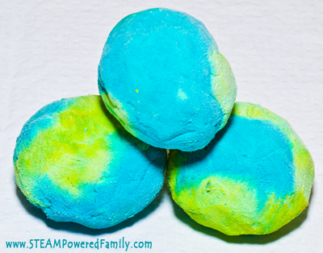
Next, take a palmful of the paste and squish it about to make a ball. Press in a dinosaur if you have any, then add more paste to the top and sides until the entire dinosaur is encased.
Place your dinosaur egg on parchment paper on a cookie sheet and set in the freezer. You could combine colours as well to make rainbow style eggs. They freeze very quickly and are ready within an hour, or you can leave them in overnight.
When you’re ready to ‘Hatch’ the eggs:
Dribble some dish soap on the bottom of the bowl.
Pour some vinegar in a cup or bowl and give the kids each a teaspoon.
Spoon your vinegar over the dinosaur eggs to start them hatching!
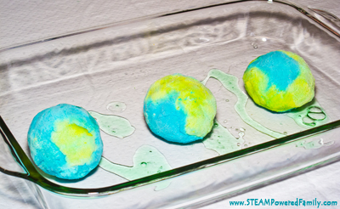

Science Activity:
Time for some Role Play!! This week in school we are opening our Animal Hospital! Using your stuffed toy animals you can open a role play veterinary centre. Using strips of old fabric maybe an old bed sheet cut up if you have one or some toilet roll if you have any spare, support your child to play animal hospital. The focus of this activity is still to label the different parts of animals. Does the toy teddy have a thorn in his paw? - Help by using some tweezers to take it out and wrap it in a bandage. Did Teddy bump his head? Wrap that in a bandage and pop an ice pack on it! Get as creative as you can using whatever you have around your house. Use torches to have a look in teddy’s ears, use a thermometer to check his temperature and tuck him into bed if he needs some rest! Which animals have tails, four legs, how many ears or eyes, and do any have flippers or fins?
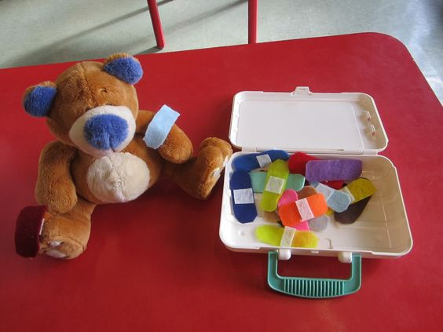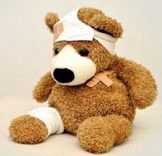
Music:
This week you will be receiving some action cards in your packs. These link to different body percussion actions and sounds. You can use them to create different rhythms and sequences and use them to beat a rhythm to some of your favourite songs.
You might make the following sequence and try completing along to one of your favourite songs or videos on YouTube:
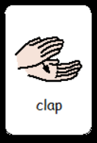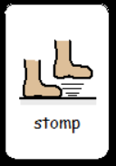
Continue to practice the body percussion actions to our Shakira song as well: Try Everything by Shakira (body percussion): https://www.youtube.com/watch?v=64M44FYz5d4
Support your child to clap and stomp in time to the music!

PE Activities:
In School this term our PE focus is ball skills and coordination. This week your challenge is to work on your kicking skills. Take a ball of any size with you out on a walk or to the park and practice kicking it to your parents or siblings. See how far you can kick it and then bring in some maths skills. Can you count using footsteps how far the ball rolled? See if you can kick it further and further each time counting your footsteps. For an extra challenge try kicking the ball gently around some obstacles seeing if you can change direction and keep your ball under control!
Try practising this every day for 5-10 minutes.

Art:
I hope you enjoyed making your dinosaurs last week! If you haven’t finished your dinosaurs (which I think might be lots of you as I haven’t seen any photos yet!) please do finish them off and send photos into the school office – they will find their way to the Beech and Maple teams! If you have finished them, please enjoy your dinosaurs, and get creative with playing with them!

PSHCE
Last week was Child Mental Health Week with that idea in mind, for PSHCE this week, we are asking you to create a link for our Fitzwaryn Chain of Kindness. Your child needs to decorate a paper link or write a positive/motivational message which will be added to our chain. Please use lots of colour and glitter to make the paperchain look beautiful! To help your child understand acts of kindness, you may want to watch this video with them. Explain to your child what is happening in the video, and if appropriate ask them what was kind? Who showed kindness? What happened when the dog was kind? Did it start a different chain of kindness? A short story on - kindness must see
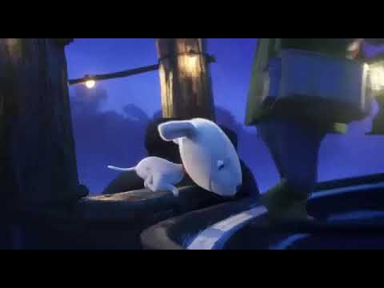

RE
In RE this week, we will be look at the Buddhist festival Nirvana Day! Please share this video with your child.
https://www.bbc.co.uk/bitesize/topics/zh4mrj6/articles/zvtxgwx
Explain that Buddhists celebrate Nirvana day (15th February) to celebrate Buddha reaching his enlightenment. Buddhists choose to celebrate is different ways, such as sharing food and reading from Buddhists texts. However, the way we are asking you and your child to celebrate Nirvana Day is through creating Mandalas, which are used to help Buddhist monks mediate.
Tibetan Monks Create Sand Mandala at Clark College in Vancouver, WA
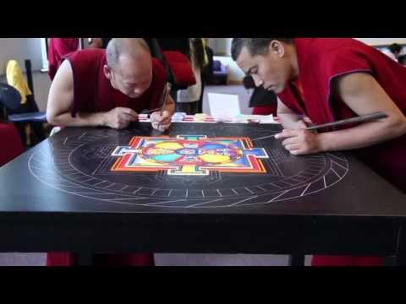
In school, we are going to use coloured sand in trays to create our Mandalas through mark making and creating circular patterns. But I know these might be tricky to get hold of at home! So, in your pack you will find a colouring sheet for your child to colour in if you have no sand available!

Horticulture
For Horticulture this week, we are asking you to make cress heads! You will need a cleaned out yoghurt pot or something similar, cotton wool and lots of cress seeds (we will send these home for you!). Your child can decorate the pot in any way they like, in school, we are putting our faces on them, so they look like hair! Place the cotton wool inside the pot and sow the seeds. Cress seeds need plenty of water, so give them a good drink and remember to water them each day. Again, we’d love to see any photos you have!

Also, don’t forget about your beans! They need lots of watering, care and attention!
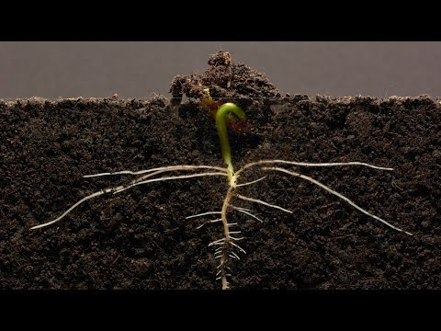

Computing
Again, in computing, we are asking you to take a photo of your plant! We are sending home some booklets where you can store your photos in to create a photo album! Please email in photos if you can’t print at home and we can return them to you printed in your home learning pack. Encourage your child to reflect on the changes between the photos and be proud of the work they have done!

