Pine and Rowan Home tasks for week 5

Below are the activities which can be completed at home. We have suggested subjects to do on certain days which correspond with what we will be doing at school. But if you want to do the activities in a different order that’s fine! We have sent home packs with phonics resources and your child’s logins for the online library and Gooseberry Planet as well as a book which can be used for activities that don’t require a worksheet or to stick in completed work. Some of the activities require access to a computer. If your child is unable to access a computer, please let me know and we can discuss how we can help.

If you have any trouble accessing the resources or if you have any questions, please feel free to contact me at school.

We are also having Zoom calls weekly. If your child wants to join in, they are as following:
Monday 10am- Social session
Tuesday 10am- Explanation session
Friday 10am- Sharing session.

If you are planning to join, please can you make sure you are ready for when it starts and if you are having any problems please let us know. You can access each of the three Zoom sessions via the following single link:
https://zoom.us/j/93878252793?pwd=UTRZczZJbEI1VWtyZFNJMXIHSU5Wdz09

Meeting ID: 938 7825 2793
Passcode: psKN9v

Monday
Subject | Activities that can be completed at home
Physical activity | Joe Wicks or Cosmic Yoga
Reading/ Phonics | Pupils can read a book at their level or complete phonics activities.  Review flashcards of sounds. Do they recognise all of the sounds? Can they think of any words that use the sounds?  Pupils can also do activities on Phonics Play.  https://www.phonicsplay.co.uk/  You may log in with the following details:  username: jan21  password: home
English | Journal Writing.  Pupils can write a sentence or more about what they have done either over the weekend. This can be done either independently, or by copying/overwriting a sentence that has been written for them.
Maths | This week we will be focusing on Time.  A set of worksheets for your child will be on the website under Maths Worksheet Week 5 (child’s initials)
PHSE | Go through the PowerPoint presentation (saved as PSHE PowerPoint week 5, explaining the key aspects of being a first aider.  Discuss the potential dangers or hazards which could be present in a situation requiring first aid, the emotions which may present themselves after providing first aid, the importance of clear communication with a casualty in a first aid situation and how to contact the emergency services.
Art | Over the term in Art, we would like pupils to make a solar system. This can be done as a model or a picture and you or your child can choose how they would like to do it. Pupils can then build on their model/picture each week as they learn more about the different planets. Below are some examples you can use for inspiration but feel free to use your imagination!  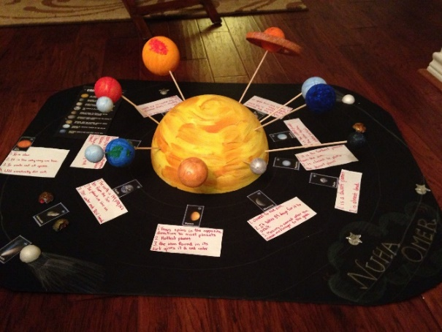  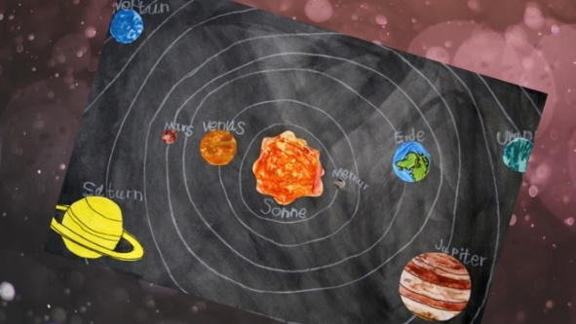  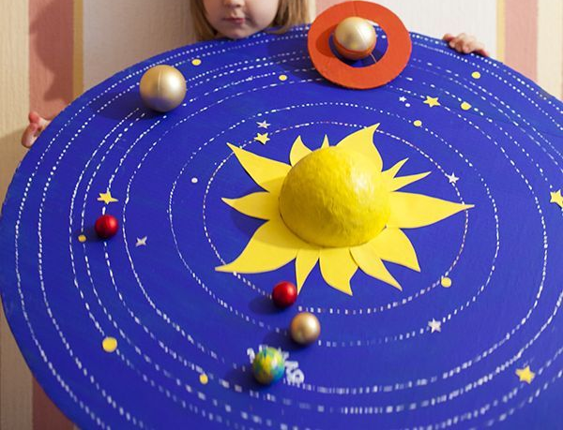

Tuesday
Subject | Activities that can be completed at home
Physical activity | Joe Wicks or Cosmic yoga
Reading/ Phonics | Pupils can read a book at their level or complete phonics activities from pack that has been sent home.  Pupils can also do activities on Phonics Play.  https://www.phonicsplay.co.uk/  You may log in with the following details:  username: jan21  password: home
Handwriting | Complete handwriting worksheets found on website.  Either continue Pencil control workbook or ‘ck’ worksheets  Extension- Pupils can write a few sentences of their choosing, ensuring they are forming their letters correctly and keeping them on the line.
Maths | This week we will be focusing on Time.  A set of worksheets for your child will be on the website under Maths Worksheet Week 5 (child’s initials)  .
RE | Watch the video of Jesus healing the paralysed man. https://www.youtube.com/watch?v=8cmppSIQUX4  Pupils can then complete the worksheet saved as RE Worksheet week 5. Pupils can either cut and stick the statements in the correct place or write what is happening in each box.
PE | Go for a walk/Bike ride/Run/complete a kid’s aerobic workout/just dance

Wednesday
Subject | Activities that can be completed at home
Physical activity | Joe Wicks or Cosmic Yoga
Reading/ Phonics | Pupils can read a book at their level or complete phonics activities from the pack that has been sent home.  Pupils can also do activities on Phonics Play.  https://www.phonicsplay.co.uk/  You may log in with the following details:  username: jan21  password: home
English | This term, pupils will be making a fact book about planets. Using the fact book template saved as English fact book week 2  Today, pupils can write a page and draw a picture about the planet Jupiter. It can range from a sentence to a paragraph with facts they have learnt about Jupiter.  Please refer to last week’s science PowerPoint in you get stuck!
Maths | This week we will be focusing on Time.  A set of worksheets for your child will be on the website under Maths worksheet Week 5 (child’s initials)
Music | Watch the orchestra version video on the BBC website using the link below  http://www.bbc.co.uk/programmes/p02b14ld  Continue on from last week. Ask pupils to think back to the previous weeks and the chants and patterns they came up with. They can choose one of these chants and patterns or make up a new one. Pupils can combine the patterns and chants. Pupils can perform the pattern either by clapping, stomping, patting legs/table or using an instrument of available.
History | This week we are learning about Ibn Battuta. Read through the slides (saved as History PowerPoint Week 5) about Ibn Battuta. Pupils can then complete the worksheet (saved as History Worksheet week 5) finding the places where some significant events took place in his life.

Thursday
Subject | Activities that can be completed at home
Physical activity | Joe Wicks or Cosmic Yoga
Reading/ Phonics | Pupils can read a book at their level or complete phonics activities from the pack that has been sent home.  Pupils can also do activities on Phonics Play.  https://www.phonicsplay.co.uk/  You may log in with the following details:  username: jan21  password: home
English | This term, pupils will be making a fact book about planets. Using the fact book template saved as English fact book week 3  Today, pupils can write a page and draw a picture about the planet Saturn. It can range from a sentence to a paragraph containing facts they have learnt about Saturn. Please refer to last week’s science PowerPoint in you get stuck!
Maths | This week we will be focusing on Time.  A set of worksheets for your child will be on the website under Maths Worksheet Week 5 (child’s initials)
Computing | This term Pupils will learn about e-safety. We will be doing this through the Gooseberry Planet website. Each pupil has their own individual login which has been sent through the post. We will be working through the Gooseberry Playground section, completing one level each week.  Complete Level 5 this week ‘Safe Selfies’. Parents/carers. please refer to the lesson plan to help guide you through the supporting slides which are saved as Computing week 5 ‘Safe selfies’ lesson presentation. Students will complete Workbook 5, ‘Safe selfies’ on the website at the points stated throughout the presentation, alternatively, they can print the activity sheets out and complete them. There is an online game at the end of each module which, as well as being a bit of fun, checks students’ understanding around what they have learned.
Science | This week we will be learning about Uranus and Neptune. Read through the slides (saved as science PowerPoint week 5). Pupils can then complete the worksheet ordering the planets. They can either write the names or cute and stick them in the right order.  Extension- design your own planet worksheet (saved as science extension week 5)

Friday
Subject | Activities that can be completed at home
Physical activity | Joe Wicks or Cosmic Yoga
Reading/ Phonics | Pupils can read a book at their level or complete phonics activities from the pack that has been sent home.
English | Journal Writing.  Pupils can write a sentence or more about what they have done either over the last week. This can be done either independently, copying a sentence or overwriting a sentence that has been written for them.
Cooking | Pupils can help prepare a meal at home. If possible, focus on asking your child to help measure out the ingredients.  At school we will be making samosas this week. The recipe is on the website if you would like to make it as well!
Geography | This week we are learning about India as this was one of the many countries Ibn Battuta explored. Read through the slides about India (saved as Geography PowerPoint week 5). Pupils can then create the flag of India. They can either draw/ create it from scratch or use the colouring worksheet provided. Pupils can either colour it in using pencils/pens or make a collage.  Extension- locate and label India on the map (saved as Geography extension week 5)
Free reading | Pupils can explore a book of their choice either independently or share a story together.

